Chapter 13:
Everyone Knows the King of the Sea
Engage
Do you remember things that happened when you were 2 years old or 3 years old? Why or why not? If you do remember do adults believe you?

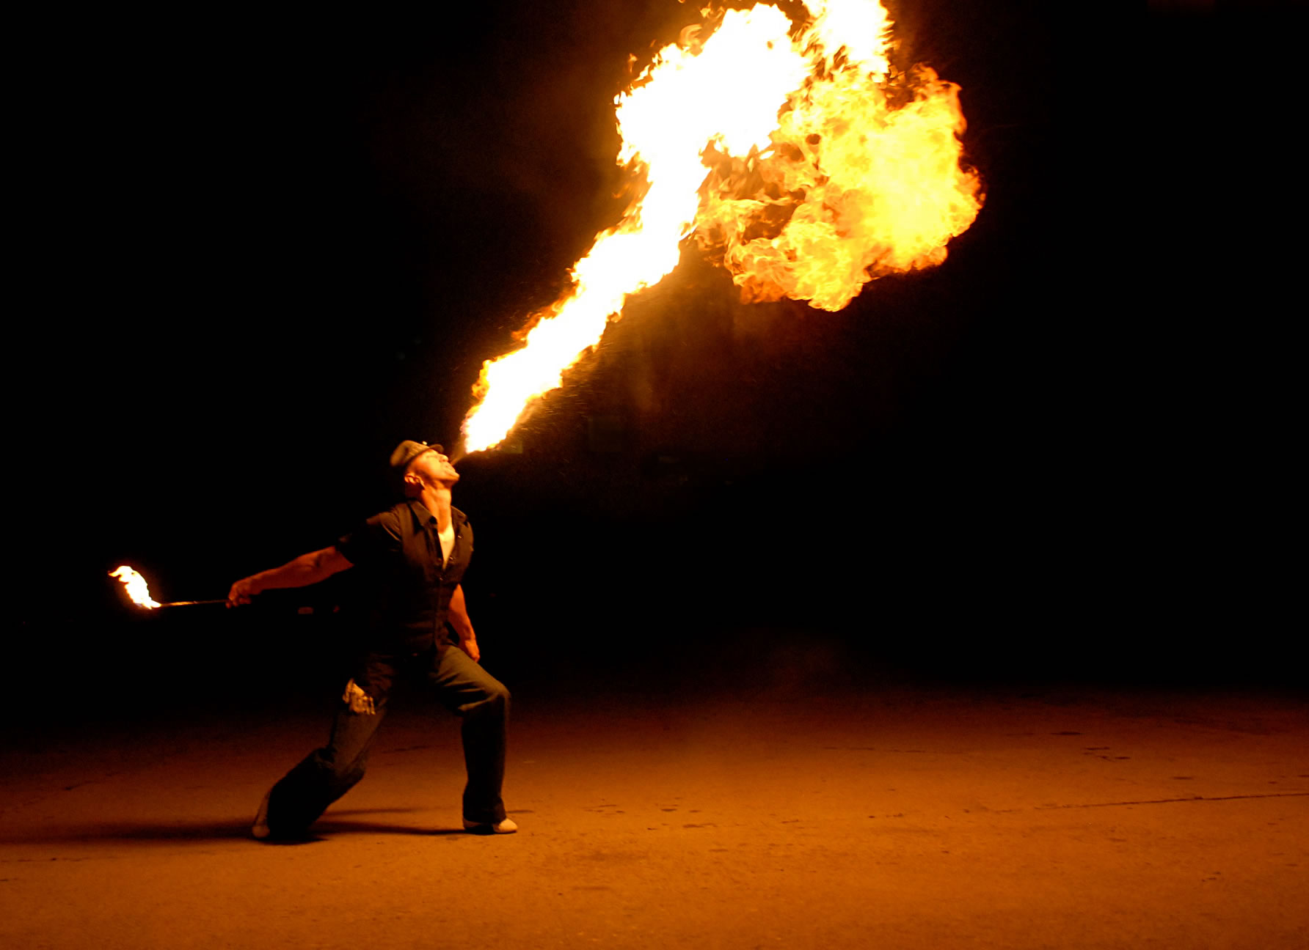  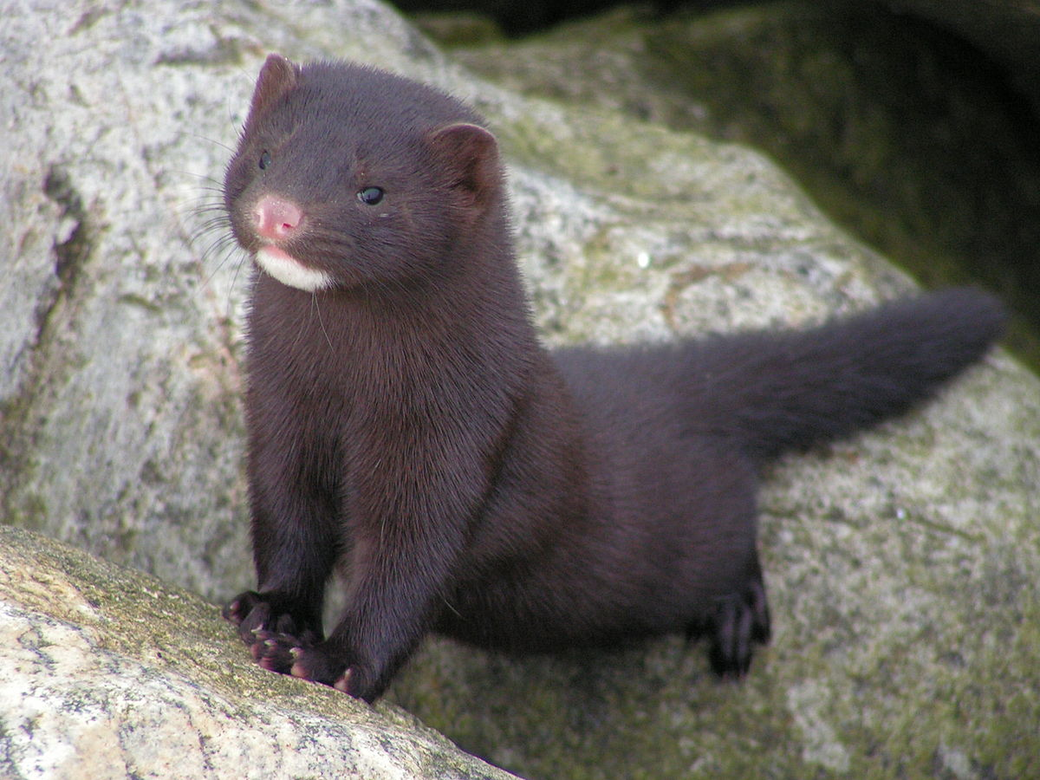  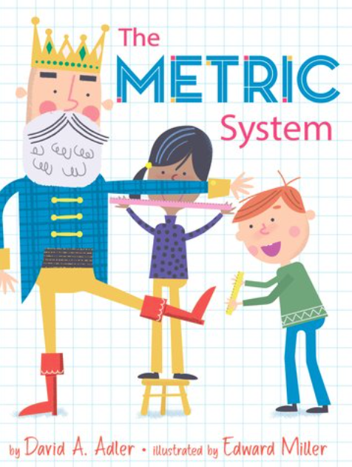 | Vocabulary
Spectacle is an unusual or unexpected event or situation that attracts attention, interest, or disapproval
“Delphine felt she put on a spectacle for the people at the library.” (p.84)-

Mink is a semi-aquatic carnivorous mammal. They are part of the weasel family and are known for having soft skin.
“She thought that names should feel as comfortable as slipping on a mink coat.” (p.82)

Metric system: is a measuring system
“... past the phases of the moon and the metric system” (pg.83)

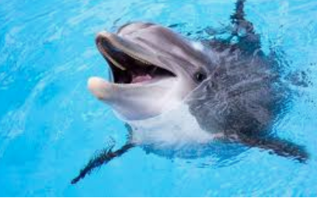 | Explain
1. Where does Vonetta’s name come from?
2. What does Delphine’s name mean? Why is she upset about finding out her own name? What did she think her name should/ could have been?

Apply
Write a poem with the letters of your name -Acrostic Poem
You can do it either way--- both describe who you are…these are 2 we created on name LUPE

L- LOUD LION. L -Loud
U Up in the sky U-understanding
P Pulse rate rising P- Passionate
E elevating me to the E- Excited
brightest stars

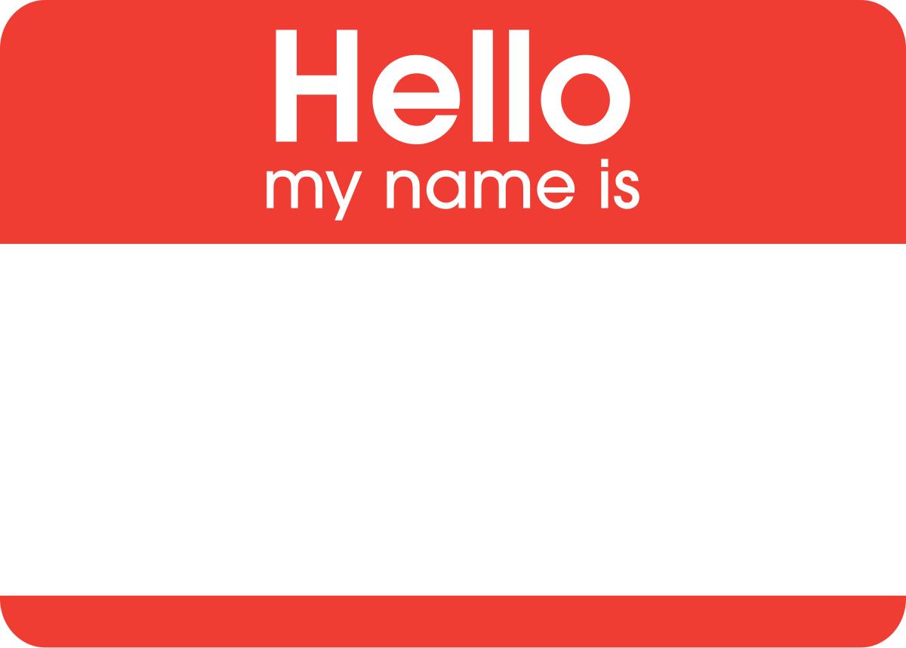 | ASK and Share
Ask someone else
1. What do you think my name means?
2. What does your name mean?

Share what your name means.

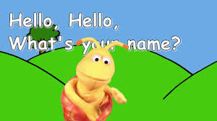 | Reflect
Where does your name come from?
Are you satisfied with your name? Why or why not?
What would you like your name to mean?

Predict
Do you think Delphine will confront her mother about her name? Why or why not?

