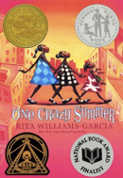
Chapter 14:
Coloring La-La
Engage
Does the news lie or do they not show all of the truth? Why and why not?

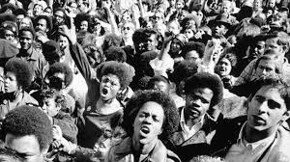 | Vocabulary
Revolution. “Yesterday we learned that revolution means change and we can all be revolutionary.” p. 88

Begrudgingly means reluctantly or resentfully. Eunice and Delphine begrudgingly shook hands.
“We begrudgingly shook hands, then returned to our posters p. 91”

Indulging: a noun: allow oneself to enjoy the pleasure of…
“ It was the only real indulgence we allowed ourselves in missing having a mother.”p. 89

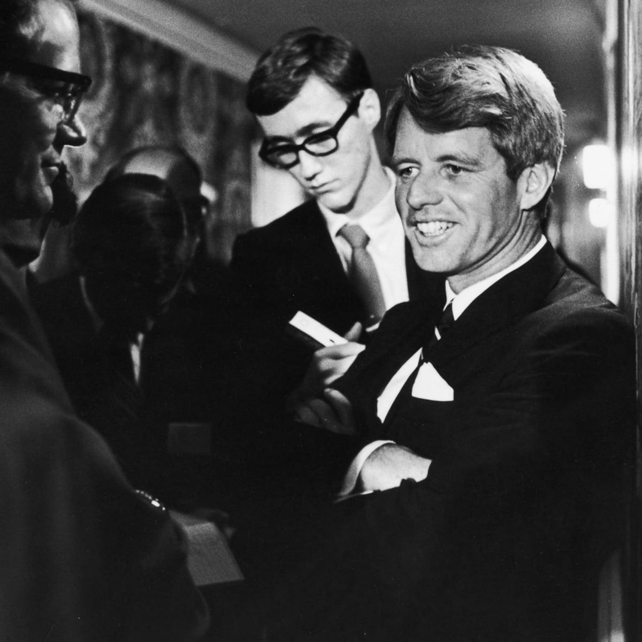  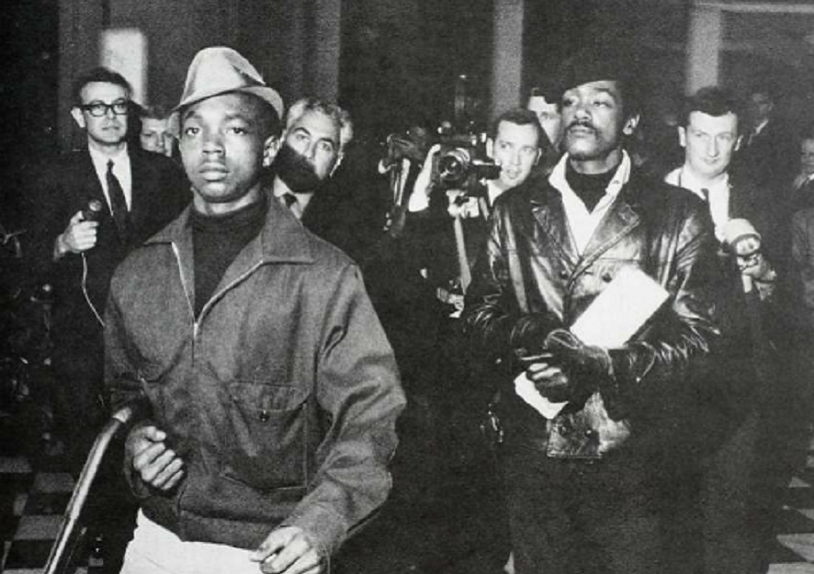  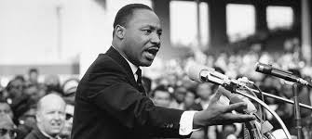  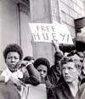 | Did you Know ….
Bobby Kennedy is Robert F. Kennedy was assassinated/ killed June 6 1968. He was running to be the president of the United States. He was a member of the Democratic Party—Nixon won the presidency Jan 1969-1974. He was a member of the Republican Party.

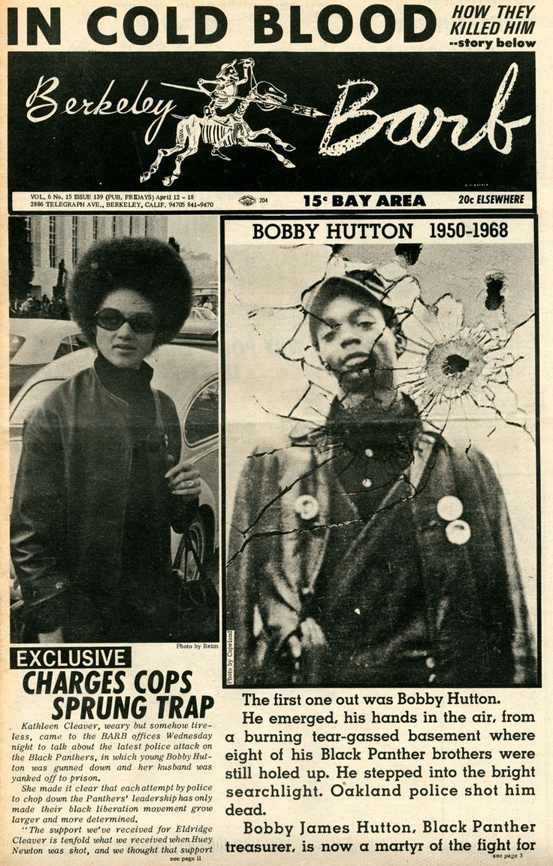
Lil’ Bobby is Robert James Hutton He was 17 years old when the Oakland police killed him in April 5,1968. He was the Black Panther’s first recruit, treasurer of the party.

April 4, 1968 Martin Luther King was assassinated in Memphis, Tennessee.

Malcom X was assassinated in 1965

Free Huey- Huey Newton was arrested in 1968 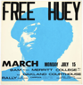Huey was freed in 1970.

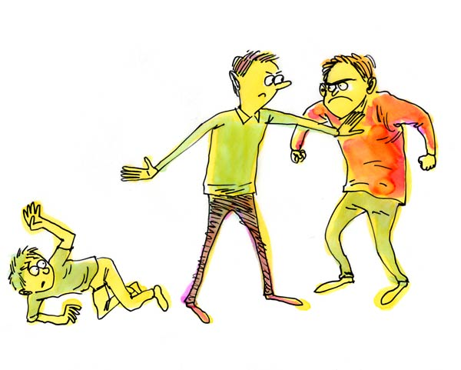 | Explain
Delphine tells Vonetta -“You’re supposed to take up for Fern ”p. 91. Do you agree or disagree with this statement - Why or why not?

What was the news saying about the Black Panthers? Was it true?

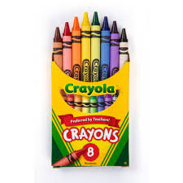 | Apply
Choose a page to color in! (Copy and paste one of these images into a document, make it big enough to fit the page, and print it, or use a coloring application on the computer.)
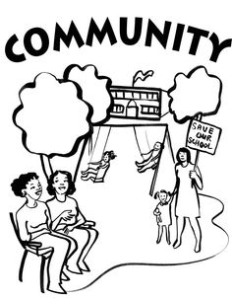

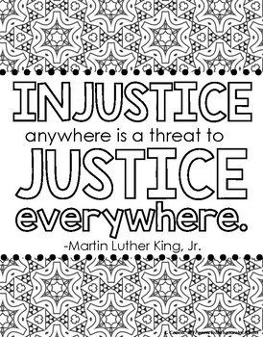

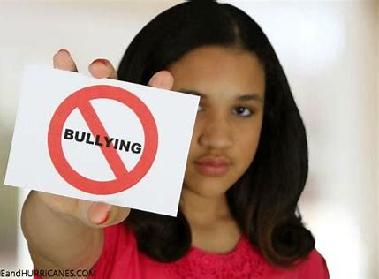 | Share
Have you ever had to stick up for a friend or family member?
Was there a time you should have stuck up for someone but did not?

Reflect
How was Delphine’s opinion of the Black Panther changing? How is Delphine’s role as a caretaker over her sisters changing?

Predict
Do you think the sisters will make up after the fight?
Would you make up with your sibling? Why or why not?

