Chapter 16:
Big Red S
Engage
Has your stomach ever hurt? What did you do to heal your stomach pain?

Vocabulary
Dread - to feel extremely worried or frightened about something that is going to happen or that might happen
“Delphine dreaded to confront Cecile to cook in the kitchen.”

Gawk - to look at something or someone in a foolish or rude way.
“She tried not gawking at the unfamiliar machines before Cecile noticed.”

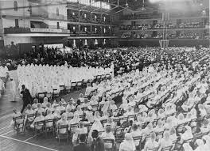  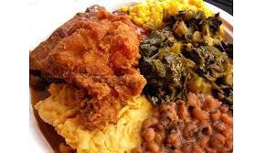 | Did you Know ….
The Nation of Islam’s leaders at the time argued that many dishes and ingredients used particularly in the form of soul food, were from the “slave diet” and had no part in the lives of modern African-Americans in the 1970’s. Wanting to push culture away from food that could be seen as a reminder of slavery, people supported businesses like the Shabazz bakery in the book.
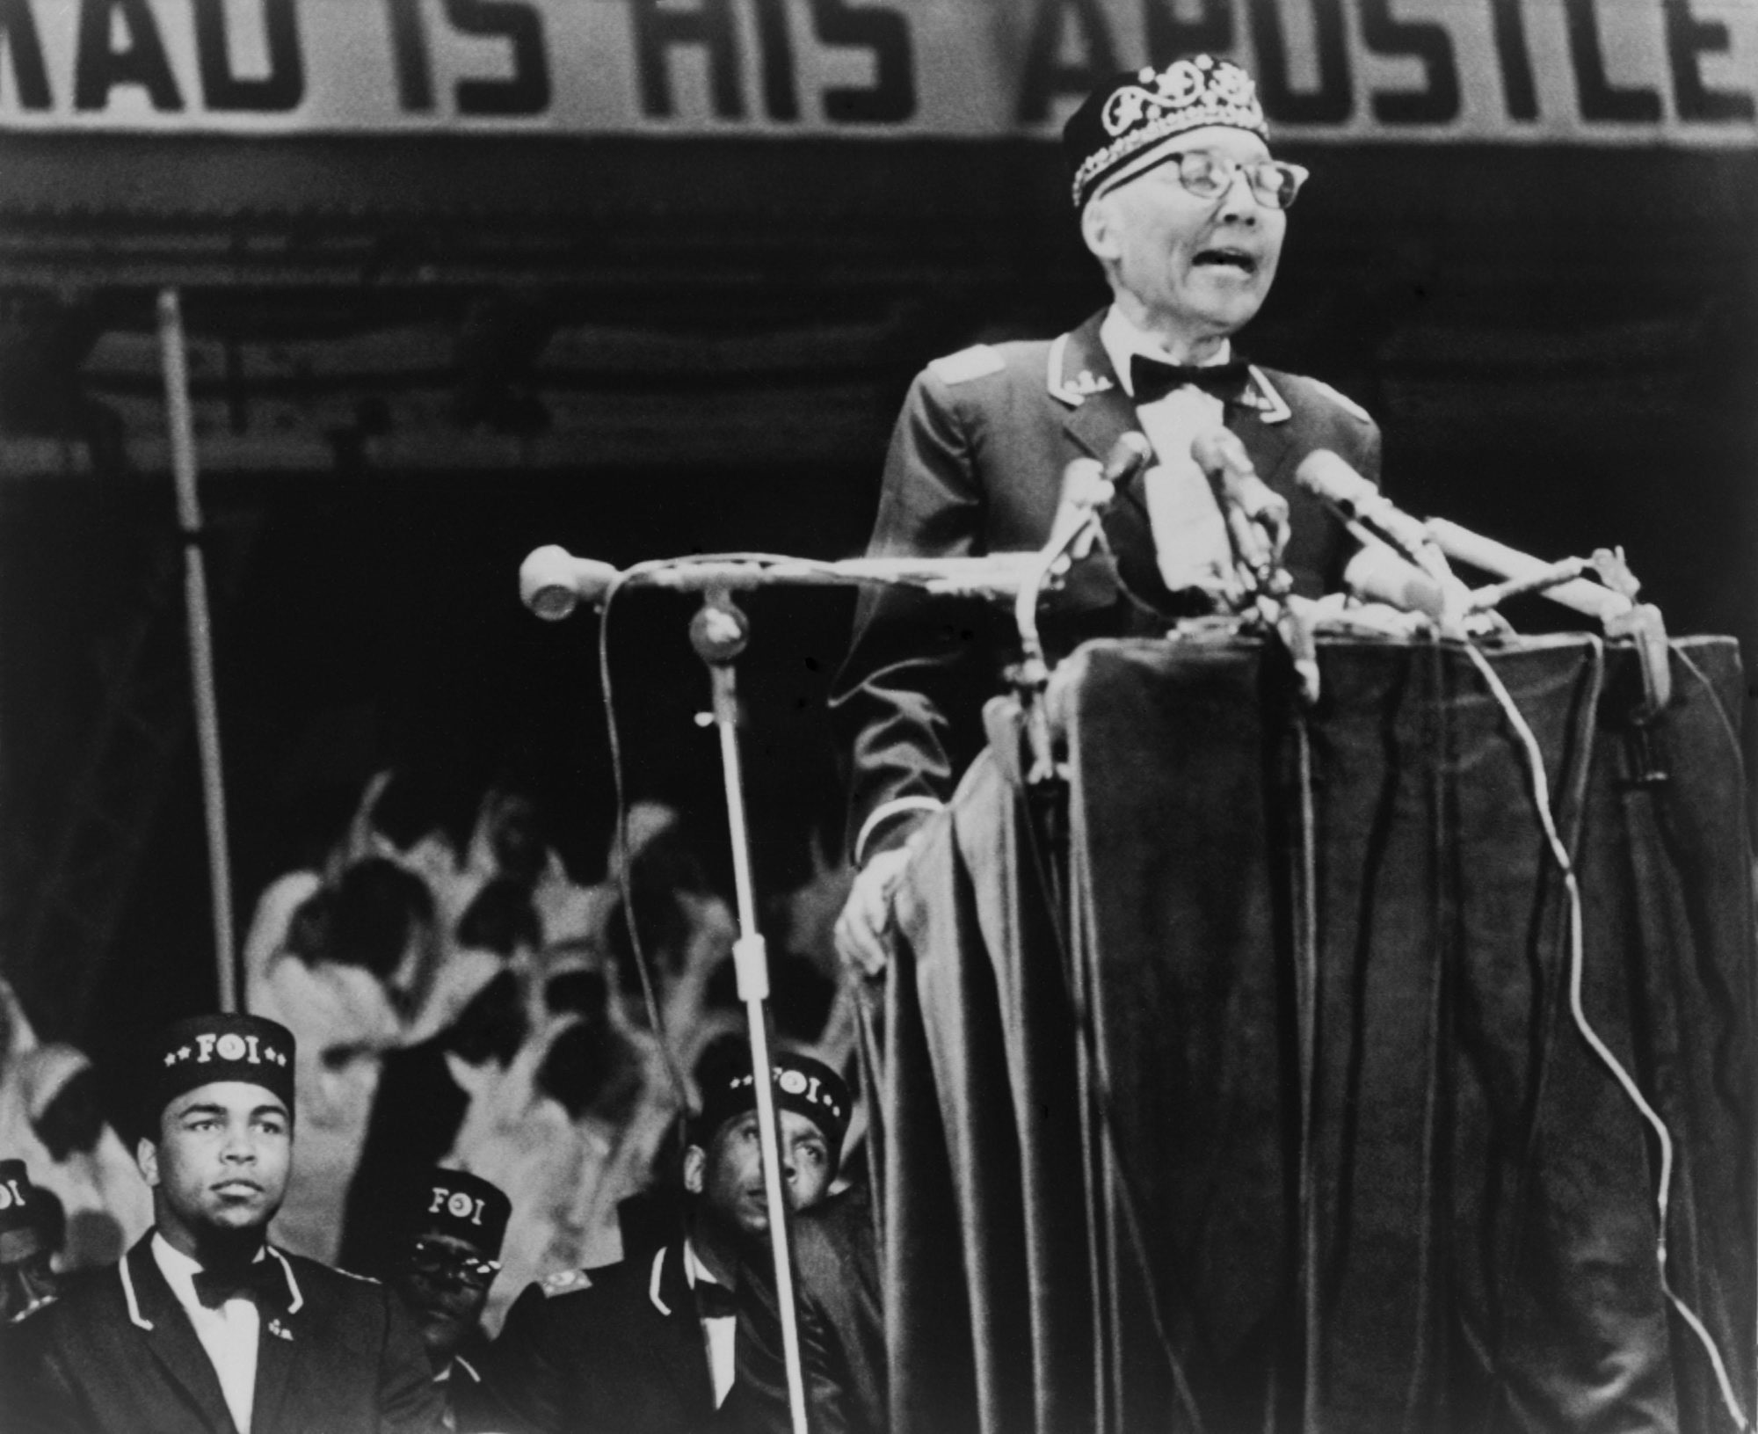
Nation of Islam leader Elijah Muhammad addressing a convention in Chicago in 1967. Muhammad Ali sits on the left.
Your Super Market, South Side Chicago, ca. 1970

Explain
Do you like to cook? What is your favorite home cooked food?

Do you eat out?

Would eating something you liked everyday make you sick of it?

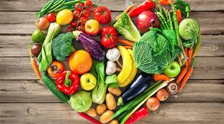 | Apply
 | COOK something healthy...

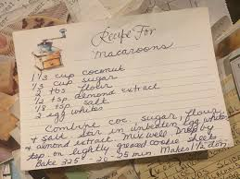 | Share
 | Share your favorite healthy snack.

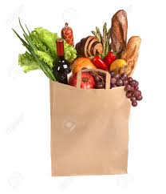 | Reflect
Why do you think Delphine decided to go to the grocery store instead of going to Mings?

Would you prefer a home cooked meal or take out? Why?

Predict
Do you think Delphine will take Cecile’s advice to “be selfish”? Will it be a good thing or bad? Will it affect her sisters?

