One Crazy Summer Chapter 18: Expert Colored Counting p.116-120

Daily Check-In: Choose a number!
- How are you feeling today?
- Not my best 😑
- A little tired 😴
- Feeling good! 😀

Engage
Have you demanded something from your parents/ guardians , teacher, principal or someone? What arguments did you use to win your demands?

What did Delphine Vonetta and Fern demand for? What arguments did they use to get what they wanted?

Vocabulary
Establishment - A group that exercises power and influence over policies and wants to resist change.
“They brought their protest songs and their demands to the Establishment, because the Establishment was in control” (117).
Why did they say Cecile was the establishment?

Flummoxed - To perplex or confuse someone greatly.
“Fern had managed to completely flummox the establishment” (120).

.

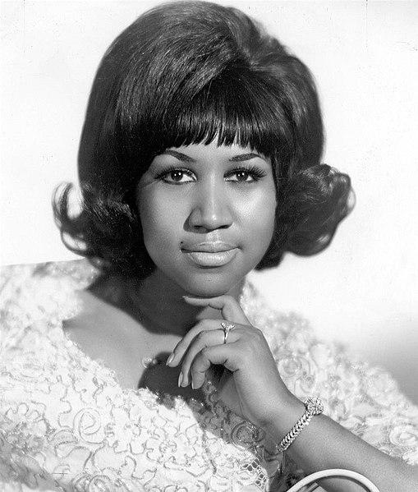  Franklin in 1968 | DID you Know
Aretha Franklin was an American singer, songwriter, actress, pianist, and activist for civil rights and women's rights. She became the first woman inducted into the Rock and Roll Hall of Fame in 1987 and was given the Presidential Medal of Freedom in 2005.

Cable T.V. originated in 1948
In the past 65 years, cable has emerged from a novelty for a handful of households to the nation’s biggest provider of digital television, movies and state-of-the-art Internet service available to millions.

Explain
Explain what Delphine Vonetta and Fern demand for? What arguments did they use to get what they wanted?

What was Cecil's argument against having a TV? What do you think about her arguments?

Apply
Think about a demand you have and Write 3 arguments why someone should meet your demands

Share
Share your demand and arguments with someone ask them what they think of your arguments --- Do they think you have strong arguments? Why or why not?

Reflect
Is it important to you to have figures to relate to in books and movies?
Do you look for people who look like you when you watch TV?

Predict
Do you think living with Cecile will continue to improve?
Was getting them the radio to be nice or just to have them away from her like the girls argued?

