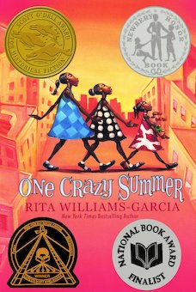
One Crazy Summer Chapter 19: Civic Pride p. 121-5

Daily Check-In: Choose a number!
- How are you feeling today?
- Not my best 😑
- A little tired 😴
- Feeling good! 😀

Engage
What is civics?
Why do we learn about civics?
What have you learned about civics?
Student rights ACLU https://www.myschoolmyrights.com/#stories

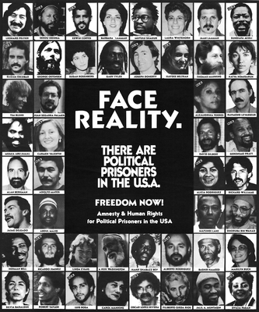  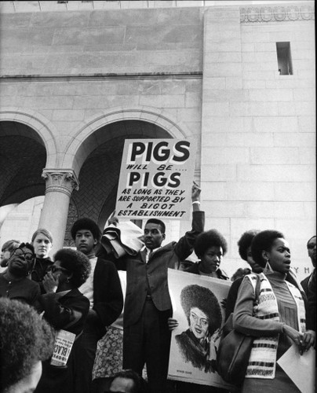 | Vocabulary
CIVIC PRIDE- is defined as having pride in your city, but it's much more than just that. On a higher level, civic pride is a part of many city departments, encompassing active transportation, progressive urban design, the overall branding of the city, historic preservation and city planning.

Political prisoner - Someone who is imprisoned because they opposed or criticized the government.
“Hirohito’s father was what Sister Mukumbu called a ‘freedom fighter’ and ‘political prisoner’”.

Pigs - Derogatory term used for the police.
“The pigs handcuffed him without respect for his rights as a citizen”.
When did we start calling police pigs and why?
This name was started in the 1960’s and was common with anti-war protesters and the Black Panthers.
Why didn’t Delphine like this term?

Burrowed
move underneath or press close to something in order to hide oneself or in search of comfort.
“...Miss Patty Cake burrowed into my side” (124).

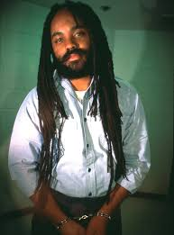  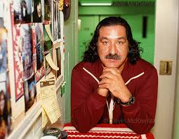 | DID you Know
Leonard Peltier is considered a political prisoner- American Indian Movement also known as AIM, an advocacy group organized to address issues related to sovereignty, leadership, and treaties.

Mumia Abu-Jamal is considered a political prisoner - he was a journalist and activist.

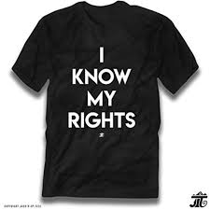 | Explain
What did the girls learn about civics at the Center?
Do you know your rights? What are they?
Why did Crazy Calvin want them to call the Oakland police pigs? Where did this come from?
What happened to Hirohito’s father? Why was he considered a freedom fighter/ Political prisoner?
Do we still have political prisoners in the US?

Apply
Teach someone their rights? How would you teach them their rights?

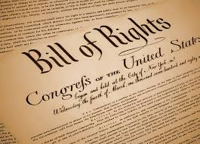 | Share
 | Share with someone what you know about your rights.

Reflect
When was Delphine truly scared?-- State police officer
Have you ever been truly scared like Delphine?

Predict
Do we think that Cecile will step in and teach her daughters their rights?

