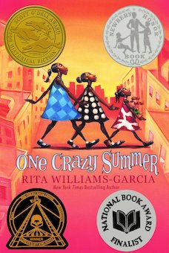
One Crazy Summer Chapter 21: Eating Crow p. 134-9

Daily Check-In: Choose a number!
- How are you feeling today?
- Not my best 😑
- A little tired 😴
- Feeling good! 😀

Engage
Are there times you have not wanted to go to a place? What do you do to convince others to not go? Does it work?

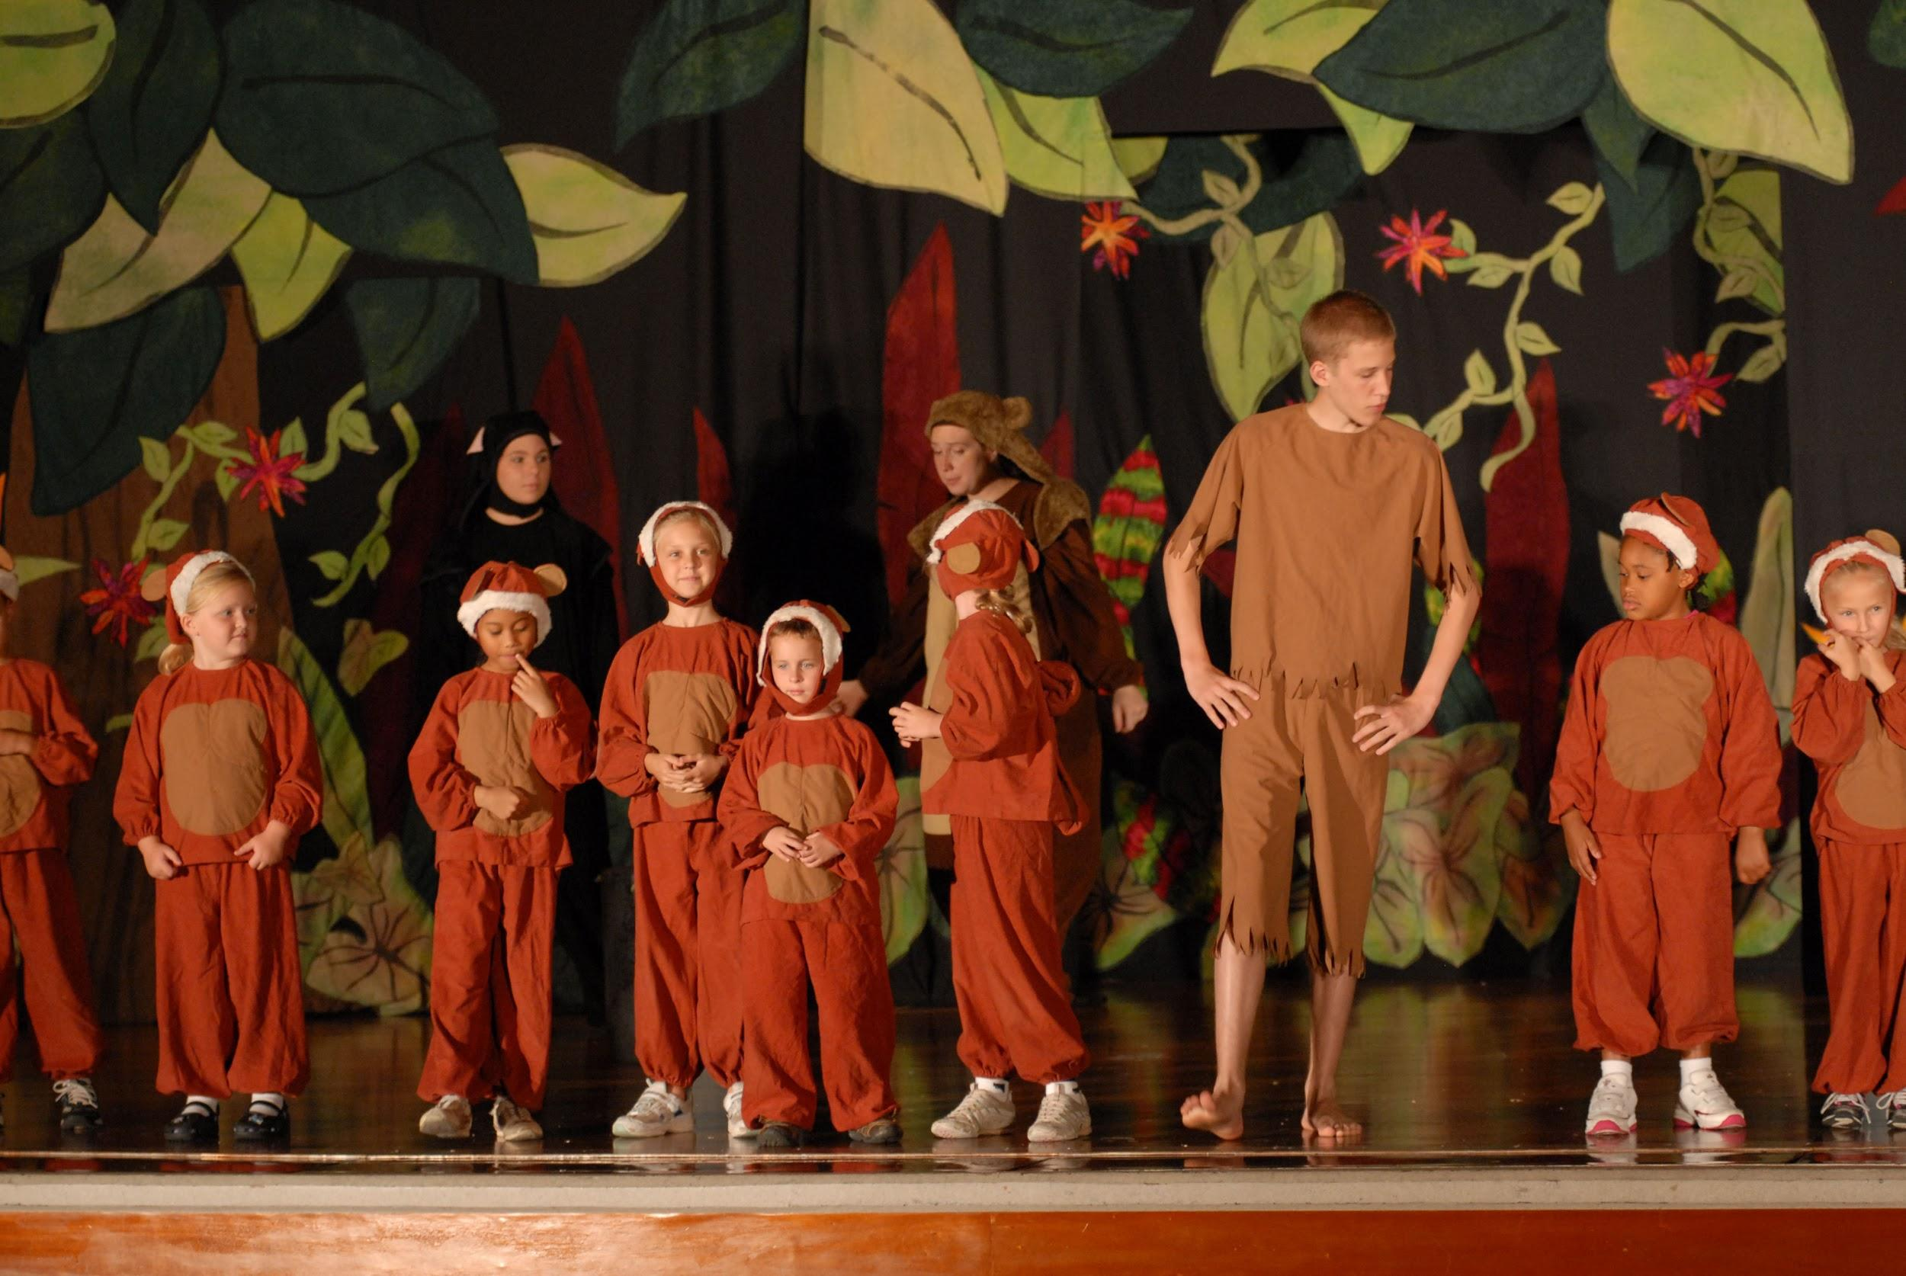 | Vocabulary
Calisthenics – “Sister Pat led us through calisthenics in the yard…” (pg.137). – It refers to playground which has a gymnastic area.

Reenactment - “They could use more actors for the class’s reenactment of Harriet Tubman leading slaves to freedom”(pg.137). Reenactment in this sentence refers to acting out like past characters like Harriet Tubman.

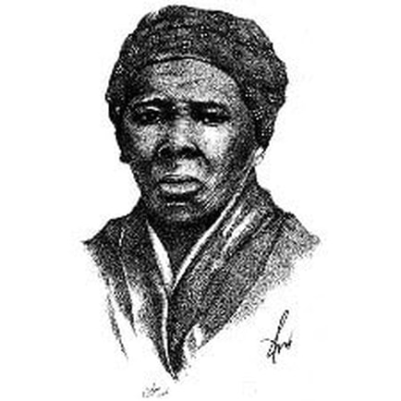 | Harriet Tubman
Harriet Tubman born March 1822. She was an abolitionist and activist. She freed herself from slavery in 1849. Her the nickname Moses, Harriet used her new freedom in the North to lead 13 missions back to the South to rescue 70 enslaved individuals with the assistance of the Underground Railroad (a network of secret routes and safe houses to lead enslaved people out of the South.)

When the Civil War began, Tubman became the first woman to lead an armed expedition in U.S. history- the raid at Combahee Ferry- which liberated over 700 enslaved individuals. (Information gathered from-Harriet Tubman -PBS) Harriet Tubman - PBS

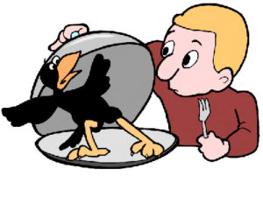 | Explain
Why did Delphine not want to go to the rally nor the Black Panther Center ?

Why did Cecile say Delphine sounded like a country mule?- p. 136

What does it mean to eat crow?- p. 137-- eating crow is an idiom--Let’s read the passage again -
“No one ever called a take back “eating crispy fried chicken.” They called it “eating crow,” and with good reason. P. 137
“I knew that having to eat crow when you were once proud and right was like swallowing a hunk of tough chewy crow meat that wasn’t about to go down easy”. p.137

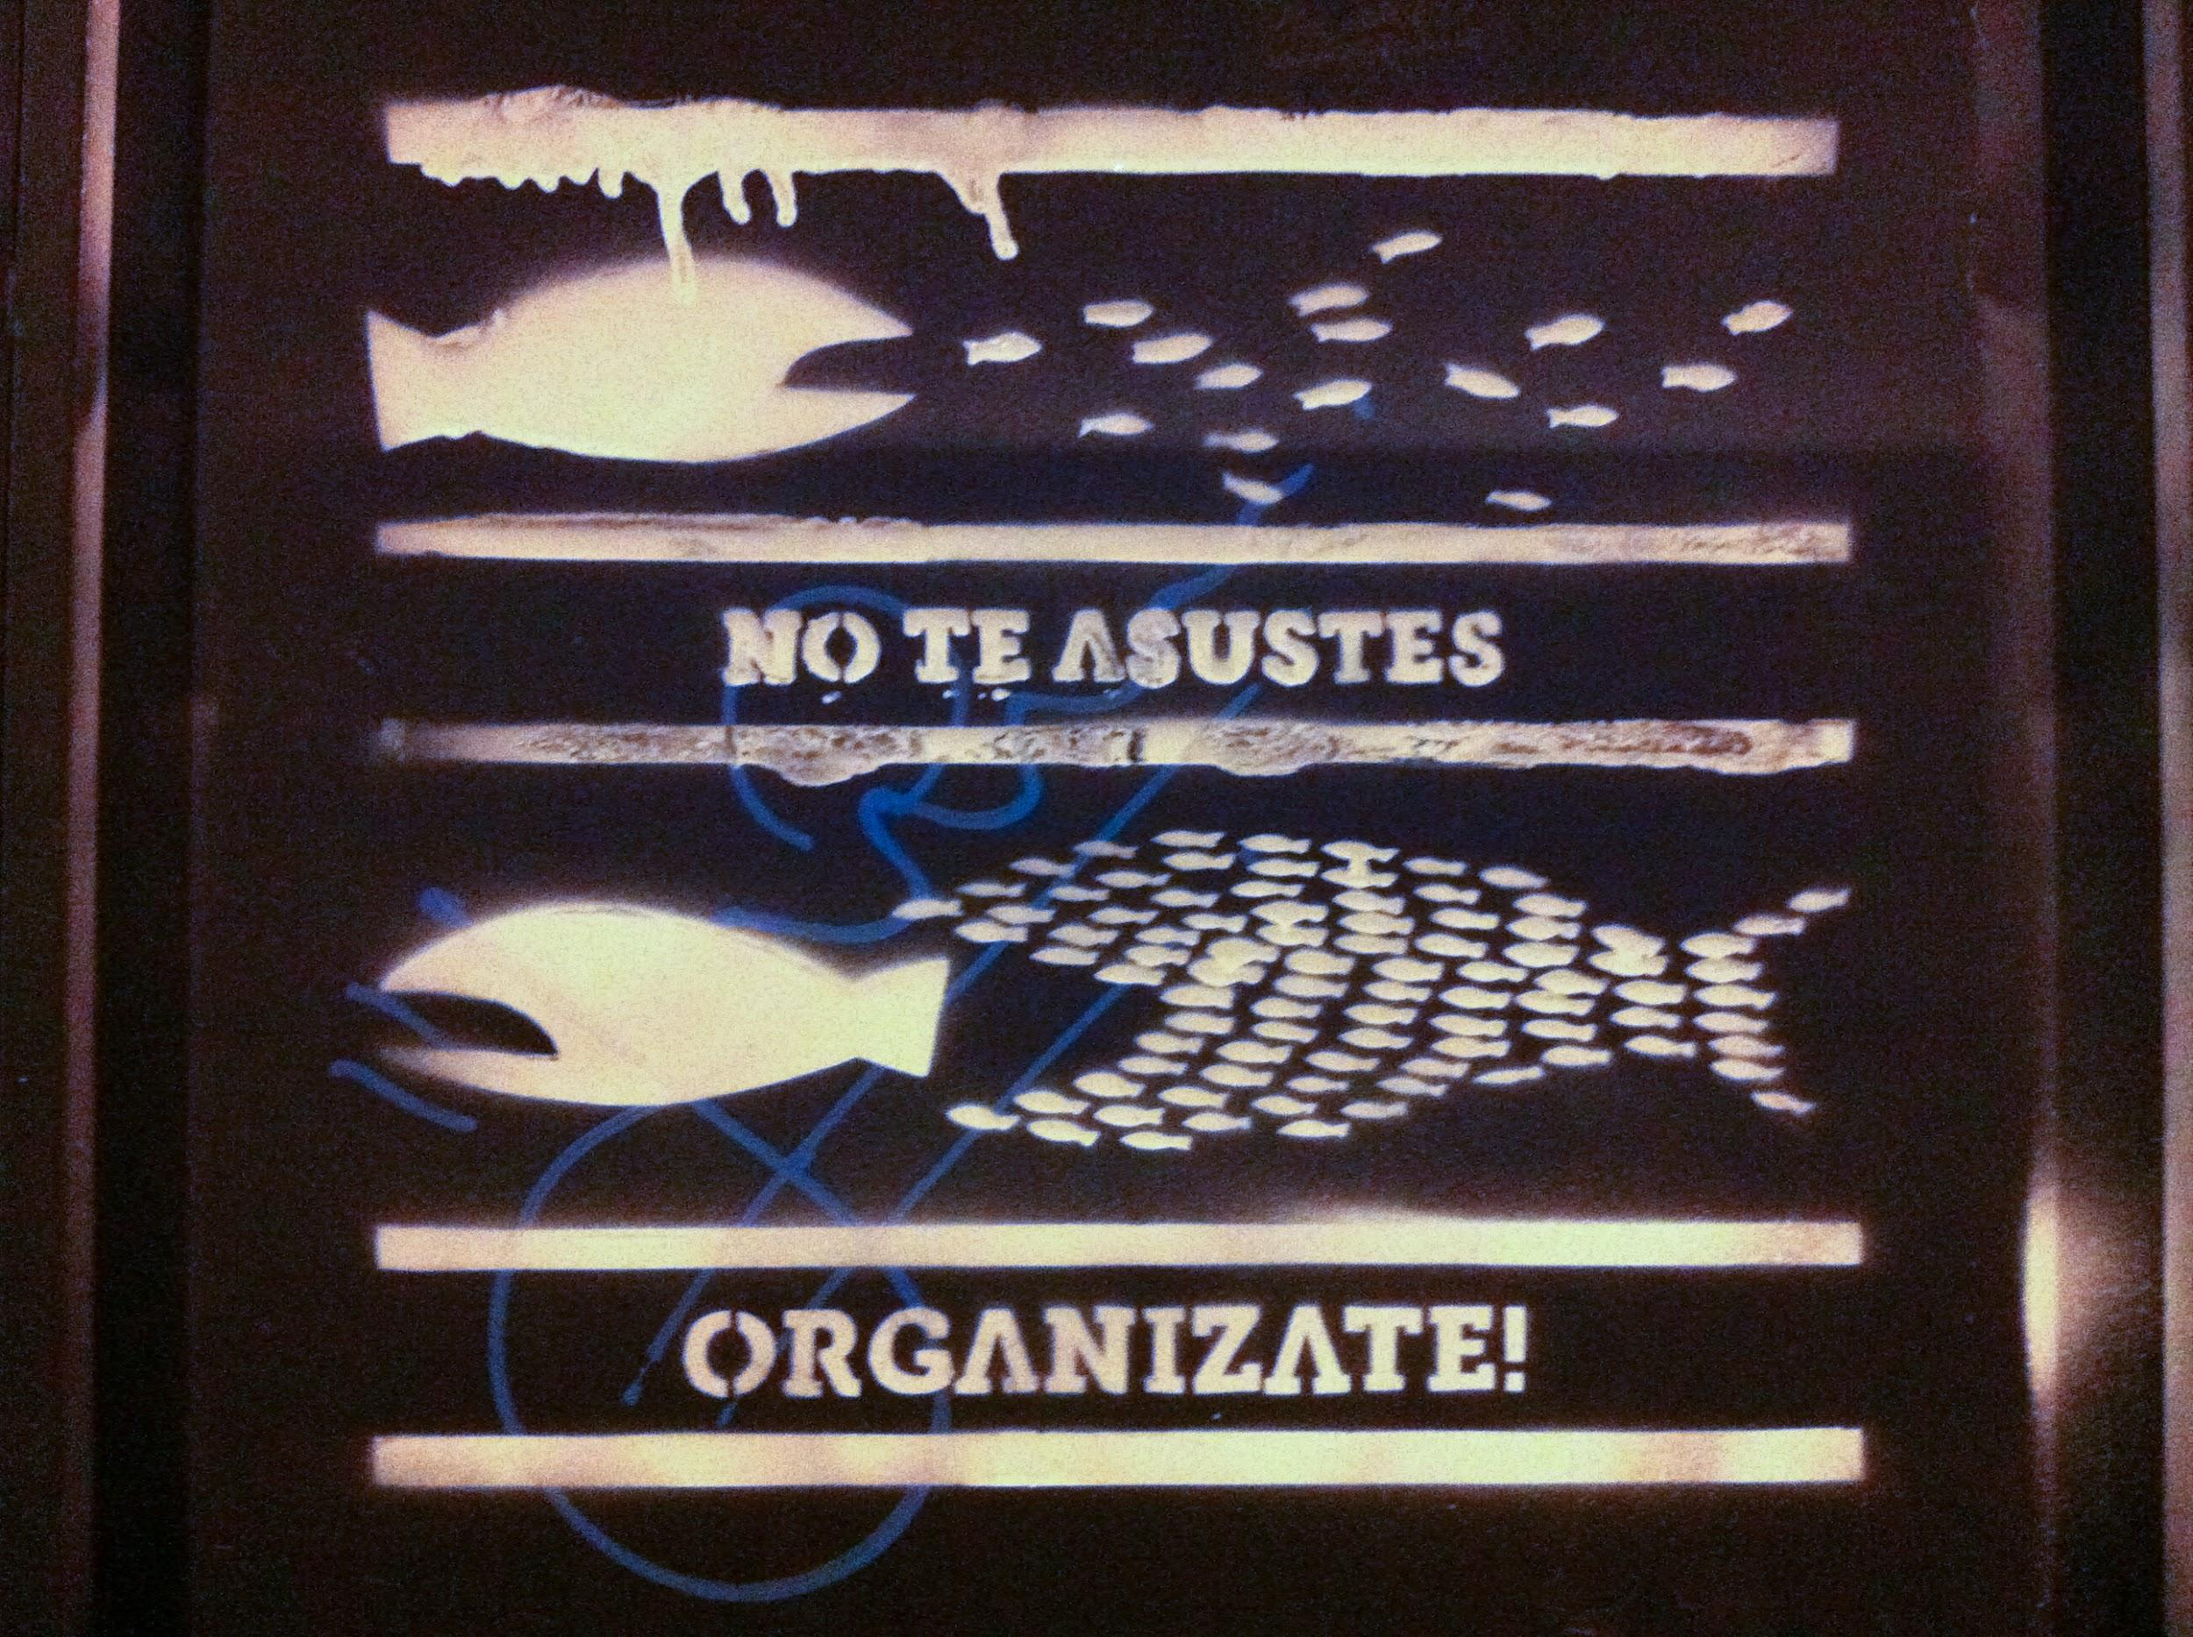 | Apply
 | Art or create your own idiom and what would it mean

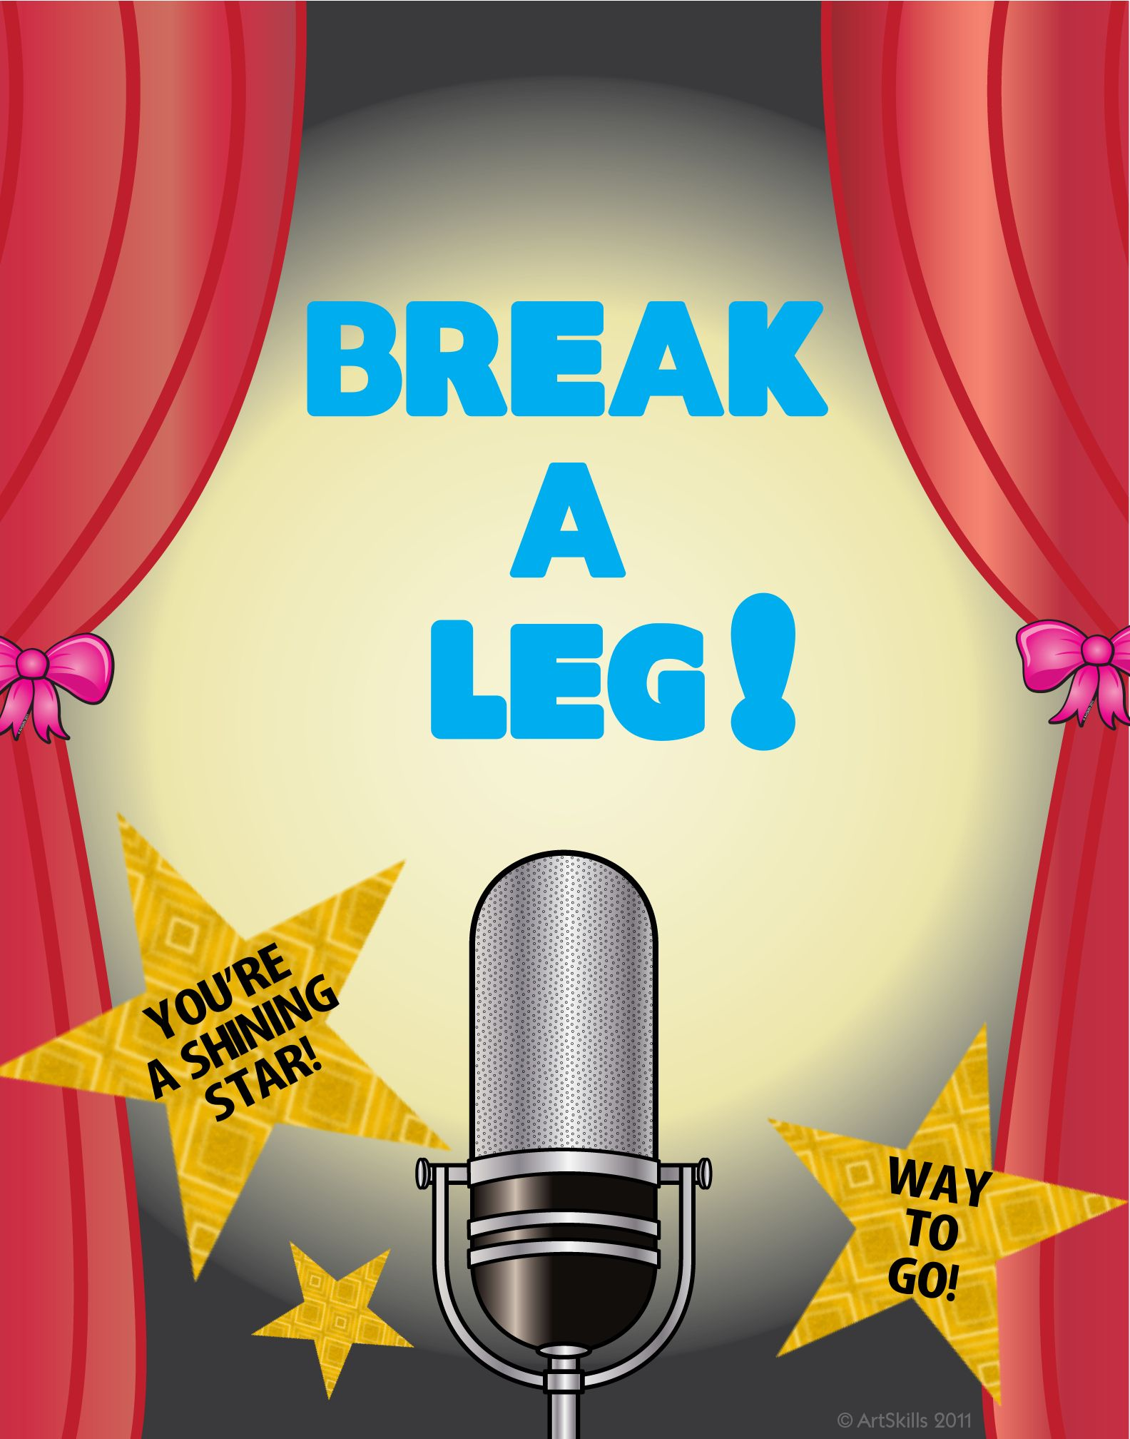 | Share
Eating crow is an idiom-- What is your favorite idiom-
Example of Idioms:
“She/he is a straight shooter” meaning speaks the truth with honesty
“Break a leg” means good luck
“It’s not rocket science”-- means it's not hard
“Red handed”-- caught you when you were doing something wrong or sneaky.

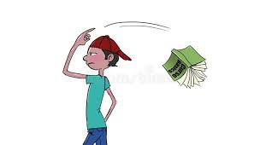  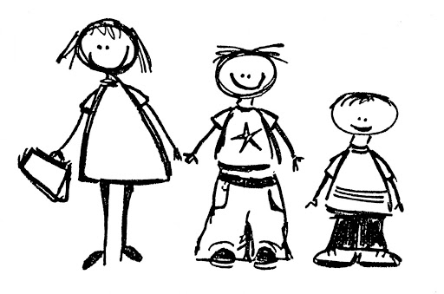 | Reflect
Have you ever felt ignorant? What do you do when you feel ignorant? What can we do to not feel this way

Are you the oldest like Delphine, middle child like Vonetta or the youngest like Fern? Do your siblings listen to you or do you listen to your older siblings? Do you think the eldest sibling still feels responsible for their brothers/ sisters or have things changed? Why?

Predict
Will Delphine and her sisters go to the rally?

Do you think Delphine and Eunice will become friends?

