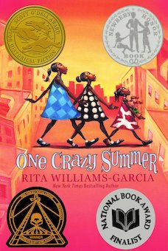
One Crazy Summer Chapter 22: Itsy Bitsy Spider p. 140-5

Daily Check-In: Choose a number!
- How are you feeling today?
- Not my best 😑
- A little tired 😴
- Feeling good! 😀

Engage
Do you have a favorite poem? What is your favorite poem?

What do you think of when -----
Delphine says “Just like I know how to lift my sisters up, I also know how to needle them just right p. 143” --Do you know how to do this as well ? Tell me about it .

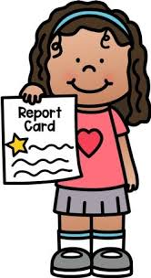  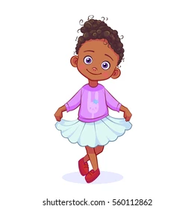 | Vocabulary
Perfectionist - is a person who wants everything to be perfect.. sometimes they are hard to satisfy.
“Vonetta was a perfectionist, but only about certain things. Things that would get her noticed or earn her applause”(pg.141)

Hollering- it is a loud cry
“Big Ma said Vonetta wouldn’t be such a show-off if Cecile had picked Vonetta up more when she was a baby hollering in her crib”(pg. 141)

Recite –read a poem out loud -
“She would recite poetry to calm us down and get us ready to learn more science or history.”(pg.142)

Pitiful- used to say that you consider something to be very bad or not satisfactory or not enough—does the cat in the picture looks pitiful?-
“Vonetta sulked something pitiful when Cecile told her to cut it out.”(pg.142)

Curtsying- Look at the picture – dancers at the end of a show will do a curtsy to show gratitude for the applause. “Last year, Vonetta practiced her curtsying more than she practiced her wings and time steps for the Tip Top Tap recital.”(pg.142)

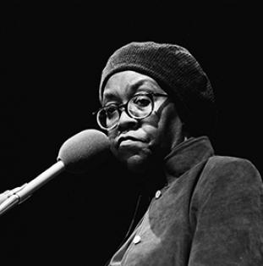 | Did you know
Gwendolyn Brooks (born 1917) was a poet, teacher and author. She was born in Topeka, Kansas but then moved to Chicago. She wrote and began publishing her poems when she was just a teenager. Brooks’ work was often very political, reflecting the civil rights movement. She wrote about the struggles of everyday people and the racial injustice that plagues America. She was the first black woman to win a Pulitzer Prize (which is a very high achievement in literature). You can learn more about her by clicking here- Gwendolyn Brooks

Gwendolyn Brooks-- Listen to her poem - We real cool- the pool players

Explain
Why is Vonetta a perfectionist?

Apply
Write a poem describing Delphine, Cecile, Fern or Vonetta--

Do this with students-

D - Delphine is the oldest
Takes care of her sisters
Lifts them up
But also needles them away
What else can we say?

Vonetta likes the finer things in life
Is a sparkling star ready to shine
Wants to be at the center of every stage
What else can we say?

Cecile has not seen
her children
Loves them
but keeps them at a
distance
a poet who writes on
Cereal boxes
And anything
Near
even a pear
What else can we say?

Fern is little
But very witty
What else can we say?

What else can we say about each character?

Share and learn
Read your poem to someone

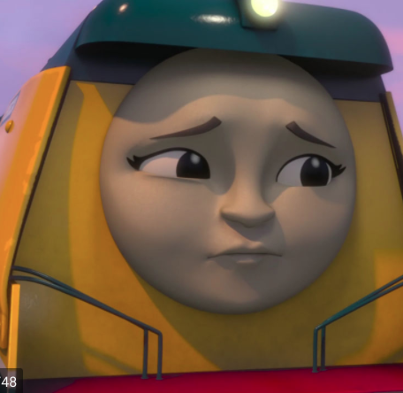 | Reflect
Why did Mrs. Peterson not believe Delphine? How do you think Delphine felt when Mrs. Peterson told her “nice girls don’t tell their classmates lies p. 142”? And then made her write 25 times “I will not tell lies in class” on the black board p. 142---
Have you ever been accused of lying when you were telling the truth? What happened? How did you feel? Was the truth revealed?

Predict
First Vonetta and Fern were going to sing Dry your eyes but now Vonetta will recite a poem by Gwendolyn Brooks-- What do you think they will perform at the rally? Will they be able to attend?

