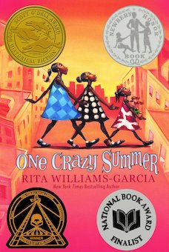
One Crazy Summer Chapter 23: Movable Type p. 146-151

Daily Check-In: Choose a number!
- How are you feeling today?
- Not my best 😑
- A little tired 😴
- Feeling good! 😀

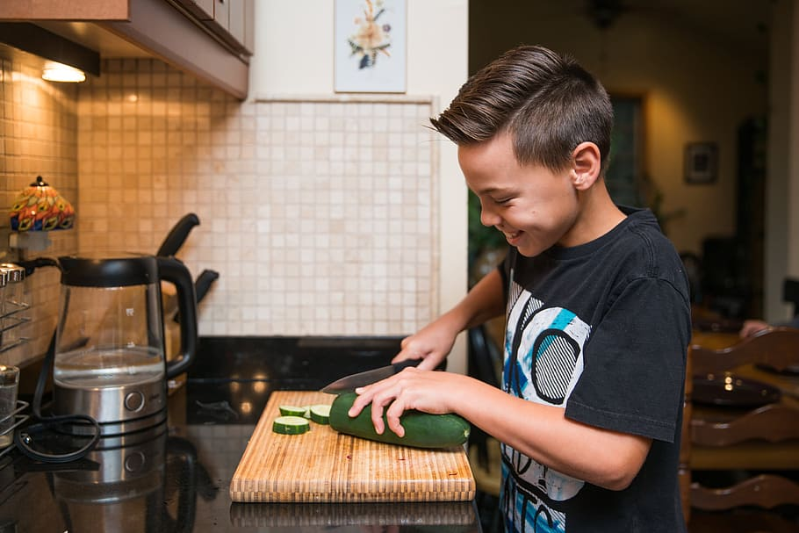 | Engage
Do you cook? Why or why not What did you cook this week?
Speaking up---- What does it mean to speak up?
Do you speak up Why or why not ? Who taught you to speak up? Is it important to speak up why or why not?

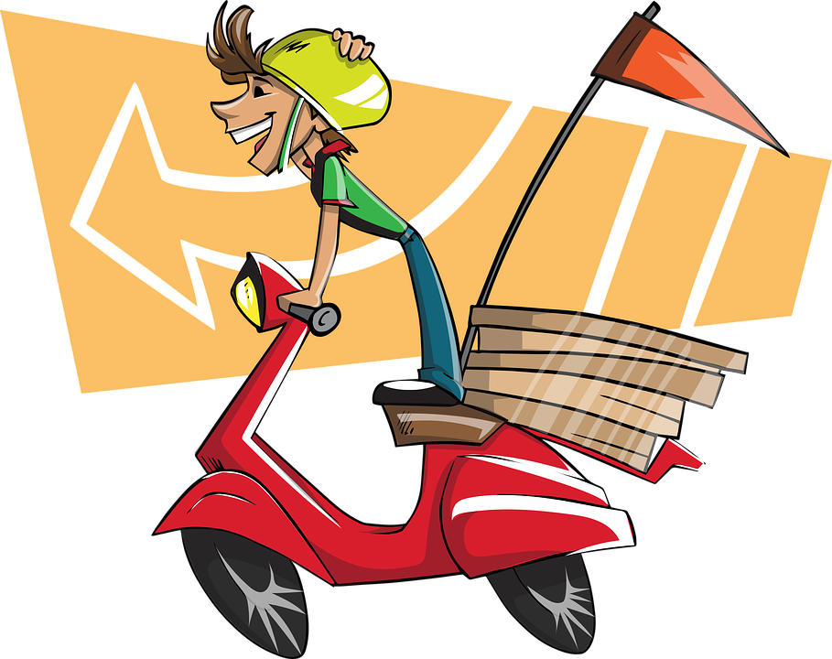  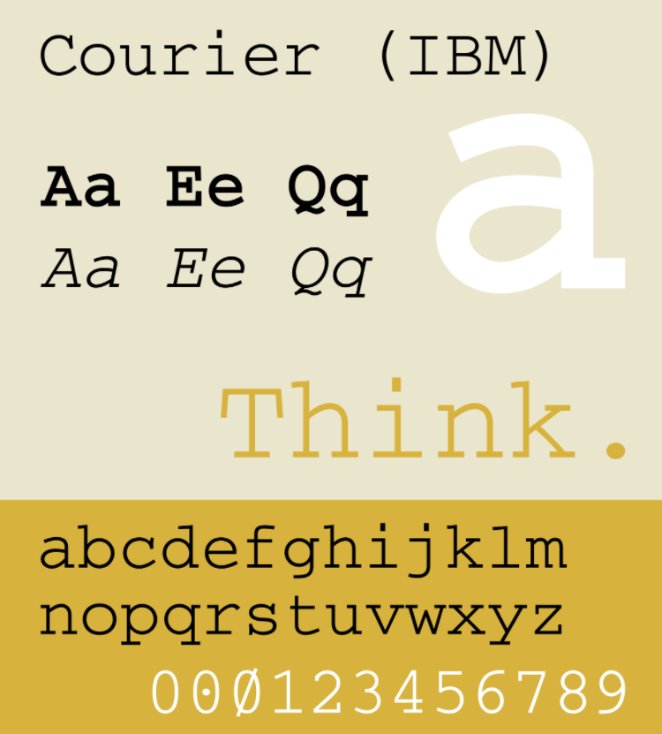  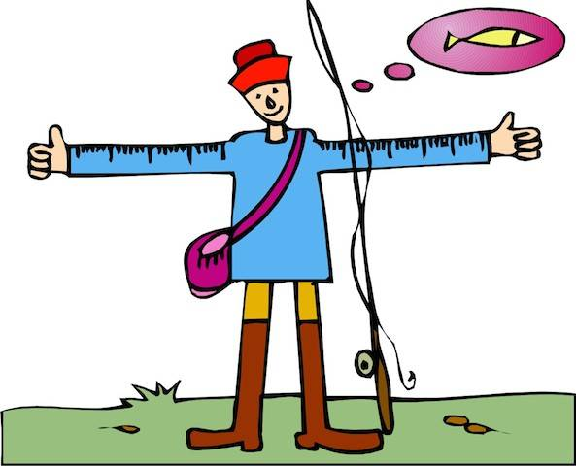  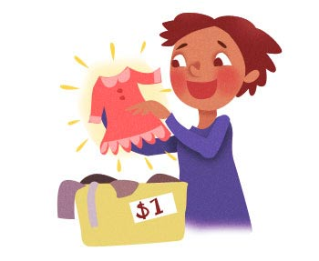 | Vocabulary
Courier - A company or employee of a company that transports packages .
Courier is also the name of a font. (pg.149)

Exaggerate - to stretch the truth; make something seem more elaborate, better, or worse than it actually is; to overstate
“I wouldn’t be exaggerating if I said I was born knowing what to do when I sat with Cecile: Don’t cry. Stay quiet. Want nothing” (pg. 146)

Sans serif - a font without serifs,
Serif as you can see in the picture has a slight line at the end of the letter – do see the slant on the A? that slant is called a serif Sans-serif does not have that.

Secondhand - purchased used for a less money; not new; thrifted; “hand-me-down”
“When I came into the kitchen to make spaghetti that evening, there was a stool by the stove. It was like everything else Cecile brought into her green stucco house. Secondhand” (pg. 146)

Did you know
Moveable type, just like the title of the chapter, is the world's first movable type printing technology for paper books. The first known use of printing using moveable type was a press made of porcelain materials and was invented around AD 1040 in China during the Northern Song Dynasty by the inventor Bi Sheng (990–1051).
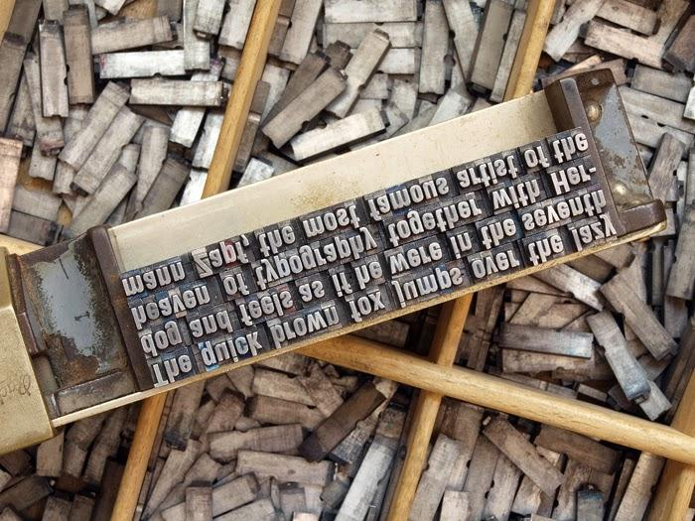
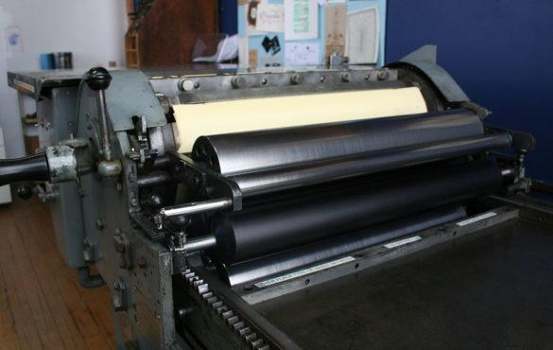
Example of a Rotary Press.

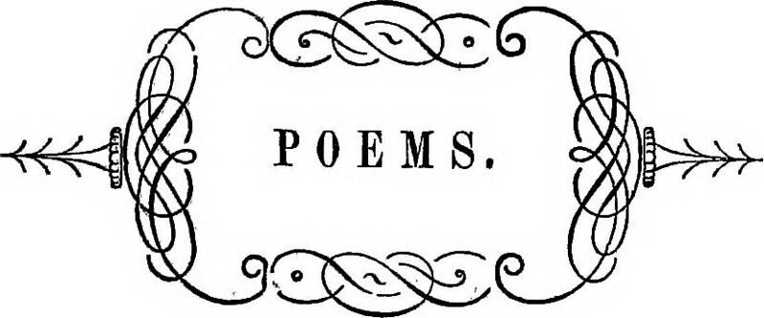 | Explain
What do you think Cecile’s poem is about?
What does it mean to you?
What message was Cecile trying to convey?
Let’s read again

Moveable type
Push here
I Move
There
Push
there
I move
Two square over
Buy those squares
From under my
Feet
I land on
The free square
Raise my rent
Rent
I
Pica (refers to 10 point font)
Elite (refers to 12 point font )
Courier (refers to a font style-)
Sans Serif (refers to a font style)
Pack light. Leave swift
I’m that type
I move
Nzila (p. 148-9)

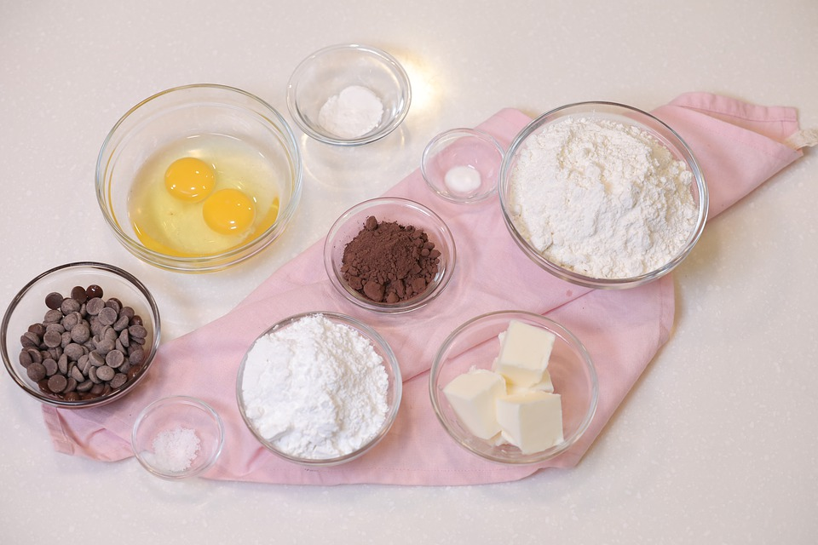 | Apply
Ideas and recipes to make a quick meal -

Or Print words on to paper

Share and learn
Tell someone what you learned from someone or
Share with someone the words you printed onto paper

Reflect
Cecile was teaching Delphine how to print--- printing her poem
Delphine was scared to make a mistake--

What has someone taught you? Did you learn how to do it correctly the first time you tried to do it on your own? How about Delphine?

Do you fear making a mistake? Why or why not?

Cecile at the end of the chapter says “ A waste of paper” --What do you think of what Cecile said to Delphine? How do you think Delphine felt?

Why do you think that Cecile chose to print Nzila in green and in a different font? Would you do this as well?

Predict
Do you think she will get better at printing?

Will Cecile’s poem be read at the rally?

