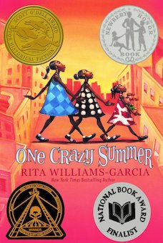
One Crazy Summer Chapter 26: The Clark Sisters p. 168-172
Chapter 27: I birthed a Nation p. 173-178
Chapter 28: Stores of the No Sayers p. 179-184

Daily Check-In: Choose a number!
- How are you feeling today?
- Not my best 😑
- A little tired 😴
- Feeling good! 😀

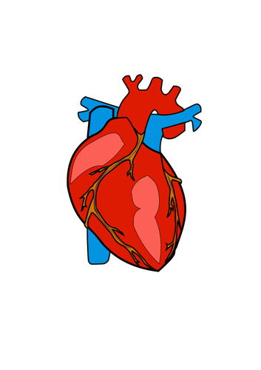  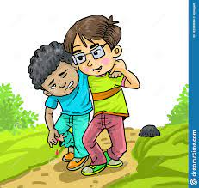 | Engage
Has your heart ever gone thump thump thump real fast? Tell us what happened?

What nice things have you done for your parents or guardians?
What kind /generous things have you done for others? Why?

Have you done community work? What community work have you done?-- What community work did Delphine, Vonetta and Fern do?

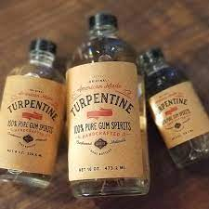 | Vocabulary
.
Warrant - a writing or document certifying or authorizing something, as a receipt, license, or commission.
“She and the Black Panthers might have demanded to see the policemen’s search warrant.”

Turpentine - an oil made from pine wood used in mixing paints and cleaning.
“Only turpentine could wipe away the black and red ink…”

Stanza - a grouped set of lines within a poem, usually set off from others by a blank line or indentation.
“We chose our own stanza but recited the last one together.”
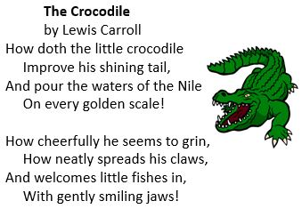
EXAMPLE-

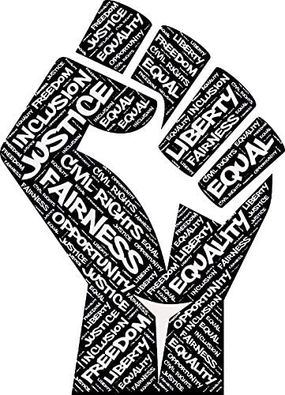 | Review
What has Delphine learned about her mother & Oakland?

- Black Panthers “Eunice, Hirohito and me also included information about free sickle cell anemia testing, voter registration, free shoes for the poor, supporting Huey Newton and changing the park’s name to the Bobby Hutton name” p.182
- Community and community service
- Freedom fighter - “oppressed by the man”
- Counter Culture-
- COINTELPRO-
Characters

 | Describe | Quotes | Learned
Delphine
Sister Nzila (Cecile)
Hirohito
Sister Mukumbu

Explain
Why did Cecile say : “ Kids? I don’t have no kids. They belong to the Clarks down the street. p. 169”.

Why did Hirohito’s mother say “We have to stick together p. 178”? What does this mean?

Why did Delphine say “We really didn’t know our mother, and we couldn’t leave without knowing who she really was p.179 ”?

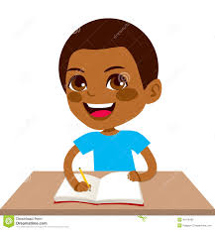 | Apply
 | Write a poem about a person or many people that mean a lot to you like Cecil did. Then, share your poem with that person.

Share and learn
Has there ever been a time that you had to take control of a situation like Delphine does when Cecil is arrested?
Did you know what to do? How did you feel?

Reflect
Has Cecile’s arrest given us insight on why she was not motherly?

What did Cecile’s poem “I birthed a nation” represent to Vonetta, Fern, and Delphine?

Is information power? How?

Why is the chapter called Stores of the No Sayers?-- Hint what type of action will Delphine take against the Stores of the No Sayers?

Predict
Will the sisters get to see Cecile again?
What do you think will happen to Cecile?
What will happen to the sisters?
Will they recite Cecile’s poem at the rally?

