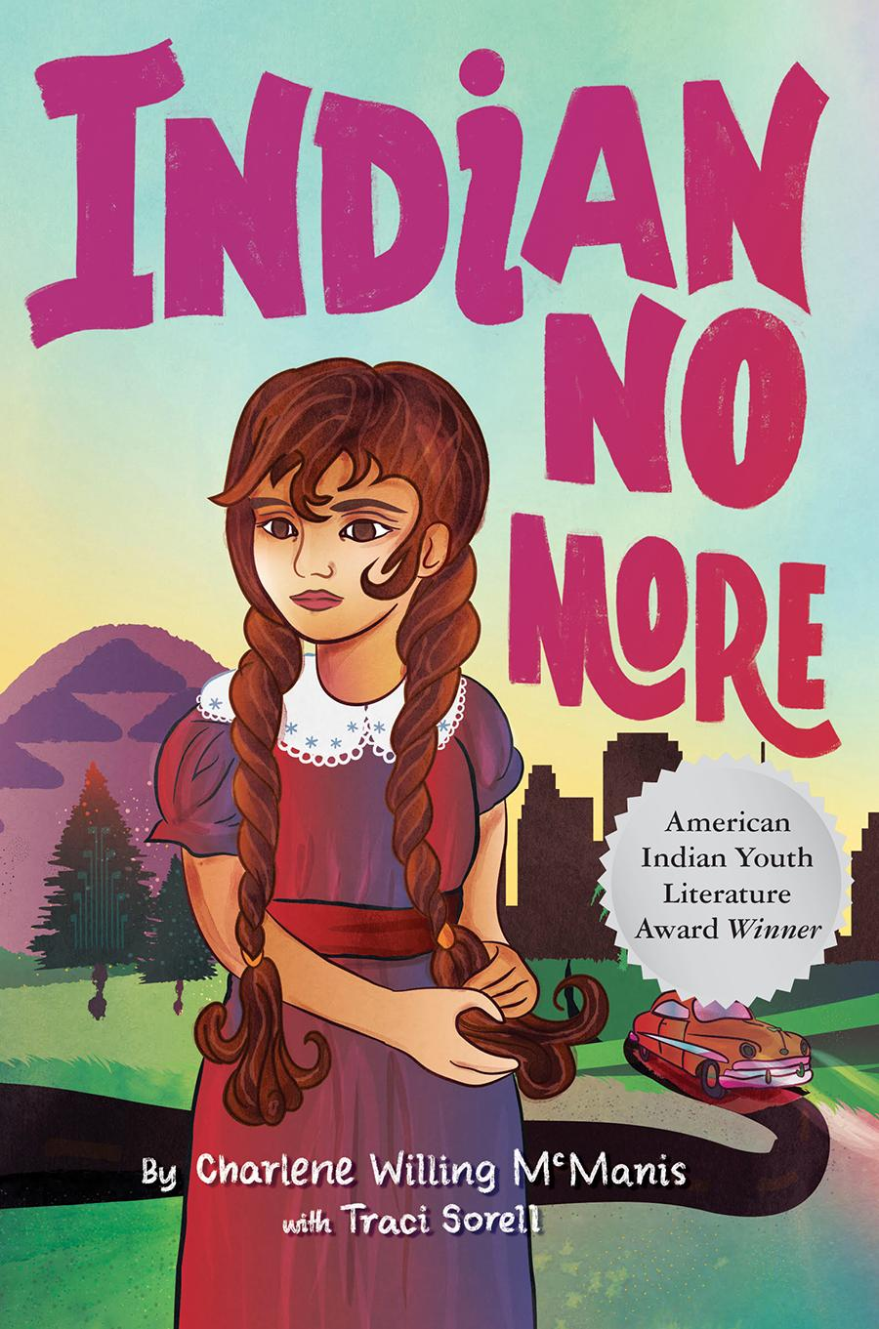

***Chapters 8-11 p. 46-67***

**If it helps, you can listen to the story by clicking on the chapter :**

[**Chapter 8: “The Wrong Kind of Indians”**](https://youtu.be/x3t3SA70G1k)

[**Chapter 9: Plankhouse People**](https://www.youtube.com/watch?v=z1cnXudHPZ8)

[**Chapter 10: Bows, Arrows, and TV Indians**](https://www.youtube.com/watch?v=rqs5IdzSCJM)

[**Chapter 11: “Summer in the City”**](https://www.youtube.com/watch?v=0RALFSf6qpU)

|  |  |
| --- | --- |
| **Look at pictures on page 179** | **Engage** |
| Look at the pictures on page 179 – observe Regina’s house on 58th st, her friends Keith and Addie, and pictures of Grand Rhonde.. If you keep looking at pictures you can observe the differences between LA and Grand Ronde-Spirit Mountain.  What are the differences you observe between Los Angeles and Grand Ronde |

|  |  |
| --- | --- |
| **Houses of the Oregon Tribes – QUARTUX**  **Confederated Tribes of Grand Ronde** | **Vocabulary** |
| **Tipi** (te-pee) A portable tent made of skins, cloth, or canvas on frame poles. Not all tipis are the same, it will depend on the place and peoples of that community and nation -  *“‘Umpqua don’t have tipis… Just make them a lean-to like I taught you”* (pg 47).  **Lean-to**- A lean-to is a temporary structure made from readily available materials like brush, leaves, and twigs.  “*Peewee and I took the dolls and ran out into the front yard. There we scavenged for sticks and leaves to make tiny lean-tos, the summer homes some Indians make when they’re away from home fishing, hunting, and gathering. Back on the rez, Daddy taught us how to make them one Saturday afternoon”* (pg 40)  ***Plankhouses*** -look at page 184 - When Regina asked why they do not have tipis Chich replies “Because our people didn’t move around like Plain Indians, she said. We build plankhouses from wood , fished in the rivers, and cultivated camas and other crops.”p. 50  **Regalia** traditional and often sacred clothing, accessories and artifacts worn or accrued during various ceremonies such as traditional dances (ex: powwow)  *“She told me how when she was little, the Indian agent would gather our people up in their deerskin regalia adorned with shells and parade them through town like circus acts” (pg 52).*  **Marionette** A puppet worked from above by strings attached to its limbs.  *“We applauded when the first marionette, a tall Spanish dancer, came onstage”* (pg 63).  **Perplexed**: To be puzzled, confused.  *“‘What about an Indian costume?’ Addie asked her. ‘Costume? No. Why would I wear a costume?’ Peewee seemed perplexed. Frankly, I was too”* (pg 47) |

|  |
| --- |
| **Did you know...** |
| 1. There are 574 Indian tribes recognized by the Bureau of Indian Affairs (BIA). 229 of these are in Alaska! However these are just the tribes recognized by the US government. There are more tribes in both North and South America’s history.     [Regalia Video](https://youtu.be/KvPHZbZ_cjU) from Grand Ronde nation    [3. POW WOW](https://www.youtube.com/watch?v=Fv6DZTNkY5w) |

|  |  |
| --- | --- |
|  | **SentiPensante**  **Think, Feel and Sense @ the same time** |
| What do the following quotes mean to you, make you feel, sense, and think, make you *sentipensar*?   * Chich to Regina: “Some people think Indians still live like they did before the white man came” (pg 51) * Chapter 8 title “The Wrong Kind of Indian” (page 46) * “Geez, what kind of Indians are you?” (page 47) * “She told me how when she was little, the Indian agent would gather our people up in their deerskin regalia adorned with shells and parade them through town like circus acts. She didn’t like the white folk’s stares… Because of that, many stopped wearing their regalia. A person gets tired of being treated like a circus animal” (52). |

|  |  |
| --- | --- |
|  | **Apply** |
| Remember POW WOW is not a show!  Write how you would explain to someone what POW WOW means based on our discussion and given text. |

|  |  |
| --- | --- |
|  | **Share** |
| Explain to someone the meaning of a POWWOW  And  Share a similar experience that invokes the feelings of a POWWOW such as family dinners, dancing, singing , celebrations. Share Intercultural, Interracial coming togethers to celebrate, sing, dance, share food etc. |

|  |  |
| --- | --- |
| **Pin on Education - Best Practices - Assessments**  **REFLECT - LEARN - CHANGE :: newtownparkparish** | **Reflect** |
| On page 51, Regina says, “But in the city, I guess Indians had to show, not tell;” why do you think she feels this way? Does your identity and cultural identity need to be obvious to everyone?  On page 47, Addie asks Peewee where her Indian costume is— Peewee is confused and asks, “Why would I wear a costume?” Addie responds by asking: “Geez, what kind of Indians are you?”  Is there such a thing as a “real” Indian?  How did Addie respond in that situation that may have been hurtful to Regina and Peewee? What are some better ways to learn about someone else’s culture that doesn’t rely on making assumptions?  On page 53, Chich says, “Regina, just remember this. You were born an Indian. Peewee is an Indian. It’s our Umpqua stories and traditions that keep you Indian. You don’t need to dress up to prove that.” Does your family or community have traditions and stories that impact who you are? |

|  |  |
| --- | --- |
| **2015 social media predictions - OrbitCarrot Marketing** | **Predict** |
| Do you think Regina will confront her friends about their portrayal of Indians? Why or why not?  Will Regina get used to her new home in LA or will she continue being homesick for Grand Ronde? |

|  |  |
| --- | --- |
| [**TREATIES**](https://www.youtube.com/watch?v=bexvE4lZRGo) | **REVIEW** |
| **CLICK to** [WATCH Why Treaties Matter - NPR](https://www.youtube.com/watch?v=bexvE4lZRGo) |

|  |  |
| --- | --- |
|  | **Self-Assessment** |
| I learned …  I still have questions about…  I do not understand…. |