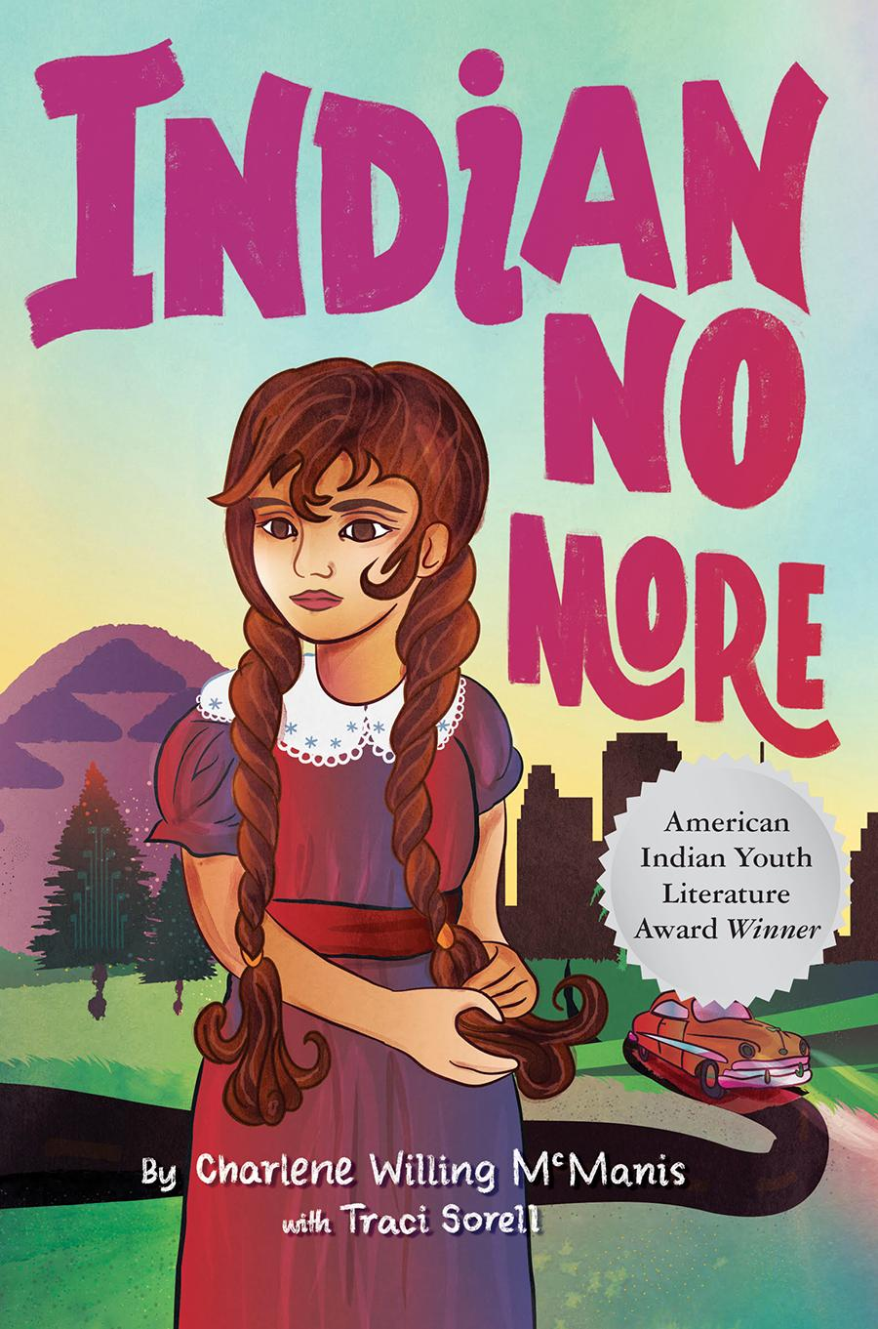
Chapters 22-24 p. 128-148
If it helps, you can listen to the story by clicking on the chapter:
Chapter 22 Living the dream
Chapter 23 No Service
Chapter 24: Indian No More

Engage
Does your family celebrate Christmas? If so, what traditions do you or your family have during the holidays?

If you don’t celebrate Christmas, does your family have other traditions that are important to you?

What makes a good gift?

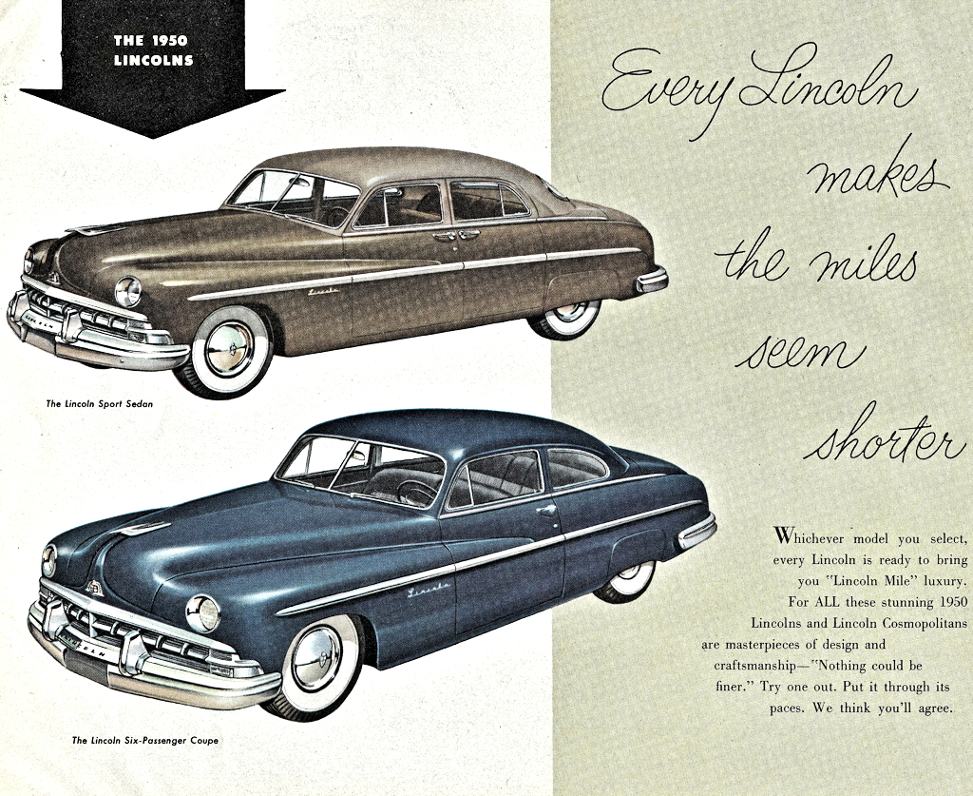  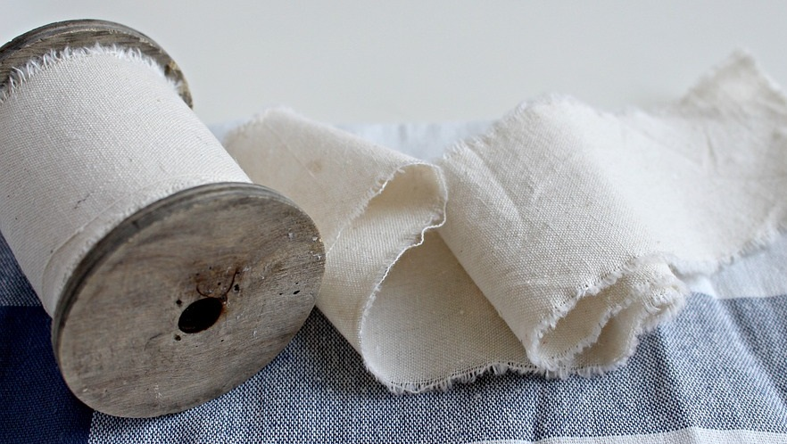  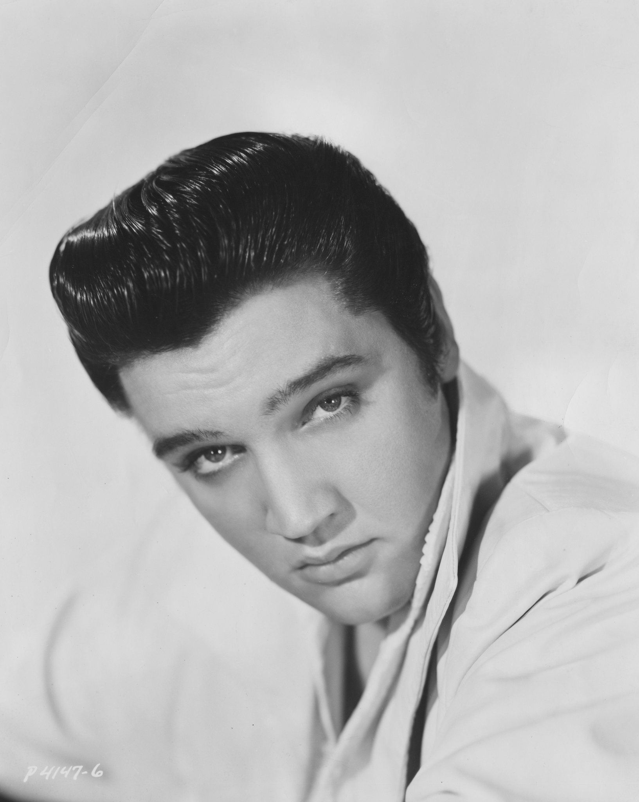 | Vocabulary
1950 Lincoln Club coupe (128) : A two door car with two rows of seating and a trunk.

“Yes, just before Christmas, Daddy bought a car. It was a brown 1950 Lincoln Club coupe, complete with working headlights, real tan leather seats, and no rust spots.”

Calico cloth (130): All cotton fabric woven in plain or tabby, weaved and printed with simple designs and in different colors.

“Peewee and I usually got dresses from Chich, and we did again, but this year they were made from colorful calico cloth.”

Elvis - (134) Elvis was an American singer, musician, and actor.

“We piled inside the Lincoln and sang “Jailhouse Rock” along with Elvis on the car radio.”

Cascade (135) A small waterfall that falls in stages; or the process of something being successively passed on

“A cascade of shimmering lights drooped down from the ceiling.”

Invaluable (135) : Valuable beyond estimation. Something so precious one cannot assign a price to it.

“I’m invaluable. ”

Did you know...
Redlining Map

Click on the map to show redlining

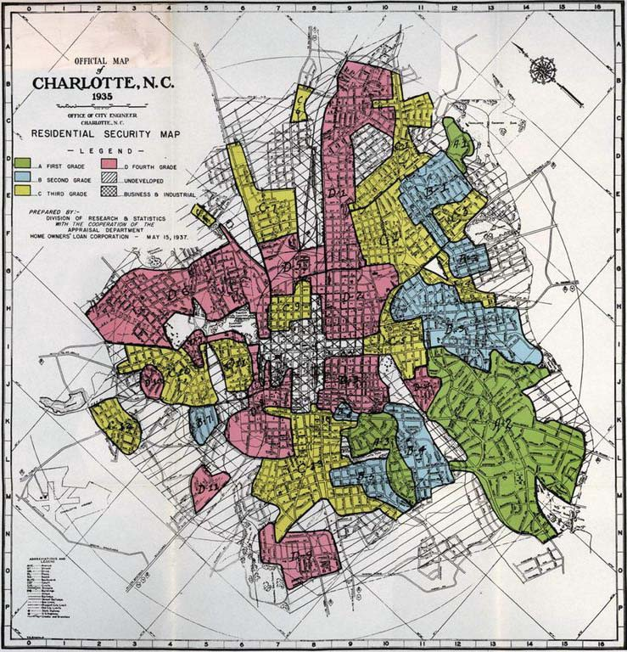

Segregation

Click and Watch -start 1.12-3:00 sec.-
(Note to teachers beginning of video has a bad word so advance video to 1:12)
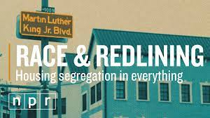

Mexican segregation in CA Schools
Click and show 1.17-3.00

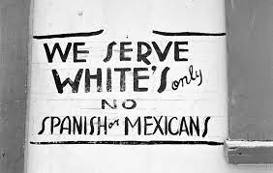

Why did they confuse Regina and her family with Mexicans?

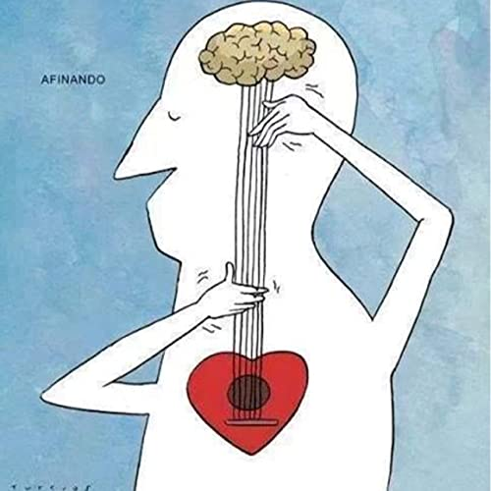 | SentiPensante  Think, Feel and Sense @ the same time
- “I don’t think we have anything here you can afford” (pg 139)
- “No matter how hard he tries, he can’t ignore who he is” (pg 142)

- “Girls, you might as well know, If you’re Indian, you’ll never get anywhere” ( pg 146)

- Chich hugged me and looked me in the eyes, silently telling me to be brave” (pg 148).

- “That night I became Indian no more” (pg 148).

Apply
“Tears streamed down my cheeks. I trembled uncontrollably. My heart pounded loud in my ears. I’d never felt this kind of anger before” (pg 147).
What are things you can do when you are angry or upset to feel better?

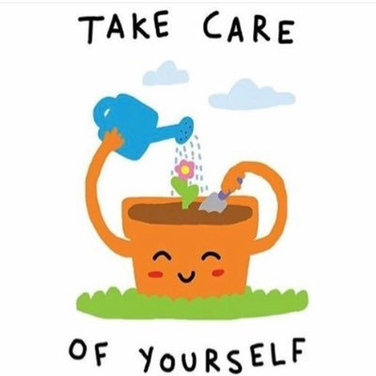 | Share
 | Share with someone some of your self-care techniques.

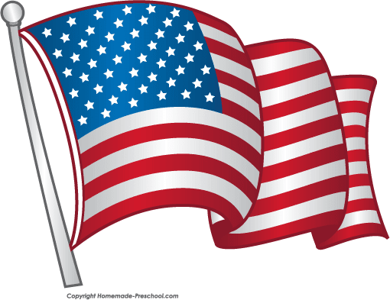 | Reflect
- “Daddy jokingly said moving to LA made us Americans, that soon we’d be white people, and Indian no more. Now I wondered if that all might be coming true” pg. 131
  - Do you think Regina is still Indian? Why or why not?

- Did Regina become an American and stop being an Indian when her dad cut her hair on page 146?
  - Remember in the beginning of the story: “Each night, Chich combed my long dark hair, saying, “Never cut it. It’s a powerful part of your Umpqua identity. When we cut our hair, it shows everyone that we are mourning the death of someone close to us” (pg 8-9).

- Have you ever stood up and advocated for yourself like Regina on page 137?

Predict
- How do you think Regina will act around her father after cutting her hair?
- How do you think Regina’s friends will react to her haircut?

Self-Assessment
I learned …
I still have questions about…
I do not understand….

