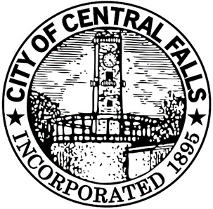

CENTRAL FALLS REDEVELOPMENT PLAN

CENTRAL FALLS REDEVELOPMENT AGENCY

CENTRAL FALLS RI

Adoption by CFRA on March 21, 2016
Approved by Planning Board in April 2016
Enacted as Ordinance by City Council in Spring 2016

TABLE OF CONTENTS

INTRODUCTION………………………………………………………………………………………………………….……...2
DEFINITIONS…………………………………………………………………………………………………………………….2

PROJECT AREA DESCRIPTION…………………………………………………………………………………………..3
LOCATION AND BOUNDARIES……………………………………………………………………………………...…5
Location……………………………………………………………….……………………………………………………5
Boundaries………………………………………………………………………………………………………………...5
EXISTING CONDITIONS……………………………………………………………………………………………………7
Demographics Overview……………………………………………………………………………………….............7 Language………………………………………………………………...………........…………….……………...…...7
Education Overview…………………………………………………………………..……...………………...……7
Health Overview…………………………………………………………………………………………....…8
Housing Overview………...…………………………………………………………………………………….............8 Infrastructure……………………………………………………...………........…………….……………...……....10
Public Safety Overview……………………………………………………………..……...………………...……10
Transportation Overview………………………………………………………………………………..…10
Land Use………………….………………………………………………………………………………..…12
Zoning……………………………...………………………………………...…..……………………………………12
Existing Zoning…………………………………………………………………………...………...……………..…….8
Blighted and Substandard Areas……………………………………………………………………….……...…..15
Contaminated Sites………………………………………....……..…..………………………………….…………...16
Combined Sewers……………………………………….……………....……..…..……………………….…...……..16
Floodplain……………………………………………………………………………....……..…..………...……….…16
Roadway System………………………………………………………...……………………....…….………...…….17
Railroad……………………………………………………………………....……..…..……………………..…..……17
Other Factors……………………………………………………………………………....……………............…........18

INITIATIVES AND ACTIONS………………………………………………………………………………...…………...19
PROPERTY ACQUISITIONS…………………………………….…………………………………………..........……....19
REDEVELOPMENT INITIATIVES………………………………………………………………………..…...……….29
LAND PHYSIOGNOMY……………………………………………………………………..………………………….….22
LAND COVERAGE, BUILDING INTENSITIES AND POPULATION DENSITY……………..………..23
ZONING…………………………………………………..………………………………………………………………..…….23
RELOCATION……………………………………………………………………………………………………………...….23
COVENANTS AND OTHER RESTRICTIONS FOR DISPOSAL AND FUTURE LAND USE
AND BUILDINGS………………………………………………………………………………………...…………….…….23
COSTS AND FINANCING…………………………………………………………………………………………..……..24
STATEMENT OF PURPOSE………………………………………………………………………………………...........24
DURATION AND EFFECTIVE DATE………………………………………………………………………………....25

CONFORMANCE WITH THE COMPREHENSIVE PLAN…………………………………………………….25

INTRODUCTION

The purpose of the City of Central Falls Redevelopment Plan is to designate a Redevelopment Project Area and establish objectives and procedures for its redevelopment for the City of Central Falls. The plan’s objective is to provide the Central Falls Redevelopment Agency (CFRA) with the tools and authority to eliminate conditions of blight by providing needed public improvements, facilitating rehabilitation through the repair of deteriorated structures, facilitating land assembly and redevelopment and providing financing for certain public improvements. Redevelopment will provide revitalization of the City, increased employment opportunities, and increased tax revenue. The intent is to support varied job markets by providing opportunities for growth of existing businesses and by attracting new businesses. Facilities and activities will be expanded through the acquisition of privately-owned, underutilized parcels as identified in the City’s Comprehensive Plan.

The parcels identified in the plan for redevelopment will serve as a catalyst for change and economic growth in the City. The development of other underutilized parcels in conformance with the city’s comprehensive plan will help to expand economic growth and develop jobs for Central Falls residents.

Definitions
Growth Districts: Areas within the City of Central Falls identified in The Comprehensive Plan as areas intended for growth, where development and redevelopment would be beneficial. Growth districts are located in close proximity to commercial arterials, older industrial areas or large vacant areas.

Project Area: All or any portion of the Redevelopment Area. A project area may include lands, buildings, or improvements which of themselves are not detrimental or inimical to the public health, safety, morals, or welfare, but whose inclusion is necessary, with or without change in their conditions or ownership, for the effective redevelopment of the area of which they are a part (Rhode Island General Laws (RIGL) § 45 -31-8 (11)) Project Area shall also have the meaning as set forth in RIGL § 45-33.2-3 (3).

Redevelopment Area: The City of Central Falls, being the boundaries of the community found by the City Council for the City of Central Falls to be blighted and substandard, where redevelopment is necessary to effectuate the public purposes declared in RIGL § 45-31-1 et seq.

Tax Increment Area: A tax increment area designated in a project plan adopted pursuant to § 45-33.2-4. The tax increment area may consist of one or more parcels or lots of land, whether or not contiguous, or one or more buildings or structures, whether or not adjacent, or one or more parcels of land; provided, that upon adoption of the project plan the aggregate taxable valuation of the property within all tax increment areas within the city or town does not exceed twenty-five percent (25%) of the taxable valuation of all property subject to taxation within the city or town. (RIGL § 45-33.2-3 (7))

Redevelopment Plan: A plan for a redevelopment project, which:

- Conforms to the general plan of the community as a whole; and

- Is sufficiently complete to indicate land acquisition, demolition and removal of structures, redevelopment, improvements, and rehabilitation as may be proposed to be carried out in the project area, zoning and planning changes, if any, land uses, maximum densities, building improvements, and the plan’s relationship to definite local objectives, respecting appropriate land uses, improved traffic, public transportation, public utilities, recreational and community facilities, and other public improvements.

Arrested Blighted Area: Any area which, by means of the existence of physical conditions, including, but not by way of limitation, the existence of unsuitable soil conditions, the existence of dumping or other insanitary or unsafe conditions, the existence of ledge or rock, the necessity of unduly expensive excavation, fill or grading, or the necessity of undertaking unduly expensive measures for the drainage of the area or the prevention of flooding or for making the area appropriate for sound development, or by reason of obsolete, inappropriate, or otherwise faulty platting or subdivision, deterioration of site improvements, inadequacy of utilities, diversity of ownership of plots or tax delinquencies, or by reason of any combination of any of the foregoing conditions, is unduly costly to develop soundly through the ordinary operations of private enterprise and impairs the sound growth of the community. (RIGL §45-31-8)

Blighted and Substandard Area: Any area that is a “slum blighted area,” a “deteriorated blighted area,” or an “arrested blighted area,” or any combination of these areas. Blighted and substandard area shall also include those areas where the presence of hazardous materials, as defined in RIGL § 23-19.14-2, impairs the use, reuse, or redevelopment of impacted sites. (RIGL Title 45 Section 31-8)

Deteriorated Blighted Area: Any area in which there exist buildings or improvements, either used or intended to be used for living, commercial, industrial, or other purposes, or any combination of these uses, which by reason of:

- Dilapidation, deterioration, age or obsolescence
- Inadequate provision for ventilation, light, sanitation, open spaces, and recreation facilities
- High density of population and overcrowding
- Defective design or unsanitary or unsafe character or conditions of physical construction
- Defective or inadequate street and lot layout
- Mixed character, shifting, or deterioration of uses to which they are put, or any combination of these factors and characteristics, are conducive to the further deterioration and decline of the area to the point where it may become a slum blighted area as defined herein, and are detrimental to the public health, safety, morals and welfare of the inhabitants of the community and of the state generally. A deteriorated blighted area need not be restricted to, or consist entirely of, lands, buildings or improvements which of themselves are detrimental or inimical to the public health, safety, morals, or welfare, but may consist of an area in which these conditions exist and injuriously affect the entire area. (RIGL Title 45 Section 31-8)

Slum Blighted Area: Any area in which there is a predominance of buildings or improvements, either used or intended to be used for living, commercial, industrial, or other purposes, or any combination of these uses, which by reason of: (i) dilapidation, deterioration, age, or obsolescence; (ii) inadequate provision for ventilation, light, sanitation, open spaces, and recreation facilities; (iii) high density of population and overcrowding; (iv) defective design or unsanitary or unsafe character or condition of physical construction; (v) defective or inadequate street and lot layout; and (vi) mixed character or shifting of uses to which they are put, or any combination of these factors and characteristics, are conducive to ill health, transmission of disease, infant mortality, juvenile delinquency, and crime; injuriously affect the entire area and constitute a menace to the public health, safety, morals, and welfare of the inhabitants of the community and of the state generally. A slum blighted area need not be restricted to, or consist entirely of, lands, buildings, or improvements which of themselves are detrimental or inimical to the public health, safety, morals, or welfare, but may consist of an area in which these conditions predominate and injuriously affect the entire area.

The definitions herein rely on RIGL § 45-31-8. Words used in this Redevelopment Plan as defined in RIGL § 45-31-8 shall have the meaning set forth in such statutory provision.

project area descripTION

Location and Boundaries

Location

The City of Central Falls is located in Rhode Island.

Boundaries

The boundaries of the Project Area are:

The City of Central Falls is defined primarily by the Blackstone River on its North and Eastern borders, the Town of Cumberland on the North and South Attleboro adjacent on the Eastern side. East of the River is Pawtucket, as well as to the South. To the West lies the Town of Lincoln.

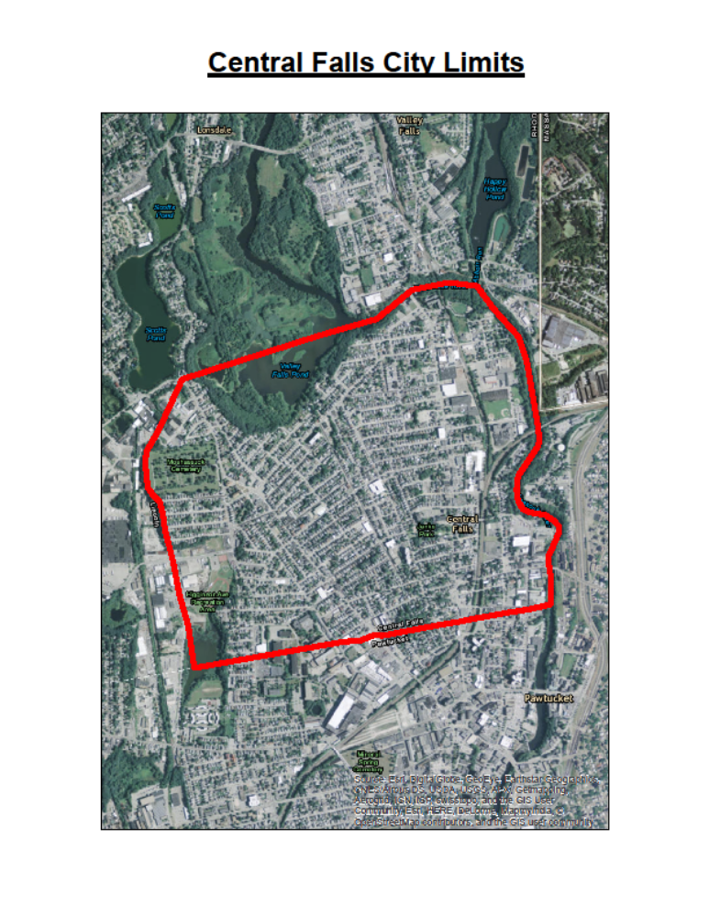

Figure 1. Project Area

Existing Conditions

Demographics Overview

The Project Area, the City of Central falls, encompasses 1.27 square miles, with 19,376 residents (2010 US Census). Women comprise 49.3% (9,552) of the total population, men 50.7% (9824), and the vast majority of the population is minority, 74.4% (14,409). 52.9% (10,258) of residents of Central Falls are white, 10.1% (1,949) are black, 0.6% (121) are Asian, 0.1% (18) are Native Hawaiian/Pacific Islanders, 0.9% (183) are American Indian, 28.7% (5,565) are of other race, and 6.6% (1,282) are of two or more races. It is estimated that about 60.3% of the population of Central Falls is of Hispanic origin (2010), a 12.5% increase from 47.8% in 2000.

In 2010, the population age distribution was (of 19,376 total): under 5, 1,727, ages 5-17, 3,917, and age 18-64, 12,048. The total population age 18 and older was 70.9% (13.732, and age 18 and under, 29.1%, or 5,644.

Central Falls has a young population as of 2010. The median age was 30.1; median age for females was 31.3, and median age for males was 29.1.

The number of residents aged 15 and over that are currently married has lowered from 6,828 in 2000 to 5,834 in 2008-2012. That’s a drop from 47.7% (of 14,313) to 39.7% (of 14,697). Within the same age perimeters (15 years and older), the number of divorced or separated in 2000 were 2,162 (15.1% of 14,313), and 2,199 (of 14,697).

Family households in 2000 were 4,356 (65.0% of a total of 6,696), not much different in 2010, were there was 4,358 (66.8% of a total of 6,526). Non-family households in 2000 reached 2,340 (35.0% of a total of 6,696), and in 2010 dropped to 2,168 (33.2% of a total of 6,526).

In 2010 single female households with children under 18 were 24.1% of 4,356, and single male households with children under 18 were 6.9% of 4,358.

Language

The number of people speaking Spanish at home rose from 8,188 in 2000 to 10,347 in 2008-2012. Those who speak only English at home dropped from 6,145 in 2000 to 4,933 in 2008-2012.

Education Overview

Of the total population of Central Falls (% of population age 25 and older), 48.5% (5,612) have less than a High School Diploma, High School Graduates comprise 25.7% (2,974), 13.9% (1,604) with some College completed, 3.8% (438) attained an Associate Degree, 5.2% (602), have a Bachelor’s Degree, 2.1% (247) with a Master’s Degree, 0.5% (61) have a Professional School Degree, and 0.3% (30) attained a Doctorate Degree.

Economic Overview

The median family income in Central Falls from 2008-2012 is $35,222, significantly higher than the $26,844 in the year 2000. The median household income has also risen from $22,628 in 2000 to $29,268 in 2008-2012. Although the median family and household incomes have seen appreciative increases, 30.4% of the City’s population still lives below the poverty level.

There is still a divide between the median male and female earnings, where males earned a median income of $25,131 in 2008-2012 (up from $19,304 in 2000), and females earned a median of $17,215 in 2008-2012 (up from $12,586 in 2000).

Unemployment in the population from 2008-2012, age 16 or older, is 6.5% (10.6% of labor force), males comprise 7.5% (10.8% of labor force), and females 5.6% (10.2% of labor force).

Health Overview

Infants with low birth weight have decreased steadily from 2005 to 2013: 83 (2005-2007), 82 (2008-2010), and 70 (201102013). Total births have seen a decrease over the same time period, from 1,190 (2005-2007), 1,087 (2008-2010), and 940 (2011-2013). Of the total births from 2011-2013 (940), 349 where by mothers without a High School Diploma, 673 by single mothers, 155 by teen mothers (ages 15-19), and 208 delayed prenatal care.

The number of children with elevated blood lead levels and asthma has decreased from 2005 to 2013. In 2005-2007 the number of children with elevated blood levels of 5+ went from 671 to 195 in 2011-2-13, and with levels 10+ went from 107 to 33.

Housing Overview

From the year 2000 to 2010, households have somewhat stabilized. In 2000 the number of households was 6,696 and in 2010, 6,526. The total population in households in 2000 were 18,340, and in 2010, 18,866.

The household size hasn’t changed significantly from the years 2000 to 2010. Average household size went from 2.74 in 2000 to 2.89 in 2010, while the average owner-occupied household size in 2000 was 2.90, increasing to 3.05 in 2010. Lastly, the average renter-occupied household size also increased from 2.69 in 2000 to 2.84 in 2010.

The median owner unit value in 2000 was $93,200. The count of owner-occupied households that spend 30 percent or more of household income on selected monthly owner housing costs was a mere 100 in 2000, and 870 in the period 2008-2012.

The count of renter-occupied households that spend 30 percent or more of household income on gross rent cost went from 2,024 in 2000 to 2,619 in the period 2008-2012.

The length of stay of householders have dramatically decreased over the years. The count of occupied housing units that have been occupied by the present householder since 1969 or earlier went from 465 in the year 2000 to almost half that amount in 2008-2012, 241. That represents a percentage of occupied housing units of 6.9% (of 6,696) in 2000 and of 3.6% (of 6,615) in 2008-2012. With respect to those in the same household since 1970-89, the count drop continues. The percentage of occupied housing units in 2000 is 18.01% (of 6,696) and 6.9% (of 6,615) in 2008-2012. In the last decade, the population of Central Falls has become dramatically transient. Same householder since 1990-2000 decreases from 5,020 in the year 2000 to a mere 805 in the period of 2008-2012, respectively, a percentage of occupied housing units of 75.0% (of 6,696) to 12.2% (of 6,615).

With the 2008 economic crash, many housing units became vacant. The number of vacant housing units for rent outweighed those for sale. The total number of vacant housing units was 574 in 2000, rising sharply to 952 by the year 2010 (from 7.9% of 7,270 to 12.7% of 7,478, respectively). From 2000 to 2010 the number of housing units that were vacant for rent went from 225 to 544 (39.2% of 574 to 57.1% of 544). Inversely, the number of housing units vacant for sale dropped from 74 in 200 to 46 in 2010 (12.9% of 574 to 4.8% of 952).

Seasonal used units are very low in the City. In 2010 a mere 5, 6 in 2000.

Regarding housing units by number of bedrooms, there is a clear tendency for 2, 3 and 3+ bedrooms. In 2008-2012 the total number of housing units built was 7,832. Out of those, 3,537 units were of 3+ bedrooms, 3,007 units of 3 bedrooms, 2,463 2 bedroom units, 1,721 1 bedroom units, 530 4+ bedroom units, and 111 units with 1 bedroom.
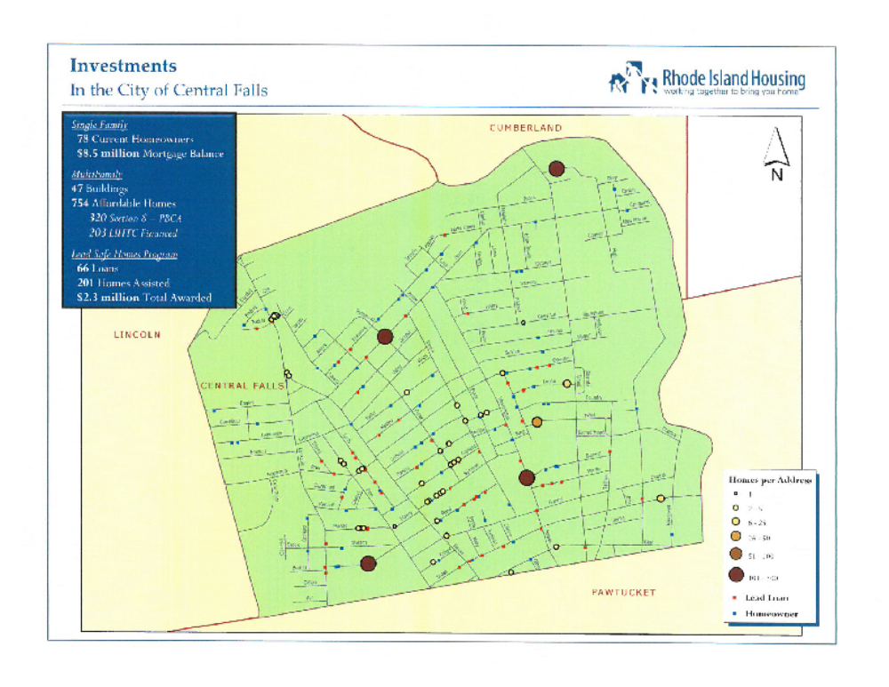
Regarding occupied housing units, in 2014 13.3% were detached, 1.7% attached, 17.3% were units with 2 apartments, 47.1% were units with 3 or 4 apartments, 11.2% were units with 5 to 9 apartments, and housing units with 10 or more apartments accounted for 9.4%. Owner-occupied housing units were: 40.5% detached, 3.1% attached, 24.0% with 2 apartments, 27.2% with 3 or 4 apartments, 1.4% with 5 to 9 apartments, and 3.8% with 10 or more apartments. Renter-occupied housing units were: 3.0% detached, 1.2% attached, 14.7% with 2 apartments, 54.7% with 3 or 4 apartments, 14.9% with 5 to 9 apartments, and 11.5% with 10 or more apartments.
Figure 2. Central Falls Subsidized Housing Map

Infrastructure Overview

In regards to broadband adoption in Central Falls, the rates in 2012 were an estimated 40%-60%.
The number of wireline broadband providers in 2013 was 8. The total number of wireless broadband providers in 2013 was 9.

Public Safety Overview

The total number of crimes in Central Falls is varied, dropping and increasing from year to year. In 2010 there was a total of 1,453 Part I (criminal homicide, forcible rape, robbery, aggravated assault, burglary, larceny-theft (except motor vehicle theft), motor vehicle theft, and arson), and Part II crimes (other assaults, forgery and counterfeiting, fraud, embezzlement, stolen property: buying, receiving, possessing, vandalism, weapons: carrying, possessing, etc., prostitution and commercialized vice, sex offenses, drug abuse violations, gambling, offenses against the family and children, driving under the influence, liquor laws, drunkenness, disorderly conduct, vagrancy, all other offenses, suspicion, curfew and loitering laws—(persons under 18), and runaways—(persons under 18). In 2011 it increased to 1,618, dropping to 1,480 in 2012, increasing again in 2013 to 1,616. Part I crimes have increased over the period studied: 630 in 2010 (43.4% of 1,453), 755 in 2011 (46.7% of 1,618), 741 in 2012 (50.1% of 1,480), and 834 in 2013 (51.6% of 1,616).

Violent crimes increased over the period of 2010 to 2012, then decreasing in 2013 as a percentage of Part I Crimes: 101 in 2010 (16.0% of 630), 119 in 2011 (15.8% of 755), 147 in 2012 (19.8% of 741), and 136 in 2013 (16.3% of 834). Of the total crimes committed, violent crimes represent in 2010, 7.0% (of 1,453), in 2011, 7.3% (of 1,618), in 2012, 9.9% (of 1,480), and lastly in 2013, 8.4% (of 1,616).

Property crimes vary in number over the period of 2010 to 2013 as a percentage of Part I Crimes: 529 in 2010 (84.0% of 630), 636 in 2011 (84.2% of 755), 594 in 2012 (80.2% of 741), and 698 in 2013 (83.7% of 834). Of the total crimes committed, property crimes represent in 2010, 36.4% (of 1,453), in 2011, 39.3% (of 1,618), in 2012, 40.1% (of 1,480), and lastly in 2013, 43.2% (of 1,616).

Regarding Part II Crimes, and of the total crimes committed, these crimes are 823 in 2010, 56.6% (of 1,453), 863 in 2011, 53.3% (of 1,618), 739 in 2012, 49.9% (of 1,480), and lastly 782 in 2013, 48.4% (of 1,616).

Transportation Overview

Public transportation saw an increase from 2000 to 2012. The count of workers age 16 and over that take public transportation to work in 2010 was 191 (2.7% of 7,000), and 244 in 2008-2012 (3.2% of 7,730).

When it comes to vehicle access by household, the general tendency is to increase.
Two periods were taken under consideration, the year 2000 and from 2008-2012.

Within these two separate time frames, vehicles available in 2000 (count of occupied housing units for all householders where one or more vehicles are available) were 5,015, increasing to 5,113 in 2008-2012 (respectively, 74.9% of 6,696, and 77.3% of 6,615).

Households with no vehicles dropped from 1,681 in 2000 (25.1% of 6,696) to 1,502 (22.7% of 6,615).

Housing units with 2 or more vehicles increased from 1,977 (29.5% of 6,696) in 2000, to 2,152 (32.5% of 6,615) in 2008-2012.

Owner-occupied households with vehicles was 1,360 (93.2% of 1,459) in 2000, and 1,461 (90.7% of 1,611) in 2008-2012.

Owner-occupied households with no vehicles was 99 in 2000 (6.8% of 1,459), and 150 (9.3% of 1,611) in 2008-2012.

The number of renter-occupied households with no vehicle was 1,582 in 2000, and 1,352 in 2008-2012. The percentage of renter occupied housing units with vehicles was in 2000, 30.2% of 5,237, and in 2008-2012, 27.0% of 5,004. The percentage of units with no vehicles available was in 2000, 94.1% of 1,681, and in 2008-2012, 90.0% of 1,502.

The number of renter-occupied households with vehicles was 3,655 in 2000, and 3,652 in 2008-2012. The percentage of renter occupied housing units with vehicles was in 2000, 69.8% of 5,237, and in 2008-2012, 73.0% of 5,004.

The mode of transportation is divided into 4 categories: Persons using bicycle, drive alone, carpool or use public transportation to work. The number of persons, age 16 or older, using bicycle as means of transportation to work were 27 in 2006-2010 (0.3% of 7,893), and zero in 2008-2012. In 2000, 4,371 people drove to work alone (age 16 or older), that’s 62.4% of 7,000. In 2008-2012, that number rose slightly to 4,856 (62.8% of 7,730).

Carpooling to work saw a decrease from 1,861 in 2000 (26.6% of 7,000 – age 16 or older), to 1,389 (18.0% of 7,730 – age 16 or older).

Finally, public transportation saw an increase in utilizers in the 12 year period from 2000 to 2012. In 2000 there were 191 workers aged 16 or older using this means of transportation to get to work (2.7% of 7,000) and 244 in 2008-2012 (3.2% of 7,730).

A good majority of these travelers don’t work very far from their place of residence. The number of workers age 16 and over that have a travel time to work that is less than 15 minutes was 2,155 in the year 2000 (31.0% of 6,961 commuting workers), and 1,508 in 2008-2012 (19.5% of 7,730 commuting workers).

Fewer workers take more than 40 minutes to get to their workplace. In 2000 there were 775 (11.1% of 6,961 commuting workers), and in 2008-2012, 1,346 (17.8% of 7,575 commuting workers).

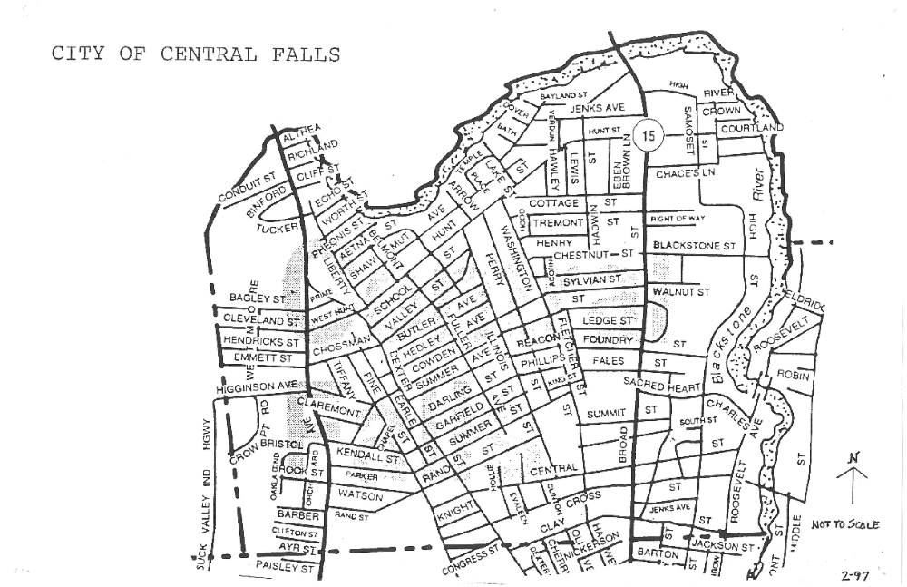

Figure 3. Central Falls Street Map

Land Uses

Land use in the City of Central Falls is laid out in the City’s current Comprehensive Community Plan, Land Development and Subdivision Review Regulations and the Zoning Ordinances.

Zoning

Existing Zoning
Currently there are 12 Zoning Districts in Central Falls

- Residential zoning districts.
  - R-1 one-household district. This zone is intended for low density residential areas comprising single dwelling unit detached structures located on lots with a minimum land area of 5,000 sq. ft.
  - R-2 two-household district. This zone is intended for medium density residential areas comprising single dwelling unit and two-dwelling unit detached structures located on lots with a minimum land area of 5,000 sq. ft.
  - R-3 multi-household dwelling district. This zone is intended for medium density residential areas comprised of structures containing single dwelling units, two-dwelling units and multiple-dwelling units located on lots with a minimum land area of 5,000 sq. ft. and a minimum land area of 2,000 sq. ft. per dwelling unit.
- Commercial zoning districts.
  - C-1 limited commercial district. This zone is intended for neighborhood commercial areas that primarily serve local neighborhood needs for convenience retail, services and professional office establishments.
  - C-2 general commercial district. This zone is intended for commercial areas that serve citywide needs for retail, services and professional office establishments.
  - C-D commercial-downtown district. This zone is intended to encourage revitalization and restoration of core business areas in the city. A variety of business, financial, institutional, public, quasi-public, cultural, residential (upper floors only) and other related uses are encouraged in the C-D district. Compatible and appropriate mixed uses are encouraged to promote commercial, retail and other business activity including office uses.
- Industrial zoning districts.
  - M-1 industrial district. This zone is intended for general industrial uses that accommodate a variety of manufacturing, assembly, storage of durable goods and related activities, provided that they do not pose toxic, explosive or environmental hazard in the city.
  - M-2 heavy industrial district. This zone is intended to provide for areas for heavy industrial uses, especially for those uses that are potentially hazardous, noxious or incompatible with the uses in any other zone.
- Overlay zoning districts. These are districts that are superimposed on existing zoning district(s) or part of a district and which impose specified requirements in addition to those otherwise applicable and/or allow alternate uses.
  - HD historic district. This overlay zone is intended to preserve structures of historic and architectural value by regulating the construction, alteration, repair, moving and demolition of such structures. This overlay zone may include single buildings and/or lots.
  - MBRD mill building re-use district. This overlay zone allows the development of obsolete industrial sites according to a plan for mixed use.
- Open space zoning district.
  - P park district. This zone is intended to preserve open space recreation use and in certain instances public education uses.
  - CM cemetery. This zone is intended to retain cemetery land for its designated purposes.

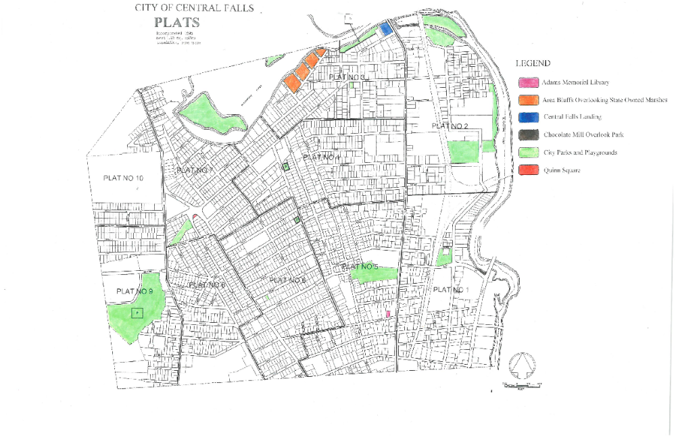
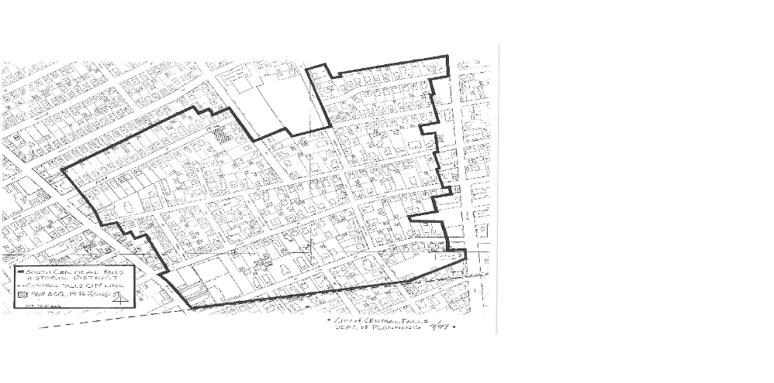
Figure 4. City Of Central Falls Open Space Map

Figure 5. South Central Falls Historic District Map

Blighted and Substandard Areas

Many areas of the City of Central Falls, specifically old industrial sites and areas, meet the definition of arrested blighted and deteriorated blighted and blighted and substandard areas, creating many difficulties in redevelopment. These include contaminated properties, abandoned properties, underutilized properties, properties with tax delinquencies, properties with substantial code violations, vacant land, and property located in the floodplain. These problems are further complicated by deferred maintenance and the graffiti and vandalism that often accompany underutilization of properties. These conditions have impacts on the social, economic and environmental vitality of the City by limiting investment and growth.

More existing conditions in many areas in the City include specifically, unsuitable soil conditions; the necessity of unduly expensive excavation and fill; the necessity of undertaking unduly expensive measures to make these areas appropriate for sound development; obsolete, inappropriate, or otherwise faulty platting or subdivision; deterioration of site improvements, inadequacy of utilities, diversity of ownership of plots; the existence of dilapidated, deteriorating and obsolete buildings and improvements; mixed character and deterioration of uses of buildings and improvements , all of which qualify these areas as both an “arrested blighted area” and a “deteriorated blighted area”, and combined with the presence of hazardous materials, qualify the area as a “blighted and substandard area”.

The following briefly describes some of these factors in more detail as they apply to the areas.

Contaminated Sites

The historic and current uses of properties, and the former and current prevalence of industrial activities within these areas, indicate the potential for contamination of soils and groundwater with hazardous materials. Many of these sites have been abandoned for some time, and are in private ownership. Assessments and eventual remediation is made difficult by that fact.

Combined Sewers

Recent improvements to the combined sewer systems operated by NBC in the plan area supplement city owned and operated storm water systems. A more detailed examination of the impacts of the two systems needs to be made.

Floodplain
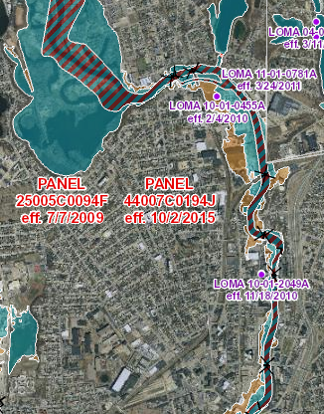
Redevelopment is also impeded by the presence of floodplains (Figure 6). Federal, State and local regulations require that the lowest occupied floor in a development be located above the 100 year flood elevation. Because many structures in the flood zone pre-date these regulations, many of them are constructed with the first floor below the flood elevation. The first floor of these existing buildings is subject to flooding, increasing the likelihood of flood related damages, reducing the potential reuse opportunities, and making it difficult or impossible to obtain insurance coverage. Raising the first floor above the flood elevation can be a complicated process for existing buildings and may depend on existing floor elevation, window and door sill heights and available ceiling height. Changing first floor elevations may also require access adjustments to ensure access for the handicapped and ensure compliance with the requirements of the Americans with Disabilities Act (ADA), increasing the costs of redevelopment when compared to structures that are not located in floodplain.
Figure 6. Central Falls Flood Map

Roadway System

The roadway system in the City contributes to some of its blighted condition by being discontinuous, dysfunctional and failing to provide needed access. Although not considered a major issue, the continuation or linkage of some streets will help to consolidate the City’s historical urban grid and create better traffic and security.

Changes in the urban grid of Central Falls could create a greater fluidity and easier access in the East-West direction, given that the North-South connections existed even before the incorporation of Central Falls, and consolidating its urban design.

Railroad

At present Central Falls does not have a passenger railroad system that serves its population. The Pawtucket and Central Falls Railroad Station, located on 307 Broad Street, built in 1916 has been closed since 1959 and was the only rail linkage that ran all the way to Worcester, MA.

Freight rail passes through the City with an unused siding on the former Osram/Sylvania plant.

Other Factors

Throughout the City of Central Falls, there are a number of other factors which contribute to the characterization of the area as blighted. Underutilized properties, vacant land and vacant buildings exist throughout. These properties contribute heavily to the general perception of decline in the city and are a deterrent to development, reinvestment and stabilization of the City.

INITIATIVES AND ACTIONS

The intent of the Redevelopment Plan is to rehabilitate deteriorated properties, visually enhance the City, provide needed infrastructure to support redevelopment, create employment opportunities and encourage excellence in design and construction techniques, all in a way that is in conformance with the City’s Comprehensive Plan. The following outlines initiatives and actions the CFRA intends to pursue to meeting the goals of the Redevelopment Plan, as well as the State requirements outlined in Title 45 Section 32 at the RIGL.

Property Acquisitions

To accomplish this Redevelopment Plan it may be necessary for the CFRA to acquire certain parcels within the Project area. The preferred method of acquisition is through negotiated purchase but the CFRA is authorized to secure property ownership through eminent domain if necessary, in accordance with RIGL § 45- 31-33.

The CFRA reserves the right to exercise it powers pursuant to RIGL Section 45-32-5, including without limitation, to purchase, lease, obtain an option upon, acquire by gift, grant, bequest, devise, or otherwise, any real or personal property within the Redevelopment Project Area or for purposes of redevelopment, such acquisition to include the consensual negotiation with property owners for the acquisition of property, and the acceptance of transfers of property from the City (including, without limitation, the acceptance of title to tax delinquent properties, which are found to cause arrested blighted areas to exist, are unduly costly to develop soundly through the ordinary operations of private enterprise, impair the sound growth of the community, and are necessary for redevelopment, revitalization, or municipal purposes).

Redevelopment Initiatives

The CFRA and the City will undertake the following redevelopment initiatives:

    - Creation of sufficient public, civic, cultural spaces: Central Falls emerged as an industrial city, hence its major building necessities were limited primarily to the great mill buildings and housing. Aside from a few churches, always and traditionally monumental in form and style (mostly built from the 1840’s to the 1870’s), and minimal commercial structures (given the size of the City, residents would go to Pawtucket to satisfy most of their shopping needs), little else could make it a great city, design wise. It tried, which means Central Falls was conscious of what made a city a city. It knew what it lacked – monumentality and art. Since time immemorial, the architects are summoned, and Central Falls did just that – architects starting to pour into the city to design the most striking buildings Central Falls would ever see. Even before the incorporation of Central Falls in 1895, this need was felt. And so it began with the first much needed monumental building – the Lincoln High School built in 1889 at 580 Broad Street (now City Hall since 1927), in the Queen Anne style, all decked out with a corner tower, attributing the area the prominence it knew it did not have. This was the first attempt to create a civic center.

In the same year, and right across the street from the High School, the old Fire Station at 551 Broad Street was built in the same Queen Anne Style as the High School, designed by the architect Albert H. Humes of Pawtucket (Mayor of Central Falls from in 1903-1904, and also the designer of Cogswell Tower in Jenks Park).

Jenks Park, adjacent to the old High School (now City Hall), was donated by Alvin Jenks in 1890, and the iconic Cogswell Tower built on the “mountain” (as it was then called) in 1904, was designed by Albert H. Humes. Jenks Park emerges at a very special era in American architectural history. During the Nineteenth and Twentieth Centuries, American cities began to urbanize at very high rates, becoming very dense and full of disease. As a response to the overpopulation and chaotic conditions, planning became a major focus of many large American cities. The City Beautiful movement was one of the many responses to the decaying city. The movement began in Chicago in 1890 with the World's Columbian Exposition of 1893 and lasted until about the 1920s. Its focus was on the design and architectural characteristics of the city. Leaders of the movement wanted to push the vision of the ideal city, and demonstrate to the world what cities could look like if they were created to be works of art. Jenks Park is a direct product of this movement, and Central Falls the grand recipient of this magnificent work of art.

Adams Library, built in 1910, followed and designed by McLean and Wright of Boston, then the exquisite Police and Court House building at 507 Broad Street, designed in 1914 by William R. Walker and Son, and the elegant Pawtucket and Central Falls Railroad Station, built in 1916, just to name a few.

The days of grandeur have now, and for some time, dissipated. Paling in contrast, Central Falls, after emerging from the dark days of bankruptcy, awakens to a future far more complex and demanding of its urban architectural structure, to say nothing of its social and cultural aspects.

The needs of a modern and contemporary city of the 21st Century are of a different nature than the fabric laid out in the 19th Century. The citizen/resident of Central Falls, as well as a visitor, expect and need many more types of qualities of spaces for leisure, culture and recreation, whether they be open or enclosed spaces (buildings), such as parks, plazas, squares, museums, theatres, among others.

    - Address quality of housing stock: The housing in Central Falls can be generally characterized in two fundamental parts, the exceptional and the typological. The non-vernacular origin of the majority of the homes in the City can be denominated as typological, the “bulk” of the built city, hence the heart of the City. Divided into many possible sub-categories, (e.g. two-family, three-family or simple multi-family) these homes were not built by the people, but rather a built “mass” for the working populace by the mill owners, utilizing whatever style at hand at the time, mostly of some sort of “classical regional” influence, if we can go that far. Nevertheless, these buildings, some surviving the 19th Century, mostly from the beginning of the last Century (before 1940), have created, as in many towns across New England, an identifiable architectural image, if not iconic, at least unique to this region of America. The high architectural density verifiable in Central Falls is the single most characterizing element of this City, setting it apart from, at least, all of the neighboring towns and cities. Anonymous in style, reporting to no specific or “grand” architectural gesture, as in all “anonymous” architecture across the globe and time, these buildings are a true testament to the “houses of the people”. Having appropriated them in part, they accepted them as their dwelling expression, even if for a limited amount of time in their lives, before moving on or perishing. They all share something very important in common, they form (or formed) a continuous, homogeneous and coherent urban discourse, hence giving the City form and meaning.
Here and there, the exceptions emerge, only to confirm the norm. Because the opportunity existed (more availability of money and knowledge) these proprietors built homes of, or purporting to be, a higher stratum, showing success, cultivation and distinction. Styles ranged from the Colonial Revival to Italianate and Second Empire, Queen Anne style, among other, creating a richer urban texture and a more diverse visual experience.

Moving forward, the diversity of housing needs are greater now than ever before. The full range of typologies need to be addressed if we intend to attract homeowners now, with its specific economic and financial challenges. From studios to town houses and apartments of every size, and equally important, a whole new set of aesthetic and qualitative standards need to emerge, and fast.

The time and opportunities lost in the last few decades have submerged Central Falls in urban and architectural confusion, decay and dilapidation. Although the surviving housing stock has maintained much of its original physiognomy, no stone has been left unturned regarding its aesthetic and stylistic characteristics.

    - Address commercial opportunities: One of the major deficiencies in the historic urban fabric in Central Falls is the commercial opportunities the City offered. Traditionally, residents of the City found their shopping needs satisfied in neighboring Pawtucket. With that in mind, and looking at the City map, the commercial opportunities offered are rather limited by the urban structure. The sheer petite size of Central Falls creates difficulties in this respect. The major commercial opportunities are centralized on Broad Street and Dexter Street, major thoroughfares of the City. These streets are ripe for a continued effort for mixed use, where commercial uses are to be primarily located on ground floors of existing and new buildings. Additionally, these streets, especially in the past few decades, have seen an excessive amount of demolished buildings to primarily give way to needed automotive parking. Albeit necessary, parking lots have in effect destroyed the continuous architectural and urban discourse once existent in these historic streets, and diminished the presence of buildings, hence lessened the commercial opportunities. In order to create more commercial opportunities to promote economic development, new buildings should be erected to fill in spaces between buildings. Parking can be resolved on street and off street where possible on neighboring streets, side or parallel streets. Structured parking should be addresses where the City requires and where the urban fabric and architectural structure permits, whether it be with parking lots behind buildings with rear access or parking buildings.

Land physiognomy Uses

Future land uses for the Project Area shall conform to the City’s Comprehensive Plan, as the same may be amended from time to time. New land uses should focus on job development or supporting businesses in the Project Area, as well as urban fabric consolidation in regards to filling in holes in street where building discontinuity is verified.
- Dexter and Broad Streets are and should continue to be Mixed-Use areas intended to support business growth, including commercial and office uses, as well as housing. Great dilapidation and disqualification of the urban fabric and architectural stock has been effected over the decades. Many buildings have been torn down to give way to building typologies, design, size, height, scale, setbacks that are improper and at odds with the history and importance of these streets. Broad Street especially has been by far the most damaged street in the city. Although buildings of architectural value exist, its skyline and streetscape is confusing in image and functionality, lacking vision, concept, quality and beauty. Dexter Street, the economic heart of Central Falls, has suffered much of the same, to a lesser degree in some instances.
Rebuilding theses iconic streets will encompass new buildings, filling in holes in the street, where vacant parking lots now exist, and attaining heights comparable to 3 or 4 stories with no setbacks. Replacement of buildings with heights, setbacks and typologies (auto shops, commercial plazas, gas stations, etc.) with mixed use buildings with higher architectural quality and authenticity.
- Housing in general saw less damage, but the neighborhoods suffered many blows to its particular and unique character. The density of the neighborhoods diminished, creating disproportions and disequilibrium in streets and blocks as a whole. The great city of Central Falls was born from a special environment, both physical and functional, its small size and its mighty industrial power produced, in comparison to its immediate neighboring city and towns (Pawtucket, Lincoln and Cumberland), one of the highest urban densities in the country, vital to its economic survival and development. This also created its position as one of the wealthiest communities in the country during the first half of the Twentieth Century. The housing stock, above all other building typologies, by its sheer number, as in many cities across the globe and history, is the “soul” of the city. It is the mass that shapes and defines the bulk of the character of the city.
It is vital to restore the integrity and character of the city block, by restoring, through modern aesthetic, in order to meet contemporary needs and interests.

Land Coverage, Building Intensities and Population Density

Land coverage will increase as land is developed in the Project Area. Underutilized lands will be put into productive use, which will increase land coverage in a manner consistent with adjacent development. New development will reflect the existing height, massing and scale of the area.

Zoning

There are no proposed changes to the Zoning Ordinance as part of this Redevelopment Plan.

Relocation

The CFRA will assist in the relocation of businesses, individuals and families displaced from properties acquired by the CFRA in the Project Area in accordance with State and Federal laws
The CFRA will:

Make fair and reasonable relocation payments to displaced businesses for moving and related expenses, as outlined is RIGL § 45-31-26 et seq.

It is not anticipated that extensive relocation efforts will have to be undertaken in order to carry out the objectives of this Plan.

Covenants and other Restrictions for Disposal and Future Land Use and Buildings

New projects in the Project Area must conform to the purposes outlined in the Redevelopment Plan. This will be guaranteed through covenants and other restrictions imposed by the CFRA and binding on respective properties and the owners thereof. These covenants and restrictions shall include conformance with the City’s Zoning Ordinance and Comprehensive Plan, special covenants governing development and use, relevant properties, including design construction and usage restrictions, timelines for development, and otherwise, and shall require property sold by the CFRA to be subject to standard performance and reverter provisions commonly imposed by the CFRA on properties to be developed or rehabilitated in a Redevelopment Project Area.

Costs and Financing

Financing new projects within the Project Area will be through the CFRA. Under this Redevelopment Plan, the CFRA shall have the authority to use public and private funding sources to implement action items that support redevelopment in the Project Area.

This project will be funded by a combination of Economic Development Administration (EDA) funds, donations from the City of Central Falls and other partners, and through the issuance of bonds by the CFRA.

Statement of Purpose

It is the public policy as stated in RIGL §45-31-6 to protect and promote the health, safety, morals and general welfare of the people of the state and particularly of the people of the communities of the state, in which blighted and substandard areas exist, by the elimination and prevention of these areas through the utilization of all means appropriate for that purpose, thereby encouraging the provision of healthful homes, a decent living environment and adequate places for employment of the people of this state and its communities in these areas through redevelopment.

Through the acquisition of underutilized and vacant properties, environmental remediation, redevelopment of parcels to expand employment opportunities in the area, this plan carries out the purposes of RIGL §45-31 through §45-33.

Duration and Effective Date

The foregoing regulations and controls contained in this plan will be binding, effectively by deed or by contract containing restrictive covenants running with the land, upon all purchasers or contractors and their heirs and assigns of the land within the area of the City, covered by this Plan. The regulations and controls incorporated in this Plan will be effective from the date of approval of this Plan by the City Council for forty (40) years.

cONFORMANCE WITH THE COMPREHENSIVE PLAN

The Redevelopment Plan must be in conformation with the City’s Comprehensive Plan.

The removal of blighted and substandard conditions in the Project Area will allow more opportunities to implement the vision of the comprehensive plan. The objectives, set forth in the Comprehensive Plan, are met by this Redevelopment Plan are as follows:

State Goal 1- “To promote orderly growth and development that recognizes the natural characteristics of the land, its suitability for use and the availability of existing and proposed public and/or private services and facilities.”
Municipal Goal 1, 2 and 3 – “Promote, orderly development”, “Provide for separation of and buffering between land uses that are incompatible”, “Encourage creative combinations of commercial and residential uses.”

State Goal 2 – “To promote an economic climate which increases quality job opportunities and overall economic well-being of each municipality and the State.”
Municipal Goal 3 and 4 – “Encourage small business development”, “Continue the Dexter Street Revitalization Initiative begun in 1997.”

State Goal 3 – “To promote a balance of housing choices, for all income levels and age groups, which recognizes the affordability of housing as the responsibility of each municipality and the State.”
Municipal Goal 1, 2, 3 and 4 – “Improve the existing housing stock”, “Target specific areas of the City in phases for comprehensive renewal”, “Encourage greater community involvement in neighborhood renewal”, “Introduce “Design Review” in certain area to ensure that new construction and rehabilitation are compatible with their existing surroundings.”

State Goal 4 – “To promote the protection of the natural, historic and cultural resources of each municipality and the State.”
Municipal Goal – “To continue to promote the protection of the City’s natural, Cultural and historic resources. Reinforce linkages throughout the system with particular emphasis on the Central Falls Heritage Walkway, the proposed Blackstone valley Pedestrian/Equestrian Trail, the Blackstone Valley Bike Trail, the Path to Heath and the City’s Historic District.”

State Goal 5 – “To promote the preservation of the open space and recreational resources of each municipality in the State.”
Municipal Goal – “To preserve, maintain and upgrade the City’s recreational facilities.”

State Goal 6 – “To encourage the use of innovative development regulations and techniques that promote the development of land suitable for development while protecting our natural, cultural, historical and recreational resources and achieving a balanced pattern of land uses.”
Municipal Goal 1 and 2 – “Establish and enforce land use regulations which provide for development and redevelopment that is compatible with current uses”, “Promote redevelopment of blighted areas.”

