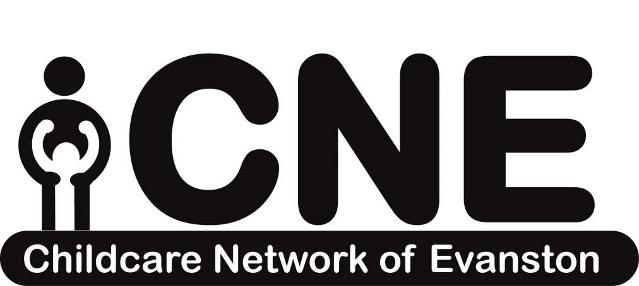

For any questions, comments, or concerns, feel free to call
The Childcare Network of Evanston at:
(847) 475-2661
Address: 1335 Dodge Ave, Evanston, IL 60201

Skokie & Morton Grove
Early Learning Programs
The following Guide to Early Learning Program is an overview of current early learning programs. We work annually with local early learning centers to maintain and update list. Please note: Inclusion in the guide in no way represents or evaluates the quality of early learning, current licensure, or health and safety at the early learning programs listed herein.

CHOOSING A PROVIDER
What are the differences between a home daycare and a center based daycare?
Home Daycare: Traditionally, home daycares have a smaller staff, smaller facilities, and classrooms with combined age groups. You may see a homelike environment, a more flexible caregiver, and perhaps lower tuition rates. While the experience can be more personal for your children, fewer caregivers may mean less supervision overall. Children may also have less exposure to a set curriculum or educational model.
Daycare Center: Traditionally, daycare centers have a larger staff, larger facilities, more children, and classrooms with separate age groups. Caregivers may have more educational or training certification and follow a more structured curriculum. However, tuition rates may be higher in some centers and vacation or sick policies may be stricter.
Here are some questions to guide your search for the right daycare center:

General:
- How long have you been in business?
- Do you have a current state license?
- Do you have other accreditations? If so, what are they?
- Do you do conduct/background checks on all your employees?
- What is the child to teacher ratio?
- What is the specific breakdown of age ranges?
- What are your disciplinary policies? How do they differ for tantrums, pushing, hitting, arguments, etc?
- What would you do if my baby/child was crying inconsolably?
- What is a typical day like for the children? How is it structured?
- Can I make unannounced visits to see/observe my child?
- What are your security or emergency policies?
- Do you allow children to watch television and/or play with electronics? If so, how is this monitored?
- What supplies do I need to bring? (i.e. diapers, change of clothes, snacks, etc.)
- Do you have your policies in writing?
- What are your hours?

Enrollment/Fees:
- How many children do you enroll at one time?
- Do you currently have any openings? If you have no openings, is there a waitlist we can get on?
- What are your fees? Do you offer scholarships or sibling discounts?
- Do I pay when my child is ill or we’re on vacation?
- How and when will you bill us?

Health:
- What is your sick child policy?
- If food/snacks are served, what kind are they?
- What is your peanut/food allergy policy?
- What is your policy about potty-training?
- What is your policy about administering medicine?
- Are there opportunities for indoor/outdoor play?
These questions provide a basic outline of what to ask daycare providers when searching for one for your child; feel free to ask ones of your own creation when looking for the best daycare fit for both your child and you.

Skokie & Morton Grove
Family Learning & Care

Amini Afsar
Address: 9444 Tripp Ave., Skokie, IL
Phone: 847-673-3585

Angels Keeper / Bushra Shekha
Address: 4633 Elm Terr, Skokie, IL
Phone: 773-430-2345

Barbara Brown
Address: 8226 East Prairie, Skokie, IL
Phone: 847-675-0802
Email: Bbrowndaqban@gmail.com

Diane Brown/Jobina Ponce
Address: 5044 Howard St, Skokie, IL
Phone: 847-983-2956
Email: Dianebrown79@yahoo.com

Children First / Matia Lewis
Address: 4151 Howard St, Skokie, IL
Phone: 847-673-2029

Elizabeth Garcia-Beiza
Address: 4028 Howard St, Skokie, IL
Phone: 773-437-9098
Email: BeizaLiz30@gmail.com

Genrietta Coders
Address: 10048 Lamon Ave., Skokie, IL
Phone: 224-238-9473

Habiba Shahid
Address: 8841 Monticello, Skokie, Il
Phone: 847-933-9239

Kid’s Hut Home Care / Kausar Khokhar
Address: 9436 Leamington Ave,
Skokie, IL
Phone: 847-763-0835
Email: Kkhokhar.00@gmail.com

Kids Club Daycare / Sumaya Khan
Address: 5521 Mulford St, Skokie, IL
Phone: 773-433-2662

Little Birds Child Care / Ahmed Mazharunn
Address: 3854 Birchwood Ave, Skokie, IL
Phone: 847-763-9124
Website: www. littlebirdschildcare.com

Mariah’s Nest / Mariah Robbins
Address: 8209 Springfield, Skokie, IL
Phone: 847-679-3255

Pearl of Isreal / Hedva Yitzhak
Address: 4116 Greenwood, Skokie, IL
Phone: 224-619-5234

Rosa Mathews Day Care
Address: 8241 Monticello, Skokie, IL
Phone: 847-933-9329
Email: Rmath61@gmail.com

Shlyapintokh Roza
Address: 6022 Capulina Ave., Morton Grove, IL
Phone: 847-967-6410

Skokie Sprouts / Erin Schmidt
Address: 9118 Kenton, Skokie, IL
Phone: 309-721-4311

Sunny Day Care / Najma Khalid
Address: 9458 Lorel Ave, Skokie, IL
Phone: 847-204-9720
Email: Sunnydaycare@yahoo.com

Vance Angels Home Daycare / Astride Pierre
Address: 9141 Skokie Blvd, Skokie, IL
Phone: 847-568-1565
Email: Vanceangelshomedaycare@yahoo.com

Skokie Center Based Early Learning Sites

Bright Horizons
Address: 9877 Woods Dr., Skokie, IL
Phone: 847-583-1052
Website: www.child-care-preschool.brighthorizons.com/il/skokie

Cheder Lubavitch Preschool
Address: 5201 Howard St, Skokie, IL
Phone: (847) 675-6777
Website: www.clhds.com

Children’s Bright Beginnings
Address: 8944 Austin Ave., Morton Grove, IL
Phone: 847-965-1003
Website: www.childrensbright.com

Children’s Learning World
Address: 5701 Oakton St, Skokie, IL
Phone: (847) 626-3800
Website: www.clw-montessori.com/skokie
Chicago Latvian Childcare & Preschool
Address: 4555 Church St., Skokie, IL
Phone: (773) 308-4977
Website: www.starins.org
Email: director@starins.org

Covenant Nursery School
Address: 3637 Golf St., Evanston, IL
Phone: (847) 673-5060
Fax: (847) 673-5061
Website: www.covenantnurseryschool.org
Email: tinav@covenantnurseryschool.org

Cradles, Cribs, & Crayons
Address: 9000 Kildare, Skokie, IL
Phone: (847) 673-5060
Website: cradlescribsandcrayons.com
Email: cccrayons@aol.com
Creative Paths Learning Center
Address: 5129 Dempster St, Skokie, IL
Phone: (224) 534-7261
Website: Creativepathslearningcenter.com
Email: CreativePathsLC@Yahoo.com
Devonshire Park Preschool
Address: 4400 Greenwood St, Skokie, IL
Phone: (847) 674-1500 Ext. 2400
Website: www.skokieparks.org/devonshire-preschool

District #68 Early Childhood Center
Address: 9300 Kenton Avenue, Skokie, IL
Phone: (847) 677-4560
Website: www.skokie68.org/ecc
Early Childhood Education Center (Oakton Community College)
Address: 7701 N Lincoln Ave, Skokie, IL
Phone: (847) 635-1441
Website: www.oakton.edu/about/ece_centers/sk_center
Email: adobocan@oakton.edu

The Goddard School
Address: 9651 Gross Point Rd., Skokie, IL
Phone: 847-773-0200
Website: www.goddardschool.com
The Grove Preschool Program – Morton Grove Park District
Phone: 847-965-1200
Email: kacevedo@mgparks.com
Website: www.mortongroveparks.com/things-to-do/early-childhood-programs
Little People Montessori
Address: 7500 Skokie Blvd, Skokie, IL
Phone: (847) 674-1808
Email: littlepeoplesmostessori@gmail.com

Mayer Kaplan J.C.C. Preschool
Address: 5050 Church St, Skokie, IL
Phone: (847) 763-3524
Website: https://www.jccchicago.org/programs/early-childhood/early-childhood-locations/#pb_8346
Mosaic Early Childhood Center
Address: 4023 Dempster St, Skokie, IL
Phone: (847) 675-7030
Website: www.mosaicearlychildhoodcenter.com
Email: mosaicearlychildhood@hotmail.com

Mosaic Montessori
Address: 4700 Oakton St, Skokie, IL
Phone: (847) 213-0899
Website: http://www.mosaicearlychildhoodcenter.com/
Montessori Academy of Morton Grove
Address: 9320 Waukegan Rd., Morton Grove, IL
Phone: 847-423-2145
Website: www.montessoriacademymg.com

Poko Loko Early Learning Center
Address: 5645 Dempster St., Morton Grove, IL
Phone: 847-966-8131
Website: www.pokolokochildcare.com

Shining Star Learning Center
Address: 4201 Main Street, Skokie, IL
Phone: (847) 933-1289
Website: Shiningstarskokie.com
Skokie Montessori
Address: 8401 Karlov Ave, Skokie, IL
Phone: (847) 679-4614
Website: http://www.skokiemontessori.com/
Email: staff@skokiemontessori.com
Swift Child Care Center
Address: 8260 Elmwood St & 8106 Lincoln Ave, Skokie, IL
Phone: (800) 675-6039
Website: swiftchildcare.com
Email: swiftchildcare@gmail.com

Tiny Tot Preschool
Address: 4346 Howard St, Skokie, IL
Phone: (847) 675 6619
Website: http://www.tinytotskokie.com
Tot Learning Center
Address: 3701 Howard St, Skokie, IL
Phone: (847) 674-1500, ext. 3400
Website: https://www.skokieparks.org/tot-learning-center
Email: fmkhan@skokieparks.org

