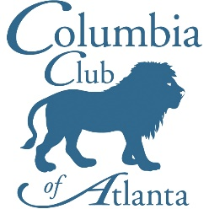

Columbia Club of Atlanta

2021 Membership Application

The Columbia Club of Atlanta operates on a calendar year, and dues are collected on an annual basis. Membership benefits include an annual gift and the member rate at our events Your membership enables us to provide a diverse selection of events and sponsor awards for local students.

2021 membership dues are $30. Please send checks made payable to the "Columbia Club of Atlanta" to:
Alan Marks
Treasurer, Columbia Club of Atlanta
222 Forkner Drive, #7
Decatur, GA 30030

You can also pay your dues online at http://atlanta.alumni.columbia.edu/

______ New member ______ Renewing from 2020

Do we have your information?
Please fill out your information or any changes for this year’s membership directory.

_____________________________________________________________________________________________________________
Name School/Class

_____________________________________________________________________________________________________________
Address

_____________________________________________________________________________________________________________

City, State, Zip

_______________________________________________________________________________________________________________
Home Phone Work Phone

_______________________________________________________________________________________________________________
Profession (title and company/organization)

_____________________________________________________________________________________________________________

Interests

_____________________________________________________________________________________________________________
E-mail address

Are you a member of Twitter: Name ________________________________________________________

Are you a member of Facebook: Name ______________________________________________________

Please take a moment to let us know what you think about the Columbia Club of Atlanta can serve you.

Would you like to get more involved with the Columbia Club of Atlanta?
____ Undergrad Applicant interviews ____ Plan an event
____ Host an event (at your home or other space) ____ Join the board

What types of events are you most interested in? Please select all that apply.
____ Lectures ____ Cultural/Arts
____ Networking/Career ____ Socials, Dinners, Happy hours
____ Community Service ____ Family-friendly

Are there any other types of events you would like to see added to this year’s program?

Please let us know if you have any other comments or suggestions.

