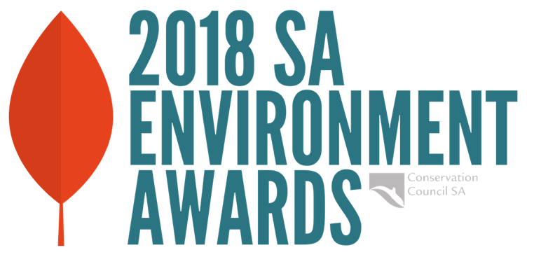

Young Achiever Award
Award information and nomination form
South Australia's young environmentalists make a great contribution to the protection of our environment through many avenues, including their involvement in community awareness campaigns, volunteerism, political advocacy, research and science, and on-ground work.
Conservation SA’s Young Achiever Award recognises those who are committed to improving environmental outcomes.
Who/what the Award recognises | The Award is to go to an individual (or group of young individuals), aged under 28 and living in South Australia who, in the past 12 months, has made a significant contribution to protecting the State’s environment.
Aim | The aim of the Award is to recognise the efforts of the recipient(s) to contribute to the protection of the environment.  For example, the Judging Panel will take into account:  - the scope of the work and the environmental outcomes of the young person’s efforts  - their impact on community behavior  - their management and leadership skills  - whether the individual has worked alone or as part of a team or group  - whether their involvement has been voluntary or paid, and  - whether they have faced difficult circumstances in achieving their goals.
Prize | To be confirmed
Who can  apply | The applicant should be under 28 years of age. The Award will be made without regard to race, religion or gender.
Nominations & closing date | Nominations must be on the nomination form – see below. Nominations close 5.00pm Friday 9 November 2018.
How it is judged | The recipient shall be chosen by majority vote of the Judging Panel, with the Convenor (Conservation SA’s President or his/her delegate) having a casting vote. Conservation SA reserves the right, in any given year, not to issue the Award.
Award  presentation | Thursday evening 6 December 2018 at Tandanya National  Aboriginal Cultural Institute, 253 Grenfell St, Adelaide.
Other | People applying for this Award are also welcome to apply for the Jill  Hudson Award for Environmental Protection.

2018 Young Achiever Award
Nomination Form

Please remember when submitting your nomination that the judges will be basing their decision on the information you submit, and that a 1-2 page statement should accompany this form detailing the nature of your work for the environment and its benefit/impacts.
Please refer to the 'Aim' box in the table above.

Name of Nominee ...........................................................................................................................
Address ...............................................................................................................................................
............................................................................................................... Postcode .............................
Phone (day) ................................................... Email..........................................................................

If nominated by someone else:
Name of Nominator...........................................................................................................................
Title / Position .....................................................................................................................................
Address ...............................................................................................................................................
............................................................................................................... Postcode .............................
Phone (day) ................................................... Email..........................................................................

Is the nominee aware of the nomination? Yes No (Please circle)
May we contact your nominee prior to judging? Yes No (Please circle)

Signature (Nominator or Nominee) .................................................................................................

Referee - Please indicate someone who is conversant with the nominee's achievements and who would act as a referee for this nomination.
Name ............................................................................................................................................
Position..........................................................................................................................................
Address .........................................................................................................................................
......................................................................................................... Postcode .............................
Phone (day) ............................................. Email..........................................................................

Please email completed nomination form and accompanying statement (Word or PDF format) to: awards@conservationsa.org.au by 5pm, Friday 9 November 2018

Or if email is not possible, post entry to The Young Achiever Award, Conservation SA, Level 1,111 Franklin Street, Adelaide 5000 by 5pm, Friday 9 November 2018

Enquiries: Paige Le Cornu 8223 5155 or awards@conservationsa.org.au

