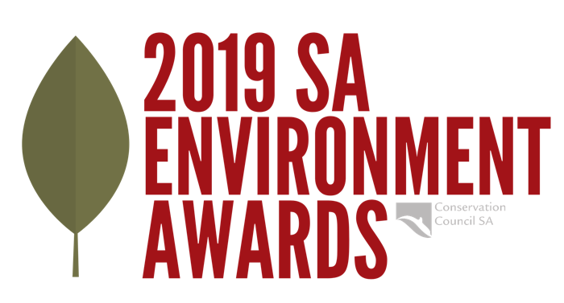

Jill Hudson Award for Environmental Protection
Award information and nomination form
This annual award is in memory of Jillian Hudson (1948 -1997) who was born, lived, studied, taught and died in South Australia. Most of Jill’s working life was spent teaching primary school children.
Jill had strong concerns for the environment and she made sure that these concerns were passed on to her students whom she told: "Life is an opportunity and its purpose is to stand for something and to make a difference."
Who/what the Award recognises | The Award is to go to a person living in South Australia who, in the past 12 months, has made an outstanding contribution to protecting he State’s environment.
Aim | The aim of the Award is to recognise not only the efforts of the recipient but also the circumstances under which the recipient worked in his/her efforts to protect the environment.  Special consideration will be given to nominees who have had to contend with significant government, political, corporate, media or institutional prejudice in their efforts to mobilise public opinion to protect the environment.
Prize | $2,000
Who can  apply | The Award will be made without regard to age, race, religion, sexuality or gender. The recipient of the Award may be a volunteer, a group, an employee of an environmental organisation, a government employee, a politician, an educator or a journalist.
Nominations & closing date | Nominations must be on the nomination form – see below. Nominations close 5.00pm Thursday 10 October 2019.
How it is judged | The recipient shall be chosen by majority vote of the Judging Panel, with the Convenor (Conservation SA’s President or his/her delegate) having a casting vote. Conservation SA reserves the right, in any given year, not to issue the Award.
Award  presentation | Thursday evening 21 November 2019 at Tandanya National  Aboriginal Cultural Institute, 253 Grenfell St, Adelaide.
Other | Applicants not selected for this Award will (if applicable) automatically be considered for Conservation SA’s two other Award categories (Young Achiever/ Unsung Hero.)

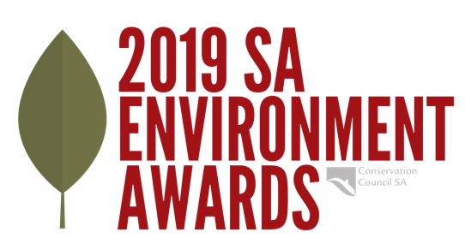

2019 Jill Hudson Award for Environmental Protection
Nomination Form

Please remember when submitting your nomination that the judges will be basing their decision on the information you submit, and that a brief statement (strictly no longer than 500 words) should accompany this form detailing:
- what the nominee did in the area of environmental protection in South Australia in the past 12 months, and
- the circumstances under which this action occurred.

Name of Nominee ...........................................................................................................................
Address ...............................................................................................................................................
............................................................................................................... Postcode .............................
Phone (day) ................................................... Email..........................................................................

One-sentence summary of nomination reasoning (additionally attach accompanying statement as full detail)
..................................................................................................................................................................................................................................................................................................................................

If nominated by someone else:
Name of Nominator...........................................................................................................................
Title / Position .....................................................................................................................................
Address ...............................................................................................................................................
............................................................................................................... Postcode .............................
Phone (day) ................................................... Email..........................................................................

Is the nominee aware of the nomination? Yes No (Please circle)
May we contact your nominee prior to judging? Yes No (Please circle)

Signature (Nominator or Nominee) .................................................................................................

Referee - Please indicate someone who is conversant with the nominee's achievements and who would act as a referee for this nomination.
Name ............................................................................................................................................
Position..........................................................................................................................................
Address .........................................................................................................................................
......................................................................................................... Postcode .............................
Phone (day) ............................................. Email..........................................................................

Please email completed nomination form and accompanying statement (Word or PDF format) to: awards@conservationsa.org.au by 5pm, Thursday 10 October 2019.

Or if email is not possible, post entry to SA Environment Awards, Conservation SA, Level 1,111 Franklin Street, Adelaide 5000 by 5pm, Thursday 10 October 2019.

Enquiries: Paige Le Cornu 8223 5155 or awards@conservationsa.org.au

