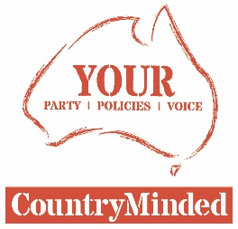
10/11/2017

MEDIA RELEASE

How Barnaby ripped 2.1billion from the economy

COUNTRYMINDED candidate for New England Pete Mailler was the Chairman of Grain Producers Australia in late-2012, when the Wheat Export Marketing Amendment Bill was passed by the Gillard Government. It had conditions imposed on its passage by Greens Senator Rachel Siewert.
Pete said one specific condition was to mandate bulk handling companies to provide weekly wheat stocks information by store, by grade and by port zone during harvest, and monthly thereafter.
“Since taking office, Barnaby Joyce has failed to enforce that condition,” he said
“The value of this information was conservatively and independently estimated to be worth between three to five-dollars per tonne of wheat to growers in Australia.
“It is information that would have helped address some of the asymmetry that exists in the grain marketing system in favour of bulk handling companies.”
Pete said as a result the bulk handlers have exclusive and full knowledge of everybody's stock position within their grain networks. In contrast, the rest of the trade and growers are essentially trading blind.
“By 2016, Mr Joyce had held office for three wheat harvests and Australian producers had produced approximately 75 million tonnes of wheat in that time. By extrapolation, this has cost growers about four-dollars per tonne of wheat produced in lost revenue from the non-enforcement of the conditions of Wheat Export Marketing Amendment Bill,” he said.
“That equates to approximately $300 million in lost revenue to the production sector on his watch.
“The accepted economic multiplier for Australian farm income is a factor of seven. So, Joyce’s inaction has cost our economy approximately $2.1 billion and most directly affected is the regional economy.”
Pete said producer groups across the country have pressured Mr Joyce to ensure this stocks information was provided consistently, but the ugly side of party first partisan politics seems to have won out.
“Like most in Canberra, it seems Mr Joyce does not understand that the hurt to farmers is amplified in the subsequent hurt on their communities. Tragically he seems to not care,” Pete said.
“CountryMinded is the credible, conservative, political alternative for rural and regional voters who have been taken for granted for too long.
“We deserve a better deal and CountryMinded can and will provide one.”

Ends.

For interviews contact: Pete Mailler
0427 265 707
pete.mailler@countryminded.org.au

