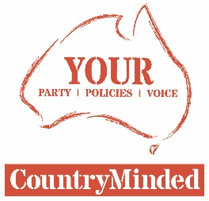
14/11/2017

MEDIA RELEASE

Joyce needs to provide answers

THE fact that 44,608 people (52.5%) from the New England Electorate voted yes and 40,932 (47.5%) voted no in the recent same sex marriage postal vote, had CountryMinded candidate Pete Mailler asking just how Barnaby Joyce will vote on legislation, should he be elected on December 2.
“Would he represent the wishes of the majority of his constituents, or would he oppose legislation on this issue?” Pete asked.
“I voted yes and CountryMinded supported the yes vote. I think this a fair enough question, considering it was his vote that sold off Telstra back in 2005, against the wishes of 80 per cent of country people.
“This is one important question among many others that need to be answered. The best way for Barnaby Joyce to answer those questions is to turn up to the Meet the Candidates Meeting in Tamworth on November 20, where he can debate the issues with other candidates, inform constituents and engage with the media. Those duties were included in his original job description after all.”
Pete said he had several issues he wished to take up with the Nationals candidate and how he intended to vote on matters of same sex marriage was very important one.

-Ends-

For interviews contact: Pete Mailler on 0427 265 707 or at pete.mailler@countryminded.org.au

