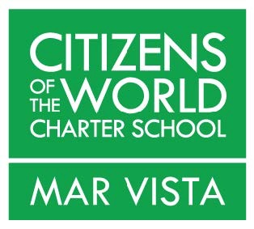

Dear (Potential Sponsor),

I am a parent at Citizens of the World Charter – Mar Vista and am writing to acquaint you with it in hopes you will be interested in becoming a business sponsor.
Citizens of the World Charter is worthy of a donation from your business because it has a unique educational model that believes in educating the whole child in a diverse environment. Citizens of the World’s commitment to diversity extends beyond the varied socio-economic, cultural and racial backgrounds of our students – it embraces the diversity of each student’s unique skills and learning style.
This “differentiated” learning style is combined with a strong social-emotional component that is embedded into every aspect of the rigorous curriculum. These philosophies are combined to develop and support the students’ individual strengths and challenges.
Additionally, our collaborative, project-based learning environment develops students’ abilities and confidence while instilling a sense of responsibility for themselves, the community and ultimately, society as a whole.
California is 48th in the nation for dollar amount of funding per student. Los Angeles Unified School District’s traditional public schools are grossly underfunded; charter schools receive even less public funding. In order to sustain our diverse and unique educational model, CWC Mar Vista must do extensive fundraising to compensate for our budget shortfalls.
Please consider a donation to our school.
Should you have any questions or if you’d like to speak further about CWC Mar Vista, please don’t hesitate to contact me.
Many thanks.
Sincerely,
Your Name and Contact Info

