Family Council Meeting 1/19/2017

Committee Chairs in Attendance: Sharon, Alison, Lisa, Paola, Liz Claire, Julie, Catherine, Larisa, Happy, Judy, Becky, Susie, Joleen, Katie

Community Members in Attendance: Meg Balian, Mike Choe, Elizabeth Bailey

Meeting Facilitators: Happy, Judy

Agenda

Proposed by | Agenda Item | Category | Details | Recommended time for item
Happy/Judy | Check-In |  | Where is everyone at?' | 5 minutes
Happy/Judy | Framework for Meetings |  | Meeting norms and expectations for community comments and questions - specifically regarding agenda items discussed during the meeting | 5 minutes
Happy/Judy | Community Q and A |  | Agenda Items from community members- in room | 20 minutes
Rebecca/Julie | Walkathon |  | How can we best support Ted? | 10 minutes
Alison | Supporting the Community Through Transition |  | "WORK TIME" Two smaller working groups-brainstorming: Qu. 1: How can we ensure transparent, informative and frequent communication from now through fall? 2. How can we elevate the idea who we are as CWCMV-including elevating the teacher and parent leaders who truly embody CWCMV values and the 'CWC Way'? | 40 minutes
 |  |  | "SHARE": Each group shares ideas with the other. | 10 minutes
 |  |  | Next steps: prioritize ideas and articulate next steps | 20 minutes

MINUTES

Agenda
1 - Opened with a check in around the room
2 - Framework for meetings
3 - School Report
4 - Walkathon
4 - Community Q&A
5 - Transition
6 - New Business
7 - Next steps and Action Items
Next meeting on November 17, 2016

1 - Opened with a check in around the room

Start at 6:45 - round the room check-in

2 - Framework for meetings

Presented Norms and Q&A Guidelines
- With High Expectations: Bring your “A” game by being accountable, respectful and empathetic;
- With Flexibility: Respectfully consider others perspectives in order to be adaptive in any given situation;
- With Clear Communications: Speak your truth respectfully using “I Messages”, listen and assume best intent, be vulnerable;
- With Risk Taking: Support others (step up, step back, open minded, positive intent), support ourselves.

Family Council Q&A Guidelines
- What kinds of issues can be raised during these sessions?
  - Anything that affects the CWC Community
  - Areas of improvement for the school
  - CWCMV committee work
  - Strategic planning for the future of the school
- What would be better discussed with class teachers and school administration?
  - Issues pertaining to individual children or families
  - Issues that are confidential in nature
  - Curriculum, learning or instructional issues
  - Teachers and other staff related issues

4 - Walkathon
- Ted needs help engaging the parents. Rebecca has set him up with timeline and review, but he really needs help rallying.
- There won't’ be any foot charms this year.
  - Comment about the foot charms - get it that we aren’t doing it. What about one sticker for participation - not per donation. Use the logo for the sticker. Helps keep the positive aspect of the kid involvement and ditch the competition aspect.
- The classes/grades are coming up with a prize for 100% participation. The prizes will be equitable among the classes.
- We could do an ice cream party for 100% participation for the school.
- Need to find a co-chair for Ted. Put on FB, email, bug friends. Becky knows a new family who ran the NY City Marathon!
- Engage the new parents - just ask people directly!
  - Reach out to the parents who ran to be the parent representatives. Dan runs these types of things and they all wanted to be a part of engaging with the parents. Judy to reach out to them.
- Communication
  - Need a bolder, simpler flyer. Something more eye catching.
  - Posters are about to go up. Formulate a flyer from the same poster since it has all the info on it.
  - Alison will be meeting with every class and will end with jazzing up and getting excited for the Walkathon.
  - Take advantage of the large amount of community that may be at the Cafecito and Town Hall. Can we have someone signing people up?
- Tie in Run for Fun? Get ambassadors from the classes? People may feel more comfortable if they are a part of a larger group and can work together.
- Incentives
  - Will still do the classroom goal in a visible way outside the classroom.
  - Will just having a sticker eliminate the incentive to get more than one donation?
  - At a previous school, they did a walkathon and had a camp sponsor where you would get different prizes at different levels and everyone got entered into a drawing for a week of camp.
  - Tracking the donations at that level is very resource intensive.
  - Do more along the lines of the class goal? Don’t want to incentivize the dollar amount. First class to 100% participation gets their walkathon t-shirt.
  - Parents know we didn’t make the annual give goal and are asking what is going to be cut. Have a really tangible thermometer that shows what we get to keep when we reach certain goals. Need to balance the anxiety and feelings of instability with the kids.
  - This can be a teachable moment to embody that it is full community participation and that we need to get up and do this in order to make the school work and have what we do.
  - Could be more unsettling for staff. So actually have the thermometer, but instead of each level saying what could be cut, have up in the corner what 100% participation will be funding.
- Need to have the co-chair be the communications piece constantly on facebook.
- We have some good potential sponsors.

4 - Community Q&A
No questions.

5 - Supporting the Community Through Transition
- Communication - get the community engaged. Transparent, frequent and getting it out there.
- The school does not rest on the shoulders of one person. When Alison leaves, want to know how we can be strategic between now and summer to provide more visibility to the school leaders to move them forward to be more visible to community.

- Split into two groups and brainstorm.
  - Question 1:
    - How can we ensure transparent, informative, and frequent communication from now through Fall 2017?
  - Question 2:
    - How can we elvate the idea of who we are as CWCMV - including elevating teacher and parent leaders who truly embody CWCMV values and the CWC Way?

- Notes when we came back together as a group
  - What would you say to a nervous parent?
  - Actually have a support group sponsored by the Wellness committee. Two meetings - Julie to work with Hawley to find a date on the calendar. Messaging should be “change is hard and here is how we can deal with change”.
  - Julie to send follow up email with two questions for the letter (pink brainstorm sheet). Deadline - Friday night. Tell your story - how we as a school have been through so much (less about how Alison has weathered this for us). What do you say to a nervous parent? New section in the newsletter - message from the Family Council.
  - Teachers are doing a “what drew you to CWC”.
  - Do a new newsletter from the Family Council. Set up a special email? Need a different header.
  - Taking the communication flow chart to the transition and leadership teams and Mark and get feedback and then bring it back to the PC.

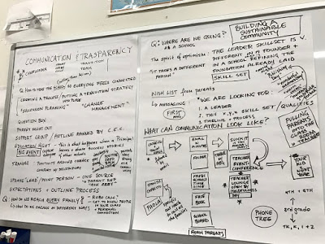
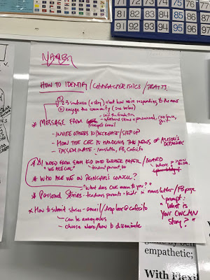

6 - New Business

7 - Next steps and Action Items

Take the notes and discussion from the brainstorm and share it with teachers/transition team and Mark to get feedback and then bring it back to the FC for discussion.

Adjourned at 8:15pm

