2018 GLAA Questionnaire for D.C. Council Candidates

HOUSING
- Will you encourage the Department of Human Services to conduct monitoring of singles shelters to ensure that LGBTQ applicants are admitted to a shelter that corresponds to their gender identity and do not face discrimination while residing there, as required by law?

I fully support requiring DHS to monitor shelter practices to insure that LGBTQ applicants are housed in appropriate locations and do not fact suffer discrimination in shelter housing. I also support efforts to expand permanent housing to move people out of shelters, which are inherently dangerous and represent only short-term solutions to the District’s housing crisis. In addition to discrimination, LGBTQ people face the very real threat of violence in many city shelters. If the District is to continue providing short-term shelter (rather than long-term housing) options, these shelters must be safe and humane places, not simply dumping grounds for people who cannot afford rent in this expensive city.

HEALTH
- Will you press the Department of Health to work with a community advisory group and allocate necessary resources to ensure the annual completion and issuance of a trans-inclusive LGBT Health Report?
Yes. I fully support this demand.

3. Will you support budgets that target funds to address LGBTQ health disparities, including in mental health and substance abuse treatment, and mandate data collection on these populations across all programs?
Yes, I will support budgets that address LGBTQ health disparities, and mandate more robust data collection to insure that these programs serve all communities. Data collection is only the first step toward insuring that all residents are served. The DOH must work with community-based service providers to improve access to information about underserved communities, in particular LGBTQ communities.

- Will you support legislation to boost public awareness of pre-exposure prophylaxis (PrEP) and post-exposure prophylaxis (PEP) as options to prevent HIV infections through the distribution of information in health settings in accordance with Department of Health guidelines?
Yes, I support legislation to boost public awareness of PrEP and PEP. I would also support efforts to insure that the costs of these treatments are covered by private insurance, Medicaid/Medicare and other third party payers. The costs of PREP in particular are extremely expensive, including prescription drugs and quarterly lab testing. Many people who may want to take advantage of these options lack financial means to pay for it.

JUDICIARY
- Will you support Bill 22-0515, 'Reducing Criminalization to Improve Community Safety and Health Amendment Act of 2017', to improve community safety and health by removing criminal penalties for engaging in commercial sex?
I support decriminalization of consensual sexual activities, including commercial sex. I also support other decriminalization efforts that target homeless and low-income people (like laws on public urination, loitering, etc.) The criminalization of sex work punishes the lowest-income workers while doing nothing to address the factors that lead people into sex work. Unfortunately, police harassment is often the most dangerous aspect of sex work.

- What opportunities would you support through legislation to improve the lives of marginalized communities who engage in commercial sex work?
No one should have to sell their bodies to support themselves, although I certainly recognize that many people find themselves with few other options to stay alive. The point is to enable people who engage in sex work to have access to other kinds of opportunities that do not place them in potentially dangerous situations and that allow for a real economic future. I support expanded employment opportunities for marginalized communities. As a steering committee member of the DC Public Banking Center, I have worked hard for the last four years to establish a DC Public Bank which could partner with local banks in promoting jobs, affordable housing, small business development. A Council-funded feasibility study is currently in process (https://www.dcpublicbanking.org/).

- What opportunities would you support through legislation to improve the lives of marginalized citizens who resort to sex work for survival?
Again, I support the decriminalization of sex work, and an end to police harassment. The people whose circumstances force them into sex work must be supported in finding alternative, safer ways to make a living. I support expanded and improved job training, apprenticeship and economic development programs. I would support targeted job training programs that would enable people to move from sex work into other kinds of employment.

- Will you support and press for passage of a reintroduced Bill 20-63, the Police Monitoring Enhancement Amendment Act, to give the Office of Police Complaints unfettered access to information and supporting documentation of the covered law enforcement agencies?
Yes. I support this legislation, but also support stronger efforts to make police accountable. Bill 20-63 does not go nearly far enough in addressing police misconduct and racially biased policing. There is currently no real enforcement of the OPC efforts, and no accountability for the police. I strongly support a more effective OPC, including one with real subpoena and enforcement power.

9. Will you support legislation to develop an avenue for sealing court-ordered name and/or gender/sex change process?
Yes. This should be a basic right.

HUMAN RIGHTS
10. While the unemployment rate in the District is 6.6%, approximately half of transgender people in DC report being unemployed. What steps will you take to address this persisting economic disparity in a timely and sustainable manner?

Low income transgender people suffer the same kinds of challenges as the mass of low income people in DC, with limited job opportunities and low-pay work when it is available. They often face the added challenge of discrimination is applying for entry-level retail and customer service positions. Although such discrimination is illegal in DC, antidiscrimination laws lack real enforcement. I support more robust enforcement of laws against employment discrimination, as well as targeted media efforts focused on employers who refuse to comply. There must be serious teeth in our antidiscrimination laws. In terms of employment opportunities, transgender people deserve respect, dignity and access to a wide variety of employment options, none limited by their transgender status.

[Talk about green jobs and the like?]

YOUTH
11. Will you support improved services and treatment for homeless LGBTQ youth, including transitional housing?
Yes. Current services for homeless LGBTQ youth are wholly inadequate, and include almost no access to transitional housing opportunities. In the face of increasing gentrification, we must expand opportunities for all residents for adequate housing and other supports. Homeless LGBTQ youth face additional challenges of navigating often hostile bureaucracies and not-so-subtle bigotry. LGBTQ youth face much higher rates of homelessness and higher dropout rates than other youth, and the District must address this continuing problem. We need to address the factors that lead to youth homelessness, including problems in our schools and communities that feed discrimination and contribute to the alienation of LGBTQ youth. The public schools can play a significant role in addressing these issues. Please note this issue in my record, under DC Human Rights City Reports.

SENIORS
12. Will you support improved services and treatment for LGBTQ seniors, including affirming senior housing?
Absolutely. LGBT seniors should have access to affordable housing where they will not face discrimination. Many LGBTQ seniors have lost family support, and are often facing struggles of aging in poverty on their own. We need housing opportunities that recognize the needs of and welcome LGBTQ seniors, rather than simply tolerate these important members of our community. Seniors should not be forced to return to the closet to get services.

13. LGBT seniors are more likely to age alone, and face higher levels of economic insecurity and discrimination than non-LGBT seniors. Will you support funding for congregate meals and other services that specifically aim to keep LGBT seniors engaged in the community?
Again, absolutely, The idea of supporting congregate opportunities for LGBTQ seniors is a good one and one I support. I would look to the LGBTQ community to help develop proposals for such opportunities and support funding to make them happen.

CONSUMERS AND BUSINESSES
14. To fight the District's notorious 'pay-to-play' reputation, will you support enacting legislation that combines the best elements of Bills 22-8, 22-47, and 22-51?

I strongly support efforts like Bill 22-47 to eliminate the role of graft and corruption in the public procurement processes. D.C. has an unfortunately notorious reputation for “pay-to-play.” My campaign, like all Statehood Green campaigns, rejects corporate contributions. The rapid gentrification in our city has made this problem worse by the encouragement of pay-to-play campaign contributions.

15. What steps will you take to ensure a transparent and equitable bidding process for city contracts?
There must be a serious review of all District contractors and bidders to insure that political considerations do not come into play in awarding contracts for government services. There should be a clear separation between political influence in the procurement process and contracting decision-making. Elected officials should have no role in influencing who gets government contracts, except in so far as exercising the oversight responsibility of the DC Council with regard to potential corruption of the process.

Signed

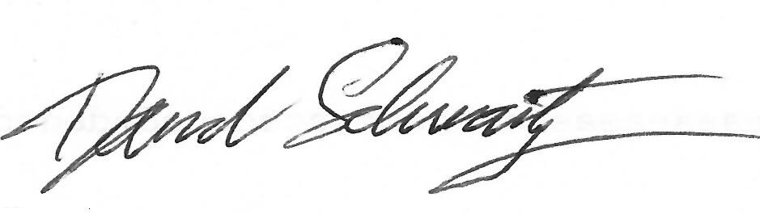
David Schwartzman
Candidate for DC Council At-Large, DC Statehood Green Party

