Join the Fight for $15 & Fairness!
Text FIGHT to 647-360-9487
Last year, in response to overwhelming popular demand by the people of Ontario, the provincial government brought in better labour laws that raised the minimum wage to $14 and will raise it to $15 on January 1, 2019.
Doug Ford may have the majority of seats at Queen's Park, but he doesn't represent the majority of Ontarians. 60% of voters did NOT vote for his plan to scrap the $15 minimum wage. And more than 40% of eligible voters did not vote at all.
Doug Ford has no mandate to reverse our decent work laws.
We know that two-thirds of Ontarians support a $15 minimum wage. This is why we need your help to mobilize and organize all those who expect and deserve decent work.
Doug Ford says HE is for the people. We are here to say we ARE the people! And WE the people demand decent work now!

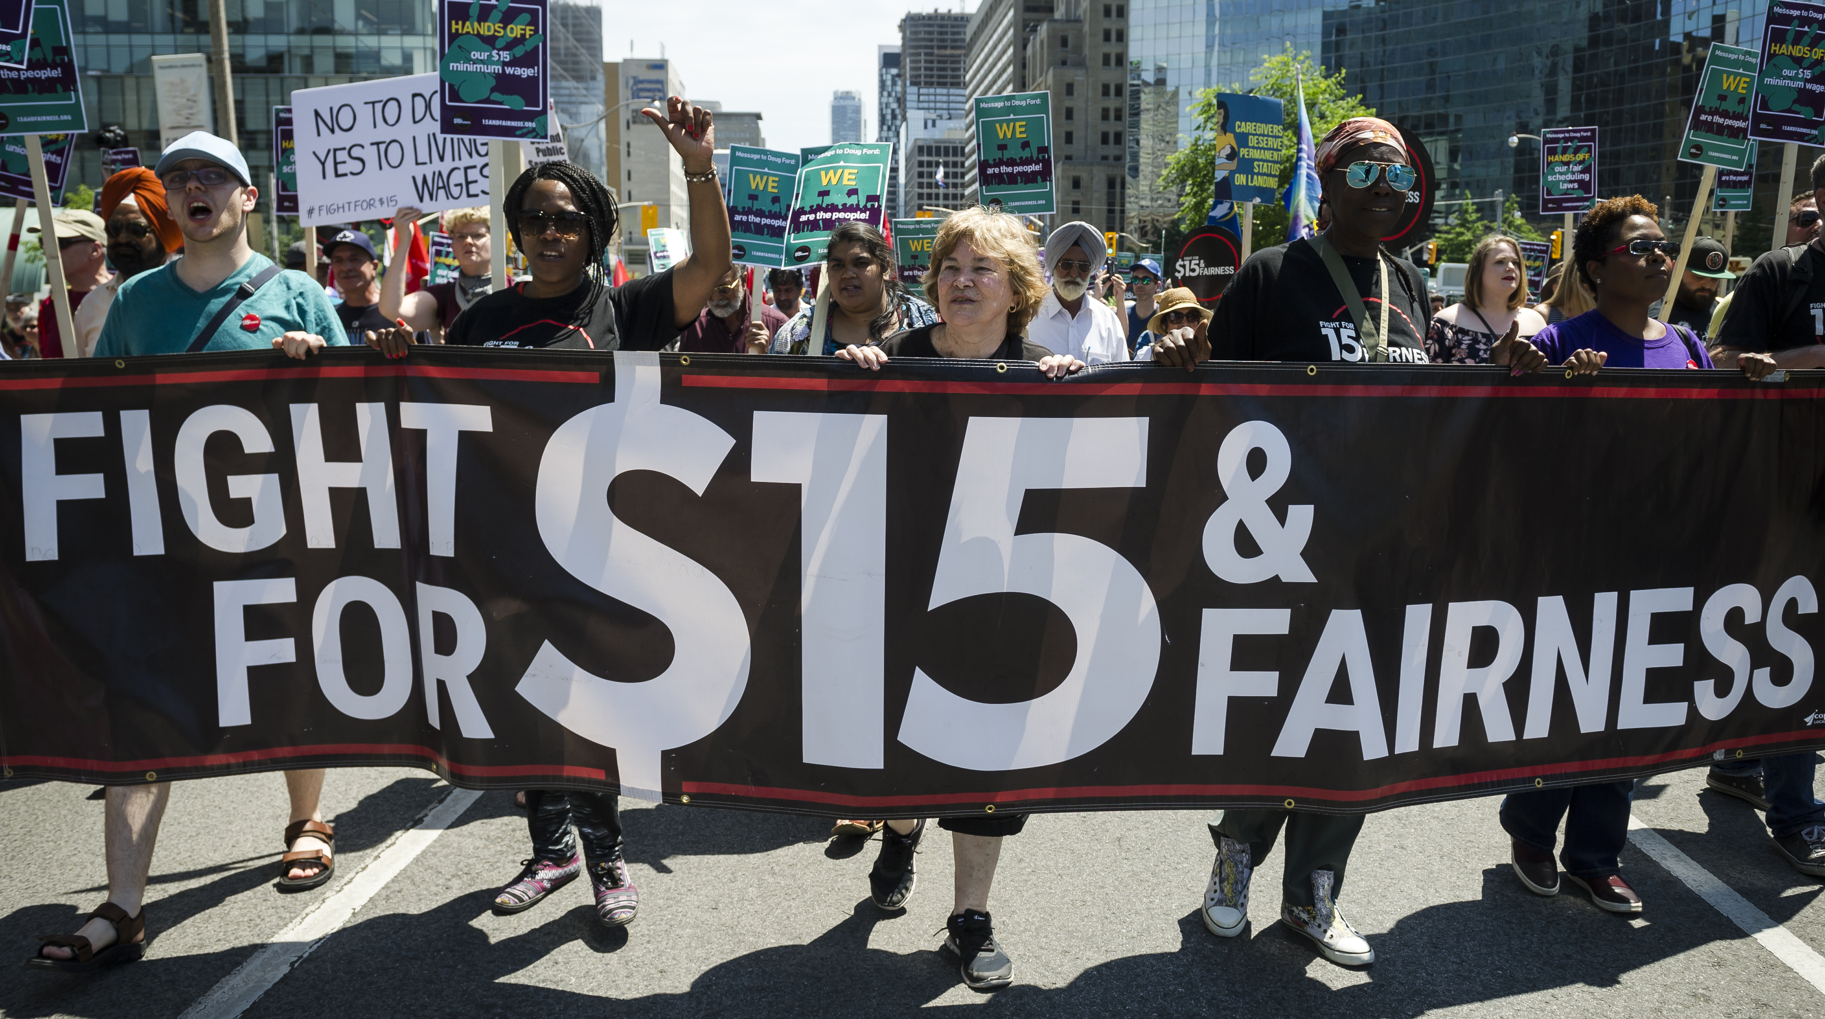
Get involved! Visit www.15andFairness.org to find out about upcoming events happening near you!

Join us at one of our upcoming organizing meetings:

CITY
Meeting Date & start times [INSERT HERE]
Address of meeting location
[INSERT HERE]
Local contact information or
any other event details [INSERT HERE]

15andFairness.org

To join the campaign, text FIGHT to 647-360-9487
15andFairness.org

#15andFairness

