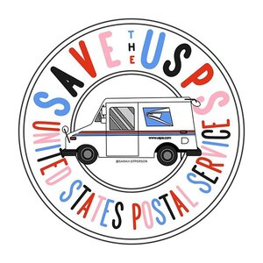Phone Script
Call the Congressional switchboard at (202) 224-3121 and ask to be connected to your Senator or Representative or go to senate.gov / https://www.house.gov/ and in upper left hand corner click on Senators/Representatives. Drop down menu to Contact. Choose a state or scroll down for a DC phone number and add to your address book. When you reach an aide or answerphone, leave the following message:
Hello, my name is X and I am a constituent who votes in (your state) from abroad. (Say if you are a supporter of your Senator.) I’m calling to urge you to ensure that the next stimulus bill saves the U.S. Postal Service from financial collapse, so that every American will be able to safely cast their ballots. This is especially important to me because many overseas citizens like myself must use postal mail to return their ballots, and a non-functioning postal service will disenfranchise us. Our democracy cannot survive without the USPS.

Email SCRIPT
Support and Protect the US Post Office
I am a voter who lives __________(country) and votes in ___________(county, state). The United States Postal Service is an essential public service, necessary for our economy and fundamental to a functioning democracy. President Trump’s outrageous attacks on the USPS and on Vote-by-Mail, and the lack of funding for these items in recent COVID stimulus/rescue packages, are unacceptable, and leave Americans everywhere at grave risk.
I am writing to ask you to protect and fund the USPS. It is an affordable, accessible public good, serving as a universal lifeline that Americans depend on, no matter where they live or what their circumstances — including for the millions of American military and citizens who live overseas. Importantly, the USPS provides employment for more than 600,000 Americans, many of whom are veterans.
The USPS provides critical infrastructure upon which the integrity of US elections depends. Millions of Americans rely on vote-by-mail to cast their ballots. As an American living abroad, I can only vote by mail. Without affordable, accessible, universal mail delivery service as guaranteed by the USPS, millions of military, foreign service officers, and civilian voters like myself will be totally disenfranchised in US elections.
While Americans abroad are enfranchised in our elections by being able to vote-by-mail, not all Americans have this right. Vote-by-mail is safe, is effective, and is something I ask you to support expanding. Without the USPS and vote-by-mail, Americans everywhere will be asked to bear additional financial, economic hardships just in order to vote, even risking their health and safety in pandemic conditions to try to vote in-person. This would be mass voter disenfranchisement. Now more than ever, we should be expanding protections of the vote, not undermining them, for ALL Americans, including overseas American voters.
I urge you to support funding for protecting the United States Postal Service and making vote-by-mail universally available for the November general election; to make funding for these two items your priorities in the upcoming stimulus/rescue package and to encourage your colleagues in Congress to do the same.
Sincerely,

PLEASE TAKE ACTION TODAY TO SAVE THE UNITED STATES POSTAL SERVICE. WE NEED TO PROTECT OUR VOTES! Post Office Bailout Blocked
The United States Postal Service (USPS) is in a dire situation. According to the Postmaster General, between June and September of this year the USPS will run out of money and will be forced to cease operations. This, only months ahead of the November General Election.
Needless to say, without a functioning postal service, our votes from abroad will be effectively suppressed.
The USPS has had operating issues for over a decade. However, the effects of the Coronavirus pandemic have gravely exacerbated the issue of decreased volumes that has plagued the agency over the past years.
Unsurprisingly, Senate Majority Leader Mitch McConnell, Treasury Secretary Steven Mnuchin, and Republican Members of Congress have to-date refused to include the Postal Service in any coronavirus relief legislation, privatizing mail delivery being a long-term goal of the conservative movement. Donald Trump reportedly had said that he would block emergency funding for the agency, putting at risk the $2 trillion Coronavirus Aid, Relief, and Economic Security Act (CARES) if the legislation had contained any money directed to bail out the postal agency.
In this critical election year where we need every vote to be counted, we cannot standby and allow the next Coronavirus stimulus bill to exclude full funding and protection for the USPS and the vote-by-mail ballots sent by overseas voters.

Please take action! The potential demise of the USPS could disenfranchise voters abroad in November. If our voted ballots cannot be delivered, how will our votes be counted?
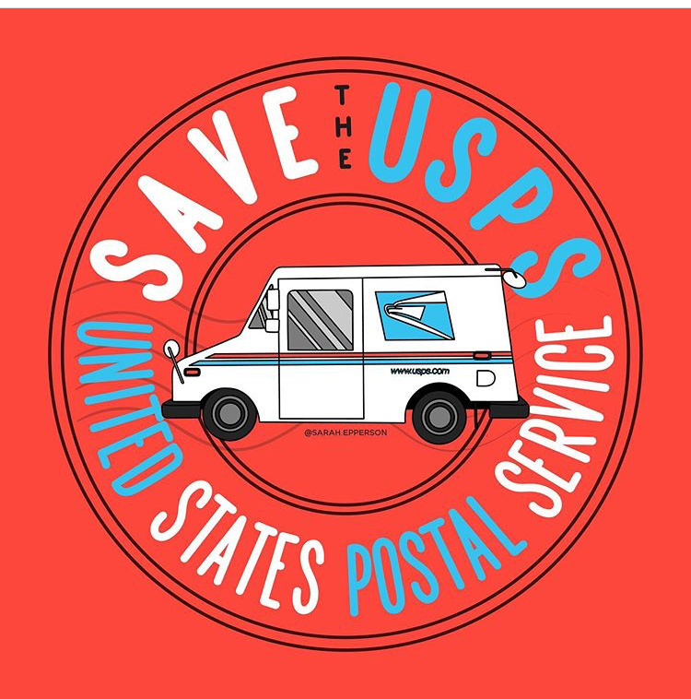
Many thanks to Sarah Epperson http://www.sarahepperson.com/about for allowing us to use her graphics. You can follow Sarah on Instagram @sarah.epperson.

