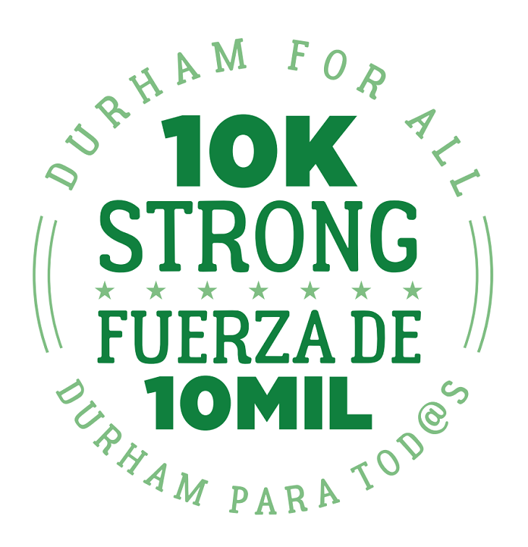
Thank you for taking the time to complete our questionnaire! Your answers will be shared with our members and posted on our website for public review. When answering each question, please describe specific proposals and/or policies that you will seek to implement if elected/re-elected. To read our 10K Strong campaign manifesto, from which these questions are informed, visit: www.durhamforall.org/10kstrong.
Candidate Name: | Tracy D Drinker
Office Sought | Mayor
Address: | P O Box 14422 Durham NC 27709
Phone:
Email: | tracy.drinker@gmail.com
Website: | tracydrinkerformayor.com
Facebook: | Drinker4Mayor
Twitter: | @Drinker4Mayor

1. Durham For All believes that everyone has the right to live in a safe and affordable home. Because of years of inadequate investment, many of our city’s public housing units are slated for demolition and/or redevelopment. What steps can the city and the community take to ensure the best outcomes for current and future residents in this redevelopment process?
I would like for the city to look into a land value tax which would tax landowners that do not develop on these properties for affordable housing and a safer environment.

2. Durham For All believes that all people have the right to a high-quality public education that fully develops their potential. What do you believe are the barriers to achieving this in Durham? What is the role of charter schools and voucher programs in enabling or limiting this right? What role should the city government play in providing educational opportunities to residents, and what types of city programs could help our public school system develop the potential of all Durham’s youth?

- Socioeconomic status, environment, access to materials aiding in learning.
- Charter schools in my opinion are for people that take their child’s education and exposure to education to a higher level and are financially stable enough to enroll their child in such schools. Voucher programs have to be sought out for by parents in order to be useful and aid in children receiving a better quality of education.
- The city should regulate and make sure that schools consist of a melting pot of people from all walks of life. Vouchers and assistance should be made available for parents that are being proactive in seeking the best education for their children.
- Vouchers, school tours, in-classroom tryouts for certain schools, uniforms for proverb stricken children, access to guidance counselors and mentors, along with de-escalation training for our school administrators. Durham just needs to open its doors to people who sincerely want to help the city instead of draining it dry of resources financially, physically and historically. Preservation and prosperity.

3. Durham For All believes that everyone has the right to the resources they need to sustain themselves and their families and to live on a healthy planet. What is your economic development philosophy? If elected, what will you do to help transform Durham’s economy into one that promotes cooperation and community investment to meet the needs of working people?
Working closely with the many educational institutes as well as staffing companies.

4. Durham For All believes that everyone deserves to feel safe and secure in their bodies, homes, and communities. Federal guidelines around immigration and refugee resettlement, as well as a growing national awareness of the police violence experienced by communities of color, have many people in Durham feeling deeply concerned. What should the role of local law enforcement be in Durham, and how should officers interact with and remain accountable to residents? How should the city of Durham interact with federal agencies such as ICE? In what ways do current city policies reflect your standard of transparency and accountability for law enforcement and belonging for refugees and immigrants in Durham, and in what ways are they lacking?
The role of law enforcement should include but not be limited to effective community policing. 21st century law enforcement places a higher demand on law enforcement to respond and resolve community problems and concerns. Law Enforcement has to engage citizen to assist with resolving issues. Law Enforcement has to be an extension of all that is going on in the community. Law Enforcement is utilized more to connect citizens to existing resources in the community. Durham should continue to partner with federal agencies to keep our city safe. We cannot take a risk and disregard federal agencies and run the risk of losing federal funding. We have to embrace our immigrants now like never before for they are the backbone of the new build of Durham. We must do our best to keep from separating families that have come here for a betterment of life and escape from persecution from their own countries. Durham is a melting pot of all and for all as is America should be.

5. Durham For All believes that Durham belongs to all who live here and that we need all residents' voices at the table to create a Durham that works for everyone. If elected, what will you do to expand democratic participation in the City’s electoral process? What will you do to create more mechanisms for democratic engagement in how the city is run on a day-to-day basis?
There will be more transparency to all and not just on cable news 8. I will make sure to be in the community making sure they know what referendums are coming before they just come and take land and jobs away.

Please email your responses to info@durhamforall.org or mail to Durham For All, 1803 Chapel Hill Rd., Suite C. Durham, NC 27707. If you have any questions, feel free to contact us at 919-727-9428. We look forward to hearing from you!

