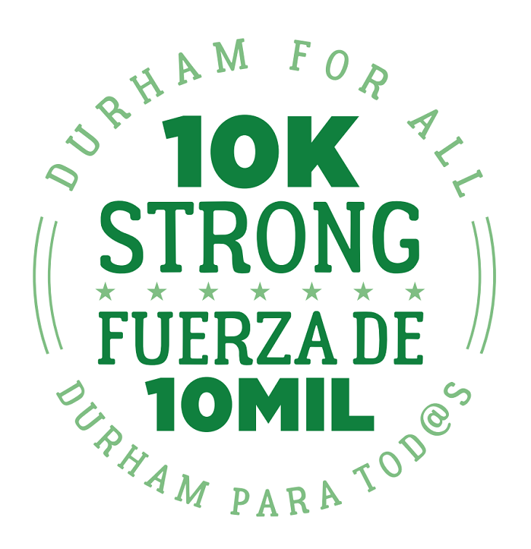
Thank you for taking the time to complete our questionnaire! Your answers will be shared with our members and posted on our website for public review. When answering each question, please describe specific proposals and/or policies that you will seek to implement if elected/re-elected. To read our 10K Strong campaign manifesto, from which these questions are informed, visit: www.durhamforall.org/10kstrong.
Candidate Name: | John Rooks Jr.
Office Sought | Durham City Council Ward 2
Address: | P.O. Box 13242 Durham, NC 27709
Phone: | 919-744-7734
Email: | votejohnrooks@gmail.com
Website: | www.votejohnrooks.com
Facebook: | John Rooks Jr.
Twitter: | Rooks2024

1. Durham For All believes that everyone has the right to live in a safe and affordable home. Because of years of inadequate investment, many of our city’s public housing units are slated for demolition and/or redevelopment. What steps can the city and the community take to ensure the best outcomes for current and future residents in this redevelopment process?
The best outcome would be that the city of Durham would construct affordable housing units using the funds that they currently receive from the 2 cent tax increase to address the chronic homeless initiative. The city must alway include our most vulnerable residents in the redevelopment planning conversation. The city should set aside funding that would be available to the affected residents of demolition or redevelopment to ensure that no resident is left without safe and adequate housing. The funding should not be in the form of a section 8 voucher.
2. Durham For All believes that all people have the right to a high-quality public education that fully develops their potential. What do you believe are the barriers to achieving this in Durham? What is the role of charter schools and voucher programs in enabling or limiting this right? What role should the city government play in providing educational opportunities to residents, and what types of city programs could help our public school system develop the potential of all Durham’s youth?
The city government has no statutory fiscal responsibility to the public school system but we have a moral obligation to ensure that our children in our city receive the best education possible. In doing so the city can collaborate with our educational system through recreational programs (parks and recs) and multi use venues such as the Holton Career Center and the new Whittered School Project.
The city can work through their workforce development department to create internships and vocational training program opportunities.
3. Durham For All believes that everyone has the right to the resources they need to sustain themselves and their families and to live on a healthy planet. What is your economic development philosophy? If elected, what will you do to help transform Durham’s economy into one that promotes cooperation and community investment to meet the needs of working people?
The city has a significant onus in expanding job creation and job quality. In as much as our developments and progresses in recent years has inspired an influx in residency, it should be our goal to see thriving businesses and new entrepreneurships meet employment demands. I would like to see City/Community Partnerships create employment opportunities. I would like to see incentives for Cooperative Housing plans, cooperative markets in urban food deserts or places where limited access to healthy food choices are available, and cooperative efforts in Sustainability.
4. Durham For All believes that everyone deserves to feel safe and secure in their bodies, homes, and communities. Federal guidelines around immigration and refugee resettlement, as well as a growing national awareness of the police violence experienced by communities of color, have many people in Durham feeling deeply concerned. What should the role of local law enforcement be in Durham, and how should officers interact with and remain accountable to residents? How should the city of Durham interact with federal agencies such as ICE? In what ways do current city policies reflect your standard of transparency and accountability for law enforcement and belonging for refugees and immigrants in Durham, and in what ways are they lacking?
Trust issue between the community and law enforcement are of major concern. In recent reports, it has been determined that Durham Police Department has struggled with trust issues, but with the most recent hire of the current police chief, efforts have been made to regain public trust in the Durham community. Racial disparities, while not completely alleviated, efforts by the new police chief, such as discontinuing stop and frisk, random road blocks, along with the collaboration with local community organizations, the issues that the community have concerns about will continue to be addressed as we continue to have open dialogue between the community and law enforcement.
I believe the city should maintain the current practice of providing safe sanctuary to all of our immigrant brothers and sisters. Those sanctuary practices should apply to any person or persons not of U.S. status that choose to seek residency in Durham.
5. Durham For All believes that Durham belongs to all who live here and that we need all residents' voices at the table to create a Durham that works for everyone. If elected, what will you do to expand democratic participation in the City’s electoral process? What will you do to create more mechanisms for democratic engagement in how the city is run on a day-to-day basis?
As a city council official I will promote more transparency utilizing technology. A better job has to be done to ensure all residents are informed. Utilizing social media, apps and digital community boards throughout the city should be used simultaneously with mail and email to disseminate information about city manners. To ensure all our residents from the richest to the poorest the ability to have input on matters that affect the city, we must address meeting times and locations that are fair to all residents. Etc...Work session hours.
Please email your responses to info@durhamforall.org or mail to Durham For All, 1803 Chapel Hill Rd., Suite C. Durham, NC 27707. If you have any questions, feel free to contact us at 919-727-9428. We look forward to hearing from you!

