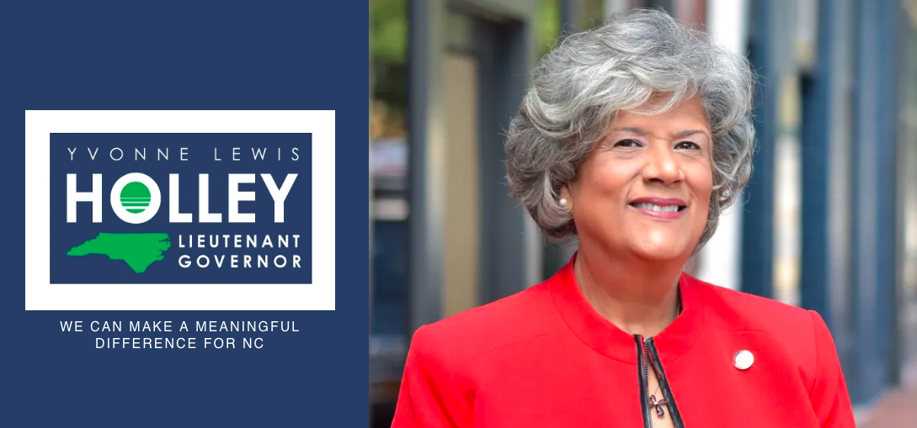

ABOUT YVONNE HOLLEY

ISSUE DRIVEN LEADER WITH COURAGE AND COMPASSION!
Representative Yvonne Lewis Holley was born in Raleigh and was part of the changing south. Early in her life, she learned the values of hard work, dedication and honor.

It was learning from her parents the importance of public service and courage that serve as motivation today. Her mother stressed the importance of education and strength while her father was a living example of community leadership. With these roots, she brings a history of reverence, hope and accountability to public service.

Educated in the Wake County Public School System, Yvonne is an advocate for education. As a student at Enloe High School, she was one of the first students of desegregation. While there were many difficult days, she was able to cross barriers one relationship at a time to build friendships. This same quality gives her the foundation of life experience working with all types of people from various backgrounds. This is a quality of an effective leader with the ability to get things done.

Working her way through Howard University, she began a career dedicated to education, health, economics, youth development and political advocacy. Yvonne's heart for public service includes twenty-five years dedicated to working as a state government employee. This life path is a direct link from a humble beginning of community awareness.

Growing up she watched and learned from community leaders and her father, J.D. Lewis. Lewis was first African-American TV Broadcaster in the Raleigh/Durham market. As Director of Minority Affairs for WRAL-TV, J.D. Lewis is an iconic broadcasting legend, host and editorialist. He is remembered today as having contributed significantly to the positive dialogue between polarized sectors during an epic time in the nation’s history. The dedicated work of her father and other community and business leaders resulted in significant growth, development and shifting race relations in our state. Yvonne witnessed this first hand from her own living room and is continuing this legacy today as the Representative of the 38th District of the North Carolina State House.

One of the most notable accomplishments during Representative Holley’s tenure in the NC House has been the extensive work to relieve Food Deserts in areas across the state. She gathered support from both sides of the aisle; Democrats, Republicans and Independents, to achieve what others hadn’t. Her efforts resulted in funding to support closing the gap in food insecure areas. Her skill and influence brought parties together to battle a common issue and garnered bipartisan support. This is the leadership we need in 2020 and forward!

