CITY OF LOS ANGELES
CALIFORNIA
EAST HOLLYWOOD NEIGHBORHOOD COUNCIL GOVERNING BOARD OFFICERS
Tereza Yerimyan, President
Cheron J. McAleece, Vice President
Jeff Zarrinnam, Treasurer
Arasele Torrez, Recording Secretary
Seta Panosian, Corresponding Treasurer
Donal Thoms-Cappello, Corresponding Secretary

GOVERNING BOARD MEMBERS
Matt Benton Craig Cox
Calixtho Lopes Bob Peppermuller Douge Haines Shahan Suzmeyan
Matt Sanderson

EAST HOLLYWOOD NEIGHBORHOOD COUNCIL
POSTAL MAIL
P.O Box 292359 Los Angeles California 90029

TELEPHONE
TBD

WEBSITE
www.easthollywood.net

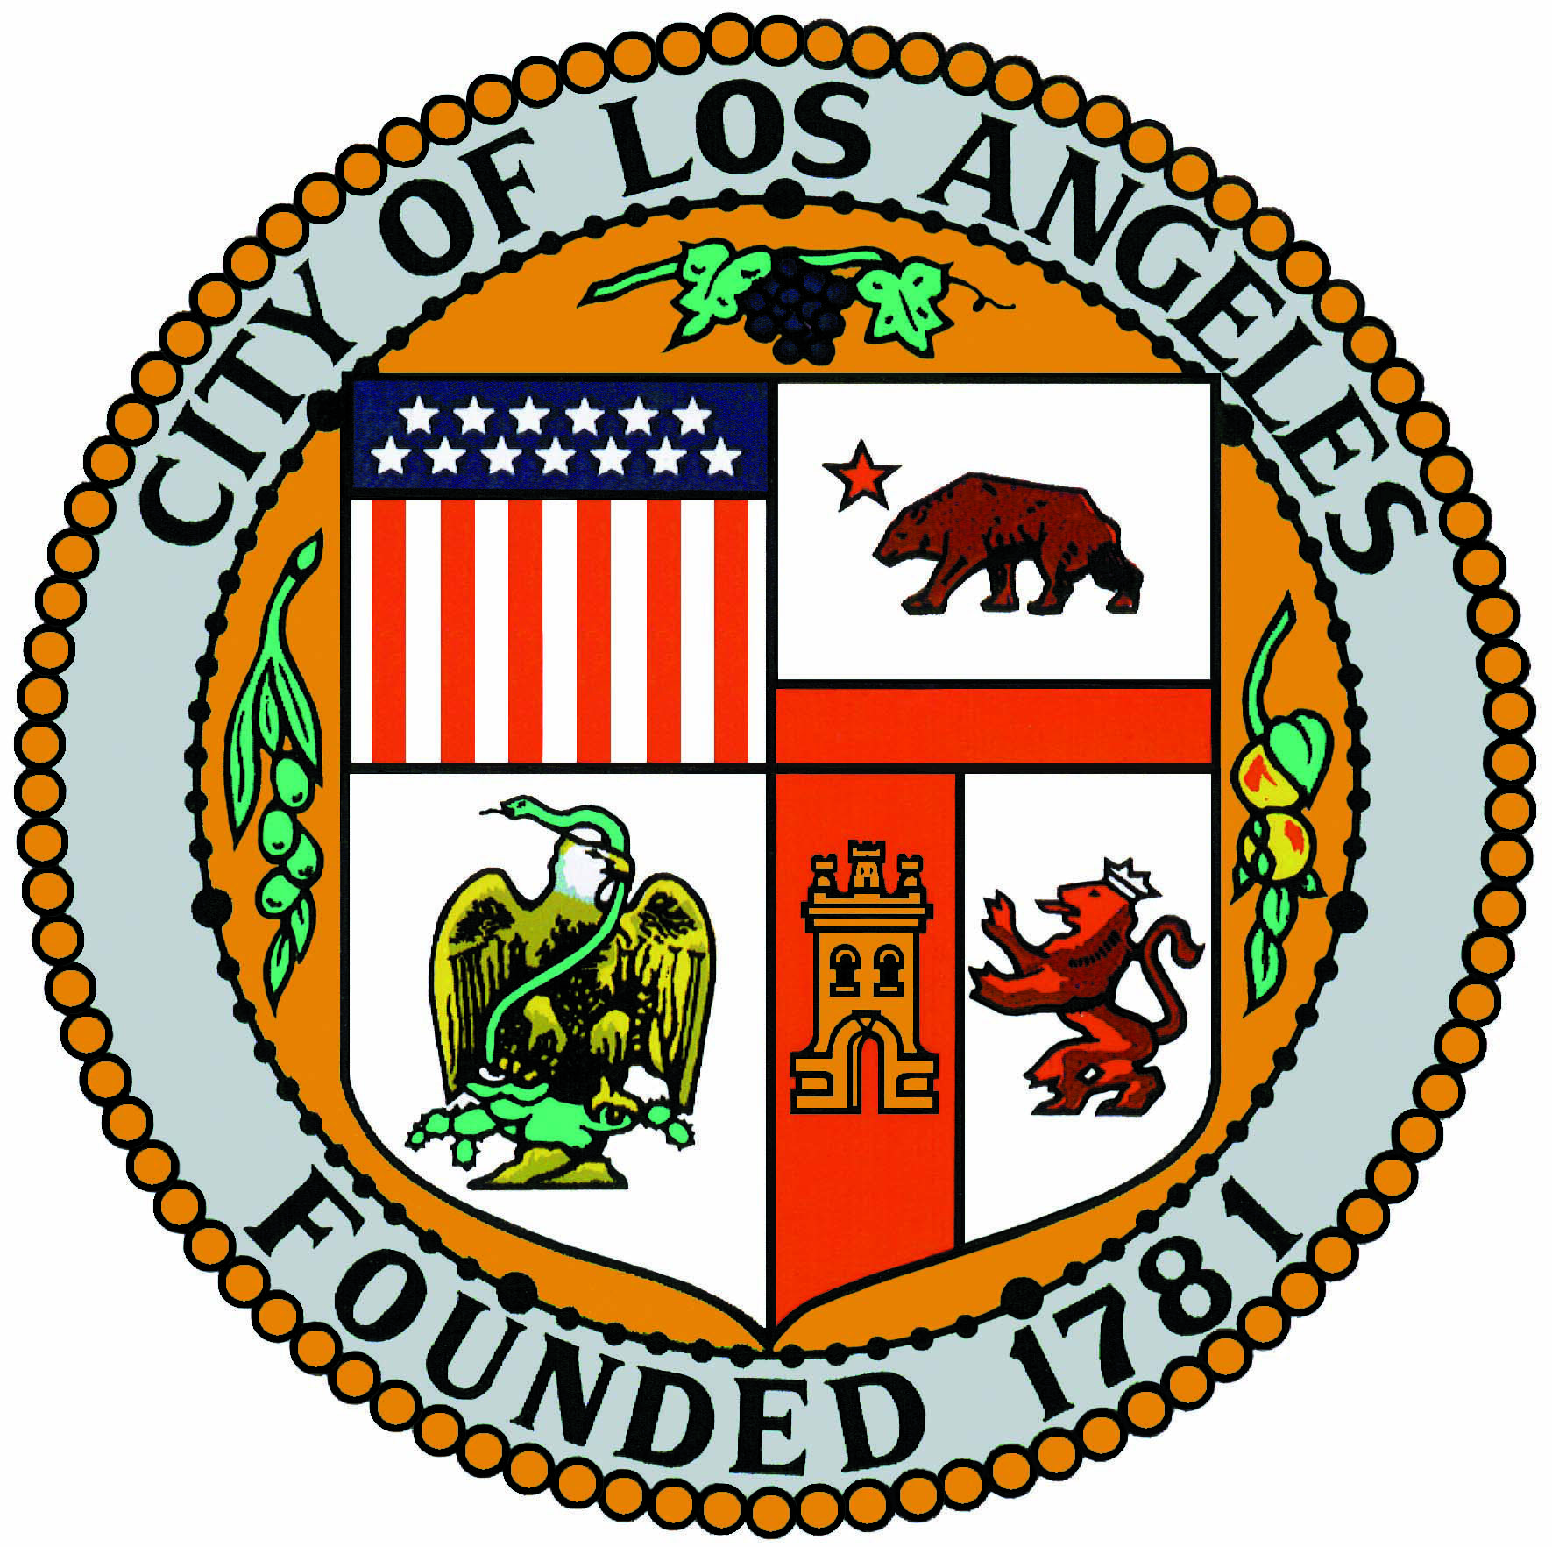
ERIC GARCETTI
MAYOR

EAST HOLLYWOOD NEIGHBORHOOD COUNCIL
GOVERNING BOARD MEETING SPECIAL AGENDA
Monday, March 23, 2015, 6:30 PM
ARMENIAN YOUTH CENTER
1559 North Kenmore Avenue, Los Angeles CA 90027

Public comments on agenda items will be heard when the item is considered. Public comments on other matters within the council's jurisdiction may be made during the Public Comment period. Public comments are limited to two minutes per speaker. Action may be taken on any agenda item except Public Comment, announcements and reports. Actions may be reconsidered only if a motion for reconsideration is adopted at the same meeting where the action was taken. You may request a copy of printed materials that are distributed at the meeting. You may record the meeting by audio, video or photographic means as long as it is not disruptive. Meeting notices and agendas are posted at various locations (see list below). If you need translation, or accommodation for a disability, please call the city Department of Neighborhood Empowerment at least three business days in advance (213-485-1360, or toll-free 3-1-1). The city is a covered entity under Title II of the Americans with Disabilities Act. If you believe the council is not following the law or its own rules you may file a grievance in writing with copies to both the Chair and the Secretary. Please be respectful of others, even when you differ with them.

- Welcome and Introductions
  - Call to Order
  - Opening Remarks/Welcome Address Tereza Yerimyan, President
  - Public Comment of Non-Agenda Items (Please limit to two minutes per speaker.)
- Community Reports
  - LAPD Report
  - B. CD13 Report, Office of Councilmember Mitch O’Farrell, Aram Taslagyan
  - C. City of LA Report, Office of Mayor Eric Garcetti, Yeghig Keshishian
  - D. Assembly District 43 Report, Office of Assemblymember Mike Gatto E. LA City Attorney Report
- Community Voices
  - Thai CDC Updates (Billie Lay)
  - Thai Rotary Club (Teresa Chung)
Break

- EHNC Governing Board Monthly Agenda Items– Public Comment will be taken on agenized items when is discussion begins on that item. All are welcome and encouraged to stay.
  - Approval of January 26, 2014, Governing Board Meeting Minutes.
  - Budget Update (Jeff Zarrinnam, Treasurer).
    - a. Discussion and possible action on Monthly Expenditure report for February.
- Committee Reports
  - Executive
  - Planning Entitlement
  - Outreach
  - Arts & Culture
  - Community Health
  - Youth & Education
  - Budget & Finance
  - By-laws
  - Business and Econ. Dev.
  - Public Safety
  - Design Review
  - IT
- Action Items
  - Discussion and possible action to write a letter of support for CF 15-0135 - Planning's CCU Fee Ordinance to support MViP (Monitoring, Verification & Inspection Program)
    - a proposed ordinance which includes fees to allow the Planning Department's Condition Compliance Unit to expand its current staffing level and more importantly to cover additional monitoring functions will be scheduled for PLUM Committee on March 24, 2015 at City Hall. Specifically these new functions will include the proactive monitoring of grants AND inspections of establishments during operating hours to ensure applicants/operators and business owners abide by the conditions placed upon them by the decision makers. This ordinance makes the Planning Department accountable for its approvals but more importantly, it will provide operators with the tools to and objective documentation to support future approvals.
  - Discussion and possible action regarding mural project at DeSano's Pizza. A community art event/contest to be planned with Arts & Culture, Youth & Education and the Outreach Committees. Approve EHNC support of such an event and discuss planning, possible dates and strategies. Marino Monferrato, General Manager at DeSano's will pay for the supplies for the murals, permits, and food for the day of, etc. We would help coordinate community participation in a contest for 3 murals as well as an event the day the murals are painted that can include a children's art festival.
  - Discussion and possible action regarding redirecting the monthly clean-ups toward homeless outreach with Center at Blessed Sacrament in Hollywood who are doing outreach to homeless individuals in Hollywood and adding their information to a coordinated City and County database which will rank them in order of urgency and work to secure permanent supportive housing and other services for all homeless in Los Angeles.
- Discussion and possible action regarding participation in the Gay Pride Parade June 12-14, 2015 in West Hollywood along with Hollywood Studio District Neighborhood Council.
- Discussion and possible action regarding sharing the costs of a booth at the Gay Pride Festival June 12-14, 2015 in West Hollywood. Costs unknown at this time but likely to be around $500 + any promotional items we might want to bring.
- Presentation by David Negrete regarding Main Street Alliance and its coalition for Raise the Wage campaign.
- Discussion and possible action on the LA Mayor’s minimum wage proposal. (Includes presentation by Poonam Narewatt).
- Discussion and possible action on Thai CDC Renters Day campaign endorsement.
- New/Old Business
- Adjournment

Council Process: Everyone who lives, works, owns property, attends school, is a member of a faith organization or works in a non-profit organization that provides services within the boundaries of the East Hollywood Neighborhood Council is a "stakeholder". All stakeholders are members of the Council. Stakeholders elect a Governing Board to represent them. This Board is recognized as the decision-making entity by the City of Los Angeles and was elected on October 30, 2007. While the Board is an official decision-making entity, meetings are conducted as much as possible in a town hall format. Committees are open to anyone with an interest in East Hollywood. The East Hollywood Neighborhood Council depends on the active public participation of its diverse, dynamic and unique community for its success. Posting Sites: Meeting notices and agendas are posted at the following locations within East Hollywood (three days in advance for regular meetings and one day in advance for special meetings). The primary posting location is the The Hollywood Hotel, 1160 N. Vermont Avenue, agenda is posted on the community board INSIDE the hotel lobby. The additional posting locations are: (1) Armen Realty, 5111 W. Santa Monica Boulevard (2) Stakeholder Residence, 772 N. Kenmore (3) Against The Stream, 4300 W. Melrose.

You can receive notices and agendas by e-mail. Please send your request, with your name and telephone number, to ehnc@easthollywood.net.

