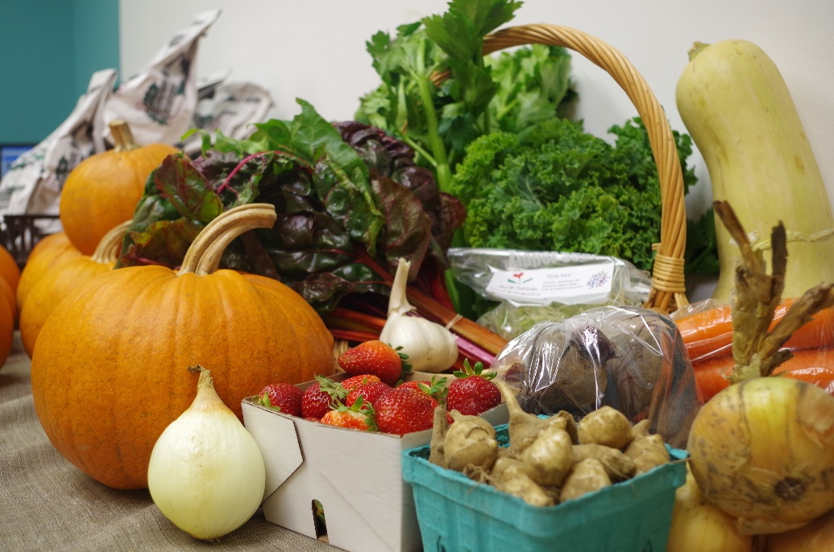
This membership agreement pertains to the 2017 Community Supported Agriculture season, which runs from June 29th to October 19th. By filling out and signing this form, along with remitting appropriate payment, you will become a member of the Eat Local Sudbury Multi-farmer Community Supported Agriculture program.
Why?
By becoming a member of the CSA, you are supporting a group of local farmers; your commitment provides these farmers guaranteed revenue during the growing season.
As a Member you can:
- Suggest vegetables to grow for next season
- Submit recipes to share with fellow CSA members
- Know in advance what produce we are expecting in the following week’s CSA in order to help with meal planning

Application Questions: Please Read Carefully! A CSA is a specific program that is right for some but not for others. If it’s not right for you we’ll have lots of fresh veggies and fruits in the store.
- Are you interested in supporting local farmers (both conventional and ecological) and Eat Local Sudbury by pre-paying for 17 weeks of fresh, seasonal produce for $675 ($39 a week on average)? Circle one: YES NO

Our farmers are a mix of conventional growers and those who follow organic methods-

Ecological growers:
Three Forks Farms (Warren)
Granite Ridge Farm (Verner)
Desbarats Country Produce (Desbarats)

Conventional Growers
John and Susanna Bauman (Massey)
Jonathan & Sheila Gerber (Warren)

You will be receiving produce from a variety of farms, and if crop production is low at the very beginning, or very end of the season, we reserve the right to supplement the box with food from other local farms in order to ensure you are getting the best quality available.

- Will you or someone you know be available to pick up your CSA EVERY Thursday night from 5:00pm-7:00pm from June 29th until October 19th 2017? Circle one: YES NO
Any missed pick-ups cannot be stored and are donated at Eat Local Sudbury’s discretion the same night. If you are unable to pick up your share, we recommend you send a family member or friend.

- Are you feeding 3-4 Veggie Lovers? Circle one: YES NO
We have found that those who felt the CSA had “too much” produce were feeding fewer that 3-4 people and those who felt it had “too little” were feeding more. Please consider the eating habits of your share eaters before purchasing!

- Does the challenge of preparing a different variety of seasonal produce every week make you excited? Circle one: YES NO
Depending on the week you may see some produce you are not familiar with, some you are, and some you may not care for! The important thing is that you are interested in eating it all, or preserving it (through canning, freezing, drying etc.), when there is more bounty than you can eat in a week. Each box will vary depending on the seasonality of produce and conditions. For example, you will generally receive more during our peak period of late August to early September, while the boxes will not be as full early and late in the season.

- Are you able to pay with one full payment or two ½ payments to secure your share of the CSA for the 2017 season? Circle one: YES NO
Full share payment is $675 for the season, or two half payments of $337.50 - the second to be paid by June 1st 2017. Your share is non-refundable. By purchasing a multi-farmer CSA you are committing yourself to helping the local food system. Please understand that the amount of planning and work it takes to grow food cannot be easily changed once the commitment has been made and seeds planted. You are investing in Sudbury’s food production future.

If you answered YES to the five questions above - then the CSA is right for you! If you are unsure about any of them, please ask someone at the co-op before committing to the CSA.
And now the big question: just what is in my share?
Each week approximately 5-12 lbs of 10-20 types of produce will be included in your box. The first few weeks will be a bit lighter, but as the growing season progresses the boxes become quite hefty. Some examples of produce we are planning for the shares (although not all at once and depending on weather), are as follows:

- bush beans
- beets
- broccoli
- cabbage
- carrots
- cauliflower
- corn
- cucumber
- eggplant
- garlic scapes
- cured garlic
- green onions
- herbs - cilantro, oregano, etc.
- kale
- kohlrabi
- lettuce & lettuce mixes
- leeks
- melons
- onions – yellow, red & Spanish
- snap peas
- hot peppers
- sweet peppers
- potatoes – red, white, Yukon gold & new
- pie pumpkins
- radishes
- romanesco
- spinach
- sprouts – pea & sunflower
- squash – buttercup, butternut, delicata, mashed potato, spaghetti
- strawberries
- Swiss chard
- tomatoes – field & cherry
- zucchini

PAYMENT:

You reserve your spot in the CSA when we receive your payment. Once paid, these funds cannot be reimbursed.

- 2017 MULTI-FARMER CSA Payment Options (Check one)

[ ] Pay for $675 share in full
[ ] Pay for share in 2 instalments of $337.50 – one payment to be made before the start of the season and one payment by June 1st, 2017*
*I understand that if I do not pay for the second instalment, I forfeit my right to the share and it will be sold to the next interested party. A $30 late fee may be paid in order to retain your share. Payments can be made by cash, debit, Visa and Mastercard in-store, or online through our website.

Member Information
I have read all of the above and understand the membership agreement.
[Please fill out the following contact information (Please print and make legible)]

Name: _______________________________________________________________________
Address: ____________________________________________________________________
Phone Number(s): _________________________________________________________
Email: _______________________________________________________________________

Other People I am sharing with/or will be picking up the share (we need their emails so they can receive the weekly newsletter and their names so when they come to pick up the share we know who they are!):
#2) Name: ______________________________________________________________________
Phone Number(s): _________________________________________________________
Email: _______________________________________________________________________

#3) Name: ______________________________________________________________________
Phone Number(s): _________________________________________________________
Email: _______________________________________________________________________

#4) Name: ______________________________________________________________________
Phone Number(s): _________________________________________________________
Email: _______________________________________________________________________

Signature: __________________________________________________________________
Date: ________________________________________________________________________

Thank you for supporting your local Food Community!

