You are invited to…
An amazing adventure called a Community Building Workshop
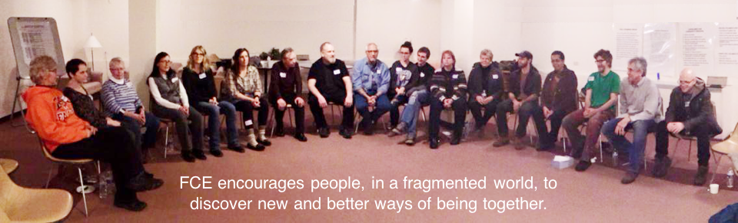

Saturday October 21st and Sunday October 22nd 2017 9am to 5pm
Lamar Community Center, 1488 200th Street, St Croix Falls, Wisconsin 54024
Wheelchair accessible

About The Workshop
At the workshop people gather together to explore how they can connect with others and create a group where everyone is deeply valued, listened to, respected and appreciated - despite the profound differences that exist between them.
People sit in a circle, and trained facilitators guide and challenge the group to see past their differences and reach a state of Community, which is defined as, “A group of two or more people who, regardless of the diversity of their backgrounds, have been able to accept and transcend their differences. They are able to communicate openly and effectively, and to work together toward common goals, while having a sense of unusual safety with one another.”
Origins
M. Scott Peck, author of “The Road Less Traveled,” originated the process of Community Building and created the Foundation for Community Encouragement, a non-profit organization that sponsors the workshops. He described the Community Building process in his book, “The Different Drum.” Thousands of people have attended these workshops and the experience is often moving and transformative.
The Challenge
Community Building is both very challenging and very rewarding. It is challenging to overcome differences, not as an abstract ideal, but as an immediate task to be accomplished with the other people sitting in the same room as you. Papering over differences or pretending they do not exist cannot achieve community -- hence the challenge. Community Building requires determination and persistence.
Reasons to Participate
The aim of the Community Building process is to become a group that has developed a deep sense of acceptance and an appreciation for the uniqueness and worth of every person in the group. In a world where divisions are the cause of so many of our human problems, participating in such an experience is both valuable and rewarding. If you have ever wondered about a viable alternative to differences preventing people from recognizing, respecting and hearing each other, you should consider attending the workshop. You should also consider attending if you would like to find out what it is like when a group fully and unconditionally accepts and values all of its members.

How it Works
The workshop takes place over two days. People sit in a circle, and after an explanation by the facilitators of the Community Building model, the group is then tasked to build itself into a true Community. The facilitators guide the group, but it is the group itself that must find out how to reach the goal of Community. At times this requires the group to explore what are the blocks that prevent it from doing so.
The Adventure
The workshop is an adventure as every group is different and will therefore face its own unique challenges as it builds itself into a Community. It is not possible to say ahead of time what these challenges will be, or how the group will deal with them and resolve them.
Benefits
When the group does become a true Community, it is profoundly moving and uplifting to discover that our differences can be so cherished and appreciated they actually unite the group with a powerful sense of mutual respect and acceptance, rather than dividing it. Community Building provides a direct experience of the possibilities and joys of connecting with other human beings.

Many people come away from the workshop better able to affirm diversity and with greater listening skills. They have an enhanced ability to communicate authentically and to bridge differences with integrity. This can make them more effective in the organizations where they work and serve, by improving their communication skills.
Our Invitation to You
So please join us on an adventure which explores our essential capacity to connect with others and to overcome our differences. Together we can discover and celebrate the glory of the uniqueness of each one of us and the power of our common humanity.

For information please email Jonathan Kahn at: cb.circles@gmail.com
Phone: (715) 203 0114
Information on the October 2017 Workshop: www.cbcircles.wixsite.com/cbcircles
Information on the Foundation for Community Encouragement: www.fce-community.org
~ ~ ~ ~
THE FOUNDATION FOR COMMUNITY ENCOURAGEMENT
The Foundation for Community Encouragement (FCE) is a 501(c)(3) educational, non-profit organization. We are dedicated to the quest for community among people from diverse backgrounds and beliefs. FCE establishes a safe place where common values can be acknowledged and differences can be explored.
We enable individuals, groups and organizations to identify and grapple with the issues that cause divisions between people. We encourage the members of the group to transcend the conflicts that may hamper progress toward accomplishing the goals they are seeking to achieve.
M. SCOTT PECK'S FOUNDING DREAM
There is a yearning in the heart for peace. Because of the wounds and rejections we have received in past relationships, we are frightened by the risk of disarming ourselves. In our fear, we discount the dream of authentic community as merely visionary. But there are rules by which people can come back together, and by which the old wounds can be healed. It is the mission of FCE to teach these rules - to make hope real again - to make the vision actually manifest in a world which has almost forgotten the glory of what it means to be human.
Community Building Workshop Registration Form
Please register me/us for the two day Community Building Workshop happening in
St. Croix Falls, Wisconsin on Saturday and Sunday, October 21st & 22nd 2017, 9am to 5pm
 | Full Name | Email Address & Phone Number
Person #1
Person #2
Person #3
Person #4
Mailing
Address
Workshop Fees
1 person $120. 2 people (same family/organization) $220. 3 people (same family/organization) $330 4 people (same family/organization) $400. 5+ people - $100 per person.
OR
I / we want to apply for the discounted $50 scholarship rate. Check this box:
To register and pay by credit card please go online to: www.signmeup.com/121601

Workshop fees $ __________
Donation to the scholarship fund (optional) $ __________
Total Enclosed $ __________
Please make checks payable to: “St. Croix CBW”
Mail registration form & check to:
Jonathan Kahn, CBW, 310 South Avenue, Apt 6, Osceola, WI 54020.

