
Working Together to End Youth Homelessness in Canada

Vision Paper

June 9, 2015

On the name, A Way Home
The name A Way Home speaks to our belief that all young people should have a home. For young people who become – or are at risk of becoming homeless – A Way Home is meant to convey the message that we should all work together to ensure that young people are supported in finding a way to the home that makes most sense for them – whether this is their parental home, their own place, or some other arrangement that offers safety, belonging and an opportunity to move forward with their lives.
The inspiration for the name comes from the work the community of Kamloops has done to develop and implement a youth homelessness strategy. Kamloops was identified in 2012 as a pilot site in the national Mobilizing Local Capacity to End Youth Homelessness Program (MLC). Nearly 2 years of research and community consultations followed, led by the City of Kamloops, Thompson Nicola Cariboo United Way, the Kamloops Homelessness Action Plan, and the Kamloops Aboriginal Friendship Society in partnership with the National Learning Community on Youth Homelessness, Eva’s Initiatives, the Canadian Housing and Renewal Association and with financial support from the Catherine Donnelly Foundation. In the spring of 2014 the plan to end youth homelessness in Kamloops was completed. Three potential names were put forward by the Kamloops HomeFree Council, and ‘A Way Home’ was chosen to represent the plan. The Youth Supportive Housing Committee was approached, and unanimously voted to adopt ‘A Way Home: A Plan To End Youth Homelessness in Kamloops’ as their own guiding framework. The committee also changed their name to A Way Home to reflect the connection to the plan.
This name has since been taken on by the national coalition, which seeks to support communities and governments across Canada in the development and implementation of plans to prevent, reduce and end youth homelessness.

A Way Home
Working Together to End Youth Homelessness in Canada
Overview
Youth homelessness is a national tragedy. On any given night in Canada, there are over 6,000 young people who experience homelessness and either sleep out of doors or access emergency shelters. An even greater number are part of the hidden homeless population and ‘couch surf’ by temporarily staying with family or friends.
Youth homelessness is not acceptable in a caring society. Falling into homelessness and becoming entrenched in the street youth lifestyle means a heightened risk of exploitation, violence and victimization. Life on the streets is inherently stressful, and mental health problems and addictions often ensue. The longer a young person is entrenched in the street youth lifestyle, the harder it is to get off the streets and move forward with her/his life. For many of the chronically homeless adults we see on the streets today their homelessness began when they were young.
As a society we have perhaps become complacent, even indifferent to this problem. While most of us recognize the importance of helping our youth navigate the path to adulthood by providing them with safety, mentoring and support, education and opportunities to fulfill their dreams, we often stop short of extending these supports to young people who become homeless. It is not enough to simply provide emergency supports like shelters and day programs for these youth. We must do more, and we can do more.
A Way Home is dedicated to preventing, reducing and ending youth homelessness in Canada. Ending youth homelessness means doing things differently. A Way Home will inspire and facilitate change by promoting effective strategies that shift the focus away from an emergency response to one of prevention (stopping young people from becoming homeless in the first place), while helping those who do become homeless move into housing with supports as rapidly as possible, in a safe and planned way. This can only be done through effective community planning, service integration and alignment of strategies and resources for maximum impact at the national, provincial and community levels.
In bringing together leading national and regional organizations as well as committed individuals as part of a coalition, A Way Home will help communities make the shift to preventing, reducing and ending youth homelessness through a coordinated constellation of strategic and practical resources, activities and supports, and consultations with national, regional, local and Aboriginal governments to develop, fund and implement effective solutions to youth homelessness.
With the right strategies and commitment, we can end youth homelessness in Canada.

Addressing youth homelessness
Youth homelessness, while a seemingly intractable problem, is one we must urgently address. Approximately 20% of all homeless people in Canada are between the ages of 13 and 25. This means that over the course of the year there are between 35-40,000 young people who experience homelessness, and on a given night at least 6,000. There are no indications that the situation is getting any better. To tackle the problem, we must begin by recognizing that youth homelessness is distinct from adult homelessness in terms of it causes and conditions, and therefore so must be the solutions.
As Canadians, we all agree that adolescence and young adulthood are crucial periods in anyone’s life. This is when youth experience important developmental changes, where they learn new things and develop adult skills and relationships. The transition from youth to adulthood is in fact a critical time of transformational change.
The experience of homelessness can disrupt all of this. Many young people become homeless after experiencing considerable family conflict, which may include physical, emotional or sexual abuse. Once on the streets, things do not necessarily get better; they can get worse.
Many homeless youth struggle with developmental and attachment issues that make their transition to adulthood more challenging. They have never lived independently or developed critical life skills. In turn, the economic and social factors related to shifting our response to youth homelessness are vast.
The longer we let young people become mired in homelessness, the more they are exposed to the risks of sexual and economic exploitation, the more likely they are to experience trauma, declining health and addictions, and the greater the difficulty they will have in leaving the streets. Once on the streets it is not long before young people become entrenched in the street youth lifestyle. The long term consequences are considerable, including:
• Increased risk of exploitation, violence, victimization, physical and sexual abuse.
• Greater involvement with the police and the justice system.
• Disengagement from school and difficulty obtaining employment.
• Stress, depression, anxiety disorders and suicide.
- Increased use of substances to cope
While many young people are able to move forward with their lives because of their incredible strength and perseverance, this is not the case for all homeless youth and many require additional supports and services in order to end their homelessness. If we believe that all young people, regardless of their background, deserve necessary supports and opportunities in order to transition into adulthood and well-being, then we have to tackle youth homelessness head on.

Preventing, reducing and ending youth homelessness
We believe that it is possible to prevent, reduce and ultimately end youth homelessness. When we say this, we do not mean that there will never be young people forced to leave home in a crisis who will need emergency supports and temporary housing. There will continue to be people in both urban and rural areas who must leave home because of family conflict and violence, eviction or other emergencies, as well as those who simply face challenges in making the transition to independent living. Rather, ending youth homelessness means eliminating a broad social problem that traps young people in an ongoing state of homelessness.
When young people and their families do not have access to necessary supports, homelessness is often a result. Many young people are forced to leave their communities, and, without access to permanent and age appropriate housing and necessary supports, come to depend on emergency services. Becoming mired in homelessness often leads to exploitation, declining health and wellbeing, and most certainly an uncertain future. Without appropriate prevention strategies or early interventions that help young people get off the streets as quickly as possible, we may be entrenching them in a lifelong struggle with poverty, addiction and mental health challenges. We also know that repeated cycles of youth homelessness can lead to chronic adult homelessness. To ensure that young people do not become trapped in homelessness, we must stop their “transition” into adult homelessness and ultimately into a life-long reliance on the adult social service sector.

Our Vision
We can prevent, reduce and end youth homelessness in Canada if:
- The general public and decision-makers understand that youth homelessness can and must be ended.
- We adopt a Family First philosophy and ensure that young people and their families have access to the necessary resources and supports to reduce the risk of homelessness.
- All responses to youth homelessness, including Housing First, must be conceived, planned and implemented based on the needs of the developing adolescent and young adult.
- Communities, governments, organizations and interested individuals work together to support change.
- Necessary resources – including affordable housing and youth focused supports – are implemented and lead to solutions to youth homelessness.
- Young people are engaged as active partners in developing solutions to youth homelessness.

Why we need to do this
One thing Canadians from all walks of life can agree on is the need to support young people – all young people – as they move through life. This means providing adult direction, mentoring and support. It means listening to young people and helping them follow their dreams. It means allowing young people to take chances and learn from their mistakes. Because we often speak of young people as our future, investing in them is crucial. For instance, we know education is critically important for young people as it helps them get jobs, build careers, develop and achieve their academic potential, realize their dreams, and live a fulfilling life. Overall, we support young people to succeed in school, engage in their communities of choice, participate in sports and/or the arts and experience nature.
Young people who are homeless are no different, nor are they someone else’s problem. While they face many challenges, they bring incredible strengths, resilience, ideas and hope that should be drawn upon to contribute to their own pathway off the streets.
Every young person deserves the chance and opportunity to live a fulfilling life, and every family should be supported to make this happen. When young people become homeless, much of this is put in jeopardy. It is unacceptable in a caring, affluent society for youth homelessness to exist. In the instances where youth do lose their housing, we need to work quickly to ensure they receive the accommodation and supports necessary to move them into adulthood in a healthy, safe and planned way and that also prevents repeat episodes of homelessness. Expecting a homeless youth to act with the knowledge and independence of an adult before they have the necessary skills to do so is not a viable response to their homelessness. Allowing young people stay mired in homelessness for any length of time undermines their ability to move forward, and can have lifelong consequences in terms of health, employability and involvement in the justice system. Our lack of action is most certainly creating a bigger problem: if we do not deal with youth homelessness today, many of these youth will become the chronically homeless adults of tomorrow.
Done well, a strategy to prevent, reduce and end youth homelessness will impact on the broader homelessness problem. We will reduce the likelihood that young people who are homeless become the chronically homeless adults of the future. By supporting healthy transitions into adulthood, participation in education and community engagement, we are investing in health and wellbeing, enhanced employability, and reduced risk that young people will rely on benefits and supports as they age. There is a longer-term return on investment that is potentially quite considerable, if we effectively shift our focus away from an emergency response.
In moving towards a national strategy to prevent, reduce and end youth homelessness, the good news is that we already know what to do. Good ideas are out there; many successful and impactful solutions and approaches have already been developed and implemented. It is time to mobilize this knowledge through the support of our coalition of leaders all across the country. Backed by a commitment from all levels of government, we can achieve collective impact by helping communities develop and implement effective plans and strategies to prevent, reduce and end youth homelessness. While coordinating an investment to end youth homelessness may seem expensive, helping young people get an education, integrate into the community and live a good life will save untold dollars in the long run. There are few who would argue against the importance of investing in our youth, and the pay off for helping young people avoid long-term homelessness is considerable. Allowing youth homelessness to exist is not necessary, and no longer acceptable.

A plan to prevent, reduce and end youth homelessness
Ending youth homelessness means doing things differently. A strategy to end youth homelessness means shifting from the historical reliance on emergency services, to include a more balanced focus on prevention and helping young people who do become homeless get access to the kind of housing and supports they need.
How do we get there?
A Way Home is a national coalition dedicated to preventing, reducing and ending youth homelessness in Canada. Through a model of partnership and collaboration, we engage in action directed towards inspiring and enabling communities and all levels of government to organize, plan and implement strategies to address youth homelessness in a co-ordinated, measurable and impactful way. By strengthening families and building the assets and resilience of youth, we can help young people avoid homelessness and make a healthy transition to adulthood.
Key elements of a strategy to prevent, reduce and end youth homelessness:
- Communities adopt strategic and coordinated plans to prevent, reduce and end youth homelessness aligned with broader strategies to end homelessness.
Effective plans need to set targets for the reduction of youth homelessness, and clearly outline strategies, programs and interventions that will lead to that result. Outcomes of plans should focus on:
- Increased housing stability for youth through rehousing (housing first for youth) or family reunification.
- Increased resiliency in young people and their families.
- Prevention of youth homelessness through school-based programming and enhanced family and natural supports.
- Access to education, income and employment opportunities.
- Effective models of accommodation and support that give young people options and choice in how they move forward with their lives.
- Healthy transitions to adulthood.

- Coordinated and integrated ‘systems of care’ are in place to ensure young people have access to the necessary youth-specific supports needed to move forward with their lives.

- Models of support are based on an understanding of the needs of developing adolescents and young adults.
- Youth homelessness, both in terms of its causes and conditions, is distinct from adult homelessness, and therefore so must be the solutions.
- The goal is not solely the transition to independence, but the empowerment of young people to achieve their full potential in their transition to adulthood and wellbeing.
- Supporting families through the Family First philosophy will help many young people in this transition.

- All levels of government work together to align policy and funding to support an end to youth homelessness

- Research, data gathering and information sharing support the planning, implementation and evaluation of effective, evidence-based solutions.

How we will work to end youth homelessness in Canada
Change at a national level rarely happens on its own. We do know that we cannot continue to rely on small-scale innovation at the local level to underpin our efforts, and for too long have lived with a partial, ad-hoc and fragmented response to youth homelessness.
A Way Home supports a new way of addressing the problem of youth homelessness. By bringing together leading national and regional organizations, as well as committed individuals, A Way Home will inspire and facilitate change by promoting effective strategies that move away from simply ‘managing’ the problem of youth homelessness through emergency services, to a more proactive approach that focuses on prevention (stopping young people from becoming homeless in the first place) and helping those young people who are homeless move into housing with supports as rapidly as possible and in a safe and planned way. This can only be done through effective community planning, service integration and alignment of strategies and resources for maximum impact at the national, provincial and community levels.

Leadership, inspiration and action for change!
A Way Home will help communities make the shift to preventing, reducing and ending youth homelessness through a coordinated constellation of strategic and practical resources, activities and supports, and consultations with national, regional, local and Aboriginal governments to develop, fund and implement effective solutions to youth homelessness.
The national partners of A Way Home will work together to achieve clear outcomes. As A Way Home evolves and our knowledge base expands, this constellation of activities will likewise evolve to better support the process of change. Communities, organizations and individuals across the country will contribute to this knowledge base, and participate in the mobilization activities.
In order to achieve the goal of preventing, reducing and ending youth homelessness, the partners of A Way Home are charting a critical path through a robust planning process. The actions of A Way Home are guided by a bold and achievable vision and carried out through a well considered constellation of activities, each of which with clearly articulated goals and objectives, and necessary funding in place to ensure success.

Preventing, reducing and ending youth homelessness will be achieved through:
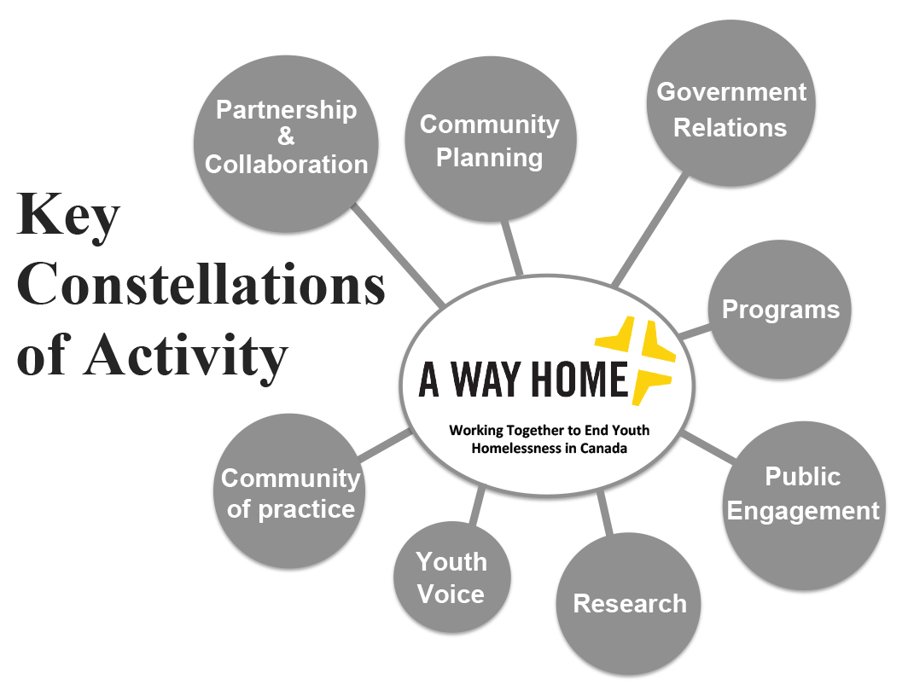
- Partnership and Collaboration: A Way Home will create a national forum to inspire, engage and mobilize those who are committed to preventing, reducing and ending youth homelessness. Our work is organized around the concept of collective impact, meaning that multiple organizations work collaboratively (while putting their own agendas aside) to develop a common vision and agenda for change. Working together at the national, regional and local levels with governments, public and private community partners, funders and concerned citizen, we will have a greater opportunity to achieve the goal of ending youth homelessness.
- Community Planning: A Way Home will actively help local communities mobilize, plan, implement and sustain effective, evidence-based and measurable strategies to prevent, reduce and end youth homelessness. This will involve building the capacity of the sector as a whole and communities in particular to deliver on the promise of preventing, reducing and ending youth homelessness. Young people, and especially those with lived experience of homelessness, will necessarily be part of this process.
- Government Relations: A Way Home will employ a government relations strategy at the national, regional and local levels that advocates for policy frameworks and the funding necessary to support the planning and implementation of strategies that address youth homelessness in communities across the country. We will also work to support the inclusion of youth focused strategies within federal and provincial plans to end homelessness.
- Programs: A Way Home will help communities implement successful program models (in areas such as prevention, employment, and models of housing and support, for instance) necessary to achieve our goal of ending youth homelessness. We will develop resources and provide technical support on the planning and implementation of successful program models.
- Public Engagement: A Way Home will raise public awareness about the causes of youth homelessness, and importantly, the solutions.
- Research: A Way Home will implement a research agenda that supports the conceptual framing of solutions, gathering of data for effective planning, and development of tools to facilitate the change across the country.
- Youth Voice: A Way Home will engage young people with lived experience of homelessness in all issues related to planning, policy and practice at the community, provincial and national levels. Opportunities for participation will be driven by, and meaningful to young people.
- Community of Practice: A Way Home will enhance meaningful and sustainable local capacity through the development and maintenance of a Community of Practice. Communities will share effective planning and implementation strategies and practices, as well as innovative and evidence-based program models that support plans to prevent, reduce and end youth homelessness.

Who is part of A Way Home?
A Way Home is a non-partisan partnership open to individuals and organizations from across the country dedicated to preventing, reducing and ending youth homelessness. The work of A Way Home is achieved by building on existing strengths, community engagement and innovation, and a strong commitment to ending youth homelessness that is emerging across the country, and alignment of the strategies and resources of leading players seeking to address homelessness in Canada. We are calling on national, regional and local partners, individuals and organizations working with young people, decision makers and funders, as well as interested members of the general public to come together to help end youth homelessness in Canada. Because of how greatly they are affected by homelessness, Aboriginal Peoples and Aboriginal organizations will be involved in all aspects of the work of A Way Home. Founding members of A Way Home include:
National partners
- Canadian Alliance to End Homelessness
- Canadian Housing and Renewal Association
- Canadian Observatory on Homelessness
- Eva’s Initiatives
- Funders Table (Catherine Donnelly Foundation, Home Depot Canada Foundation, etc.)
- National Learning Community on Youth Homelessness
- Raising the Roof

Supporting A Way Home
We invite public and private organizations and individuals to become members of A Way Home and support the work of preventing, reducing and ending youth homelessness in Canada.

