St. Paul’s College
3015 4th Street NE
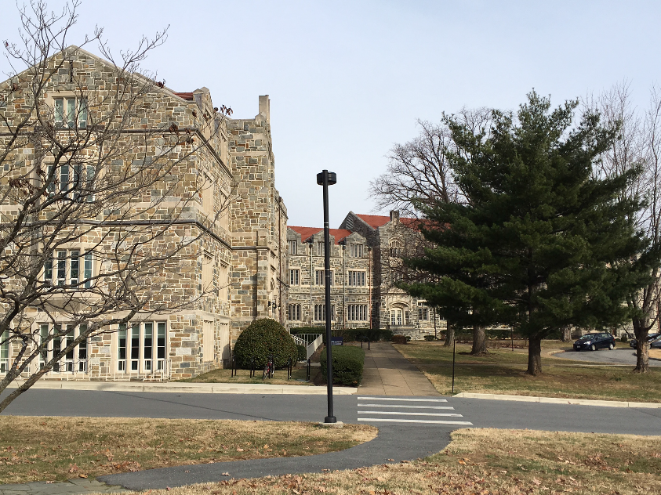
Sponsoring Organization: DC Preservation League

Date Constructed: 1913-1958

Period of Significance: 1914-1958

Architect: Frederick V. Murphy and Walter Olmsted

Summary Statement of Significance:
St. Paul’s College is one of the more impressive academic/seminary campuses surrounding the Catholic University of America. The original 1913 building (now expanded) was designed by master architect Frederick V. Murphy and Walter Olmsted. They co-designed some of the most significant Catholic and university structures in the Mid-Atlantic, some of which are listed on the National Register. St. Paul’s is a prime House of Study serving Catholic University. It qualifies for DC Criteria D (architecture and urbanism), E (artistry), and F (work of a master), and similar National Register Criterion C because of its design and being the work of master architects.
The building is also significant under DC Criterion B (history) and similar National Register Criterion A. St. Paul’s is the only House of Studies built by the Paulists in their history. The Paulists assured the finest quality architecture for their Washington House and sent to it their best instructors. The Paulists were the first order to affiliate with CUA and remain a presence there today. It is one of the establishments that brought the moniker “Little Rome” to the neighborhood.
St. Paul’s College Facts:
- Master architects Fredrick V. Murphy and Walter Olmsted designed the campus in Collegiate Gothic style, using stone, brick, and steel. The linked structures comprising the single building are two and three stories, with elaborated stone entrances and windows.
- Construction of the original campus occurred during the 1910s. The final expansion concluded in 1958. The buildings are all joined to appear as a single unit to the casual observer.
- The campus is set on a large open space, of which a front lawn and flanking woods remain.
- The building retains excellent integrity. The original architecture is intact with minimal exterior alterations.
- Murphy and Olmsted likely designed the campus’ first and second expansions (1930, 1942) given their active portfolio and the seamless design of the work matching the earlier building. The final expansion (1958) was the work of prominent regional church and academic buildings architect Paul Gaudreau.

DC Inventory – Landmarks Nomination Process
DC Preservation League (DCPL) is a non-profit, member supported organization dedicated to historic preservation advocacy and education. It is not part of the DC Government, Historic Preservation Office, or Historic Preservation Review Board.
DCPL regularly nominates buildings to the DC Inventory. Listing on the DC Inventory protects the building against demolition. Additions or major exterior alterations to a listed building must be proposed to and approved by the Historic Preservation Review Board (HPRB).
Listing on the DC Inventory does NOT mean that a building can never be changed. Rather, proposed changes undergo design review to ensure that changes are compatible with the historic fabric of the structure, while allowing the structure to be usable in the present. Routine maintenance and painting of any building in DC are not subjected to HPRB review and do not require permits.
The process DCPL follows when nominating a building to the DC Inventory such as St. Paul’s College is:
-A nomination that describes the building’s architecture and historic significance is written and submitted to DCPL’s Board of Trustees. The Board votes on whether or not to proceed in filing the nomination with the city. If the Board votes in favor the DCPL staff moves forward.
-DCPL sends a letter to the building’s owner, as well as the DC Historic Preservation Office (HPO), Advisory Neighborhood Commissioner, and ANC Single Member District in which the building is located. This letter explains DCPL’s intent to file the nomination and the site’s significance. DCPL provides time for the owner to respond and discuss the proposed nomination with DCPL’s Executive Director.
-DCPL submits the nomination to the DC HPO. Staff at HPO review the nomination for completeness. If the nomination is satisfactory, HPO adds it to the list of pending nominations and notifies DCPL and the building’s owner of the building’s status. The building is now protected like a listed site until the HPRB hears the case. A list of the pending nominations is on HPO’s website.
-HPRB generally meets twice a month. Typically, cases are heard within 60 days of the nomination’s filing. However, the city determines when to schedule cases for review.
-Once the building is put on the HPRB calendar for review, this information appears on HPO’s website. The time and place of the hearing are included on the publicly available agenda.
-The case goes before the HPRB. DCPL presents the case for designation at this public meeting. The meeting is also live broadcast on HPO’s website. Anyone can watch or attend. HPO, the building’s owner, the ANC, and members of the community speak at the hearing in favor of or opposition to the nomination. Those who cannot attend in person may submit letters supporting or opposing designation.
-HPRB determines whether or not to list the building on the DC Inventory by majority vote. There are nine members of the HPRB, each appointed by the mayor. They are a mix of architects, architectural historians, a historian, an archaeologist, and citizen members.
-If HPRB votes in favor of listing the site, it is added to the DC Inventory and protected against demolition and major alteration without review. It is also forwarded for review for inclusion on the National Register of Historic Places (a largely honorary designation). If HPRB votes against listing the site, it does not become a designated historic landmark and is not protected against demolition or alteration.

