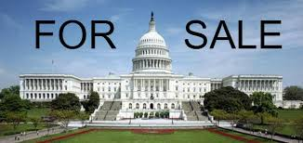
www.GetMoneyOutMD.org
Get Money Out
www.facebook.com/GetMoneyOutMD
410-849-0670

How to Get Big Money Out of Politics
by Amending the Constitution

The Problem
Income inequality and rigged campaign finance rules form a vicious cycle – only those with access to big money can get elected and then governmental action favors donors’ interests. Only 0.18% of households give 65% of campaign contributions. (OpenSecrets.org.)

Dark money is growing at an alarming rate (see graph, below). Citizens don’t know what economic interests back candidates and campaign ads.

“[E]conomic elites and organized groups representing business interests have substantial independent impacts on U.S. government policy, while mass-based interest groups and average citizens have little or no independent influence.” (Gilens and Page, 2014.)

Since 2010, 22 states passed laws to suppress voting by restricting registration drives, limiting registration locations, curtailing early voting periods, carelessly purging voter rolls, requiring voter IDs, and disenfranchising ex-felons. (Washington Post, June 17, 2014.)

Judicial Elitism
The U. S. Supreme Court has absolutely capsized several precedents and state laws, effectively saying that money is equivalent to speech and that corporations and the ultra-rich have the right to drown out the voices of average citizens.

Citizens United v. FEC (2010) granted corporations unlimited political speech rights.

The core of Maryland’s campaign finance laws – aggregate limits – was struck down by the U. S. Supreme Court in the McCutcheon decision in Apr. 2014.

The Supreme Court has said in three cases (Bush v. Gore, Richardson v. Ramirez, and Alexander v. Daley) that there is no Constitutionally-guaranteed right to vote.

Our Solution
We work in the Maryland General Assembly to apply to Congress via Article V of the US Constitution for a convention of the states to draft the 28th Amendment. Our resolution limits the scope of the convention to these 3 topics: 1) “affirm every citizen’s individual right to vote,” 2) “reject the doctrine that artificial entities have inalienable political rights,” 3) “regulate campaign contributions and electioneering expenditures. . . .”

Public opinion is on our side. We expect to win in the 2015 session. Read on

www.GetMoneyOutMD.org
Get Money Out
www.facebook.com/GetMoneyOutMD
410-849-0670

How We Work
We know Congress is totally stalemated and bought by corporations and the ultra-rich. With our approach, We the People can bypass Congress to amend the Constitution.
- Get Money Out (AKA GMOM) is affiliated with Wolf PAC (www.wolf-pac.com), which is working nationwide in state legislatures to call for the convention.
- Everyone at GMOM is 100% volunteer, and we do not spend time fundraising.
- Our main work is to have constituents contact delegates and senators. We have various ways of recruiting volunteers and of targeting people who we think would be likely to do that. We are focused on garnering majority support in both chambers of the Maryland General Assembly

Our Progress
VT and CA have passed convention call resolutions.

Our resolution, backed by powerful sponsors and 35 co-sponsors, was reported favor-ably in a bi-partisan Senate Committee by a vote of 9-2 and passed second reader.

Our support is strong and growing: hundreds of active volunteers, plus key organizations such as Progressive Maryland, NAACP, Working Families, CROP, Chesapeake Climate Action Network, and Unitarian Universalist Legislative Ministry.

Public Opinion
Voters are angry and cynical, but free and fair election reforms are popular with Independents, Republicans, and Democrats.
- In an August 2012 poll by AP and Roper, 67% support limits on the amount of money individuals can contribute to campaigns for federal office, and 83% think there should be limits on the amount of money corporations, unions and other organizations can contribute to outside organizations trying to influence campaigns for federal office. (AP-National Constitution Center Poll, p. 21.)
- 79% of voters in a June 2013 Gallup Poll would vote for a law that would put a limit on the amount of money candidates for the U.S. House and Senate can raise and spend on their political campaigns. Gallup also found “10% confidence in Congress – the lowest for any institution that we have tested in our Gallup Poll history.” (Campaigns, Congress)
- A July 2014 poll (by Greenberg Quinlan Rosner) of the 12 states where control of the US Senate is being contested, “shows that voters of all political persuasions . . . are ready to vote” for reforms, including “a constitutional amendment to overturn Citizens United” as well as “public matching funds for candidates that reject large donations.” (Democracycorps.org)

www.GetMoneyOutMD.org
Get Money Out
www.facebook.com/GetMoneyOutMD
410-849-0670

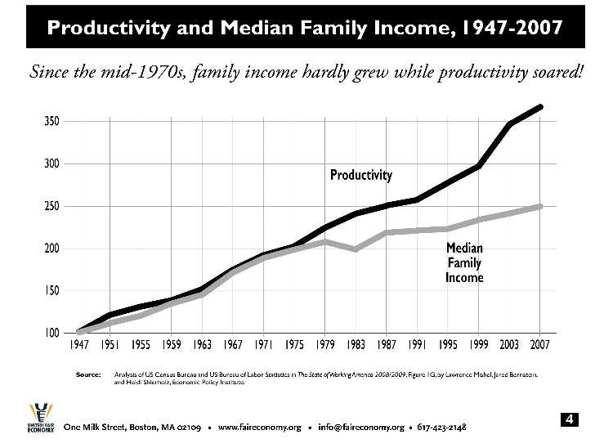
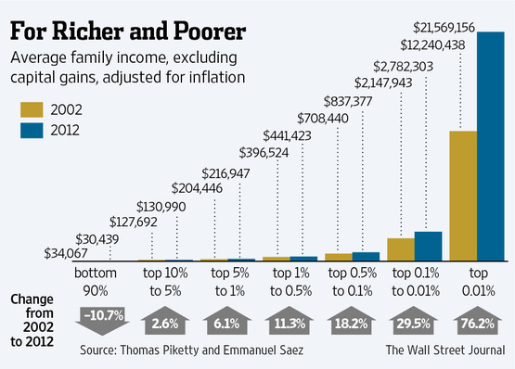
“Independent Expenditures” by Disclosure Status (Excluding Parties) – Millions of Nominal Dollars, Opensecrets.org

“Only” $6.25 billion spent in 2-year 2012 federal election cycle, but two years of corporate profits is over $3 trillion – a factor of 500-1. The torrent of money has barely begun to flood the system.

