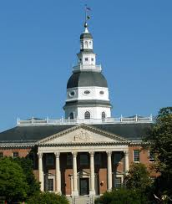

Big money is the “first problem” in U. S. politics. A tiny wealthy elite and multi-national corporations and the politicians who spend 5 hours per day dialing for dials have a collective stranglehold in our representative democracy. Citizens United (January 2010) exacerbated an already dreadful situation and reinforced the spurious concepts of “corporate personhood” and “money is speech.” This is why we cannot make progress on health care, environment, poverty, war, and a host of other problems.

We the People must address this threat with an amendment to the Constitution and can do so most effectively by asking our state legislatures to call for a convention of the states. When 34 states ask for a convention on the same topic, Congress must call one. State legislators are, generally, much more accessible than members of Congress who must (in order to remain in Congress) work on fundraising 5 hours every day. Nancy Pelosi attended 400 fundraising events in 2011.

“Independent Expenditures” by Disclosure Status (Excluding Parties) – Millions of Nominal $
Opensecrets.org

Get Money Out – Maryland
(www.getmoneyoutmd.org) has organized the effort in Maryland, and we have partners in about 40 other states. We have grown from 6 people to 600. Here is our progress:

- SJ 6, introduced by respected constitutional scholar Sen. Jamie Raskin and 10 co-sponsors, was heard in the Senate EHEA Committee on Feb 27. The reception was encouraging. We are optimistic that we have the votes to bring it to the floor.
- Ways and Means Chair Sheila Hixson and 26 co-sponsors have introduced the companion resolution HJ 7 in the House of Delegates. It will be heard on March 3. We are contacting Delegates on the Rules Committee to gather support.
- Well over 80% of the public favors regulating money in politics.
__________________________________________________________________________________________
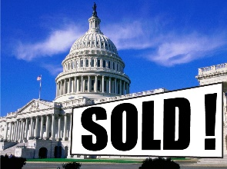
TO CONTACT YOUR DELEGATES AND SENATOR: Go to http://mdelect.net, enter your address, and click on the name of the Senator and Delegates for contact info.
Message: “Please support resolution SJ 6/HJ 7 sponsored by Sen. Raskin/ Del. Hixson to have a convention of the states process to draft the 28th Amendment to restore free and fair elections by protecting the freedom to vote and getting big money out of politics.”

