The
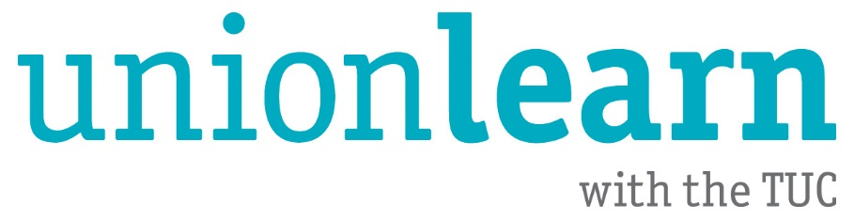
guide to

FREE

Online Learning

Most people don’t realise it, but if you want to learn something, there are lots of free courses available online. These cover many subjects and are delivered at all levels. So why not check out some of the options available? One of them might just be what you are looking for!

https://skillcheck.unionlearn.org.uk/

SkillCheck is unionlearn’s free online assessment tool. Test your skills in key areas!

- The assessments are available as an app on your phone or on a computer | - These are not courses. After you’ve found out your level, you’ll have to identify a suitable course to help improve it
- Quality initial assessments in maths and English

https://www.khanacademy.org/

Khan Academy is a non-profit educational platform created by Salman Khan with the goal of creating a set of online tools that help educate students.

- The courses are basic, interactive and very easy to use | - The choice of courses is weak on the arts and social sciences
- You can earn a variety of astronomically themed badges through your learning  - The choice of courses is strong on maths, the sciences and economics  - Some great basic courses | - The courses are not accredited

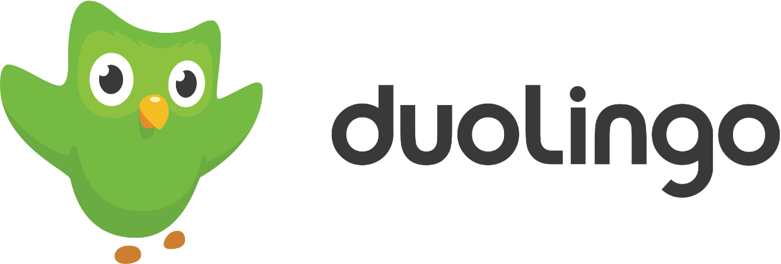

https://www.duolingo.com/

Want to learn a language? Then Duolingo might be the right site for you. Duolingo offers free online courses in 36 languages from Hindi to High Valyrian.

- Duolingo test your level when you start so you don’t have to relearn what you know already | - Because the course progresses with you, there’s no completion date or certificate at the end
- The course uses a daily digest system and the level progresses as you progress | - Courses are not accredited
- It’s available as an app on your phone

http://www.open.edu/openlearn/

OpenLearn is the Open University’s free online learning site. Courses are mostly extracts from real OU courses.

- The courses are of a high standard and contain interactive elements (e.g. videos) | - There are few really basic courses
- When you complete a course you can print off a free, quality certificate with the Open University logo on it | - The range of courses is good but does not cover everything. Some of the courses can be a bit specific
- New courses constantly being added | - Courses are not accredited

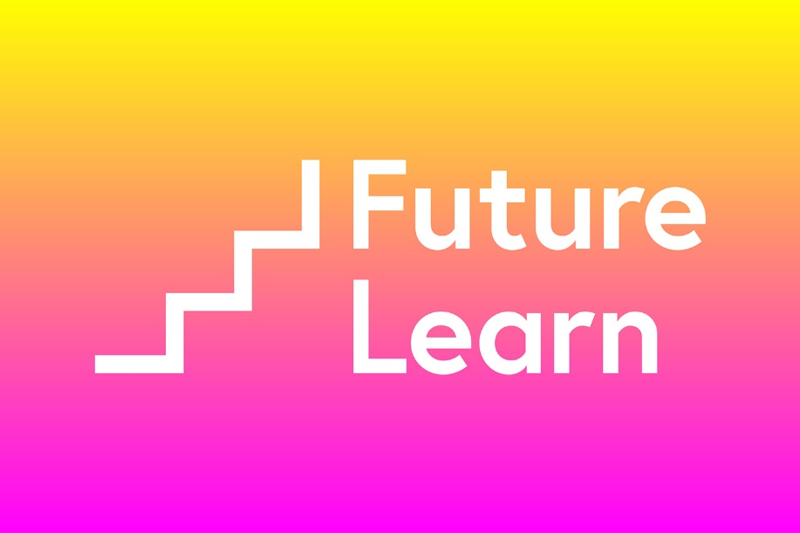

https://www.futurelearn.com/

FutureLearn is also run by the Open University, although in partnership with other universities around the world. So, for example, you can learn about Korea from Korean experts.

- The courses are of a high standard and contain lots of interactive elements (e.g. videos) | - There are few really basic courses
- Courses are run by different universities around the world so you are really taught by the experts | - The range of courses is good but does not cover everything. Some of the courses can be a bit specific
- New courses constantly being added | - Courses are mostly not accredited although some accredited options exist (if you pay)
- There’s support from real tutors and lots of student discussion on the message boards | - The courses are only free for a limited time. For permanent access and a certificate, you have to pay. There are course-only and full-year payment options
- If you do choose to sign up, the certificates are very high quality

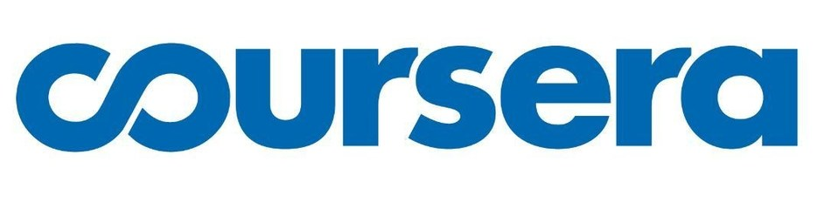

https://www.coursera.org/

Coursera is almost identical in concept to Futurelearn. High-quality courses from revered academic institutions worldwide.

- The courses are of a high standard and contain lots of interactive elements (e.g. videos) | - There are few really basic courses
- Courses are run by different universities around the world so you are really taught by the experts | - The range of courses is good but does not cover everything. Some of the courses can be a bit specific
- New courses constantly being added | - Courses are mostly not accredited although some accredited options exist (if you pay)
- There’s support from real tutors and lots of student discussion on the message boards | - The courses are only free for a limited time. For permanent access and a certificate, you have to pay
- If you do choose to sign up, the certificates are very high quality
- There is an option on some courses to go for ‘Honours’ status (if paying). By doing extra work and assessment, you can get this higher status

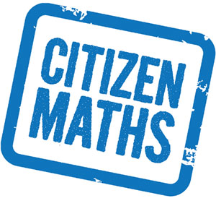

https://www.citizenmaths.com/

Citizen Maths is a free, online Level 2 maths course.

- The course is of a high standard and can really help you with your maths issues | - It is only available at Level 2 (equivalent to A*-C in the old GCSEs)
- When you complete a course you can print off a free statement of participation as proof of your learning | - The course is not accredited

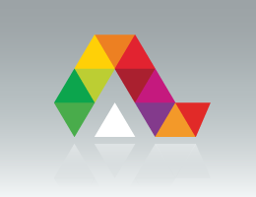

https://alison.com/

Alison is the largest provider of free online learning. They have courses on absolutely anything you want.

- The range of courses is unbelievable. If no one else offers what you’re after, Alison probably will | - Some courses have typos and errors in them. The quality is not as high as with other providers
- When you complete a course you can pay for a certificate | - Alison is not a British provider which means that you need to be careful. Any course discussing the law may well be inaccurate for British users as they use American law and terminology
- New courses constantly being added | - Courses are not accredited
- Courses include tests which you must pass to check learning | - Some browsers have problems accessing Alison courses
 | - You have to pay for your certificate at the end of the course

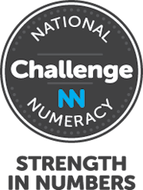

www.nnchallenge.org/unionlearn

The National Numeracy Challenge is all about maths and making it accessible. The site has both an initial assessment and maths courses

- You can assess your maths skills before you start and then learn what you need to | - Only maths on offer here – for anything else look elsewhere!
- When you complete a course you can print off a free certificate | - Courses are not accredited
- Specially designed for people who find maths a bit daunting
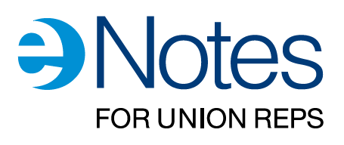

https://www.tuceducation.org.uk/

Are you a union rep or someone who wishes to learn about issues at work? If so then the TUC’s eNotes are for you.

- The courses are of a high standard and contain interactive elements (e.g. videos) | - These generally cover subjects connected with life at work only.
- When you complete a course you can print off a free certificate | - eNotes are not accredited
- An extensive range of notes already and new eNotes constantly being added

And remember, if you need any further assistance with your learning needs, then do not hesitate to contact your Union Learning Rep (ULR) or us here at unionlearn on ulweb@tuc.org.uk

Happy learning!

Remember to follow unionlearn on Facebook for lots of exciting updates and information!
https://www.facebook.com/tucunionlearn

Remember to follow unionlearn on Twitter
@unionlearn

Updated 17/03/20

