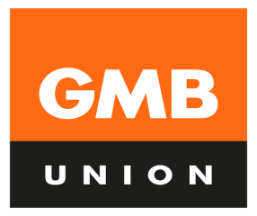
GMB@WILKO
your voice in Wilko

Bulletin No 11 - April 2020
WILKO – CORONAVIRUS UPDATE
Dear Members

We’ve been having conference calls with management and we’ve raised issues given to us by GMB members and reps on a daily basis. Here’s a summary of the matters we spoke to management about last week:
- Team members’ fears about being at work when government is advising people to stay at home and stay safe.
- Extending the 12 week payments to other vulnerable groups (Wilko says this will be too costly, but they will look at this on a case by case basis)
- Hand sanitizer, (Wilko says this is in and should have been distributed)
- Selling of essential & non- essential items
- Social distancing – implementation and adherence
- Store marshals
- Sneeze guards (Wilko says these will be fitted between 4th & 9th April)
- DC turnstiles
- Masks
- Childcare & Furloughing

If you have health, safety and welfare concerns raise them with management. If your issues don’t get resolved in store, raise them with GMB. Keeping team members safe must be management’s priority.

Please speak to your GMB rep or regional organiser if you need assistance. You can join GMB online www.gmb.org.uk

Recognition & Reward
Retail and distribution workers are on the front line in these unprecedented times and like other employers have already done, Wilko should recognise and reward team members for the work they are doing during the coronavirus outbreak.

Wilko has increased pay rates for the lowest paid in line with national living wage as required by law. But, as these workers have shown through the coronavirus crisis, they deserve more than the minimum wage, and team members on higher rates of pay, who have yet to receive a pay rise, should get one. GMB has also asked Wilko to pay a bonus to team members. It’s now up to Wilko to step up and do the right thing.

Retail and Distribution workers need to be recognised and rewarded for the essential jobs they do.

Join GMB www.gmb.org.uk Pushing for better pay and job security.

Yours sincerely
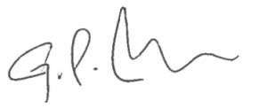

GARY CARTER, GMB NATIONAL OFFICER

