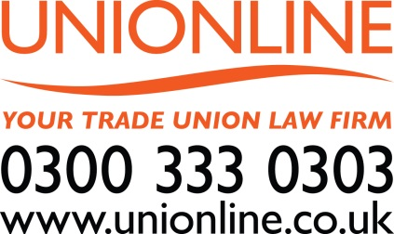
UNIONLINE & GMB YORKSHIRE & NORTH
DERBYSHIRE LEGAL SERVICES
UNIONLINE was set up by GMB in May 2014 to provide members
with access to a full range of legal services. GMB and UNIONLINE
work with other specialist law firms so between us we can provide
national and regional support to our members.

UNIONLINE HELPLINE: 0300 333 0303

Call the Helpline for personal injury cases including:
- accidents anywhere, anytime, at work, at home or in a public place
- road traffic accidents
- industrial disease
- clinical negligence
- criminal injury compensation cases.

A UNIONLINE advisor will discuss the claim with you and explain the next steps. They understand that suffering an injury can be very stressful and traumatic so they are there to help you. As specialists in personal injury they are best placed to assist you in your time of need.

Call the Helpline 0300 333 0303 for:
- preparation of wills for a GMB member and spouse / partner
- support for members accused of driving offences through the Motor
Drivers’ Fund (just 20p a week - contact regional office for details)
- Free initial advice on non-work related legal enquiries.

Discounted preferential rates for GMB members and their
families:
- family law and matrimonial advice
- probate
- conveyancing services.

For these services or any other non-work legal problem
just call the 0300 333 0303 HELPLINE

NB Have your membership number to hand when calling UNIONLINE
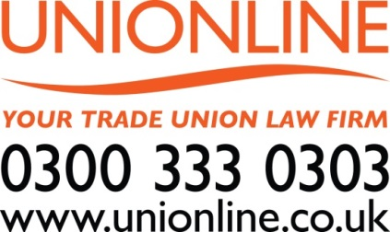

EMPLOYMENT RIGHTS
If you have a problem at work…
- Involve your GMB workplace representative first. GMB representatives
are trained to help you defend your rights. They will do everything they can
to resolve your problem at the workplace.

- If you do not have a GMB workplace representative you are still legally entitled to have a GMB representative accompany you to a grievance or disciplinary hearing.
Just call 0345 337 7777 and you will be put in touch with a GMB representative.

- Sometimes problems at work require legal action. That is why Yorkshire & North Derbyshire Region has its own legal department providing expert employment law advice and Employment Tribunal representation.

- If legal action is needed a GMB officer will help you deal with the pre-Employment Tribunal claim requirement to take the complaint through
ACAS Early Conciliation.

Criminal Law & Regulatory Body Proceedings
Helpline – Call 0300 333 0303

GMB members often work in occupations that may make them vulnerable to false allegations. You need to know you will get the right level of support when and if it is needed. GMB members accused of a work related criminal offence will get free initial advice and representation.

For members who work in a profession that is governed by a regulatory body, such as nurse, free advice and representation is available for regulatory disciplinary proceedings. Just call UNIONLINE on 0300 333 0303.

All legal services are subject to Rule 27 in the GMB Rulebook. For more information about Yorkshire & North Derbyshire Region visit our website: http://www.gmbyorkshire.org.uk/

