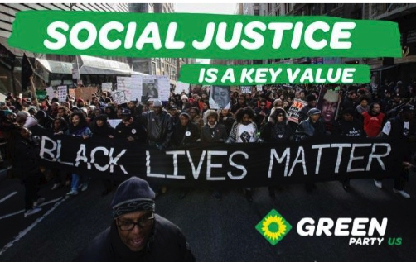
...a more just America
- Better educational opportunities for children and adults, regardless of income or citizenship.
- Restorative justice rather than retribution.
- Reform of the so-called criminal justice system to respect human and civil rights, from police to courts to prisons.
- An end to the racist, classist death penalty; fairer sentencing guidelines for lesser offenses.
- An end to the ineffective and wasteful drug war, along with rehabilitation instead of prison time for addicts.
- Living wages for our manufacturing and service workers, and closing of tax loopholes that benefit the super-rich.
- Study, and eventual implementation, of some form of reparations for the enslavement and slaughter of Africans and indigenous Americans.
- Marriage equality for consenting adults, and the freedom of individuals to define family as what works for them.
- Maintaining reproductive choice through access to effective birth control and safe abortion when the need arises.
- Single-payer comprehensive health insurance for all Americans.

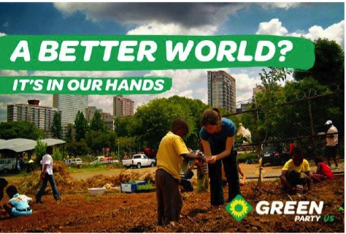
...a cleaner, greener America

- A Green New Deal that will provide jobs for all adults who seek employment.
- Investment in alternative energy sources (solar, wind, hydrogen, biofuels) to decrease dependence on fossil fuels.
- No more commissioning of coal or atomic power plants.
- Increased tax credits for developing local, organic, and sustainable agriculture.
- Strict enforcement of the Clean Air and Water Acts to protect our air, water, and soil from industrial pollution.
- Common-sense approaches to urban and interurban mass transit; commuter rail and complete streets instead of bigger freeways and more tollways.
- Massive restoration of the nation's commons: roads, rail lines, bridges, sewers, national parks and forests.
...a less menacing America
- An end to strong-arm foreign policies, including the use of armed drone aircraft, that have made America the most hated and feared nation on earth.
- Complete withdrawal of U.S. forces from Afghanistan and other foreign deployments as quickly as safety allows.
- Abolition of all practice of torture, including extraordinary rendition of captives to other countries.
- The best possible medical and psychiatric care for veterans of all foreign entanglements, to help them reintegrate into society.
- No more trade agreements that benefit corporate fat-cats first and foremost; complete renegotiation of NAFTA (the North American Free Trade Agreement) and WTO (World Trade Organization) to protect workers and natural resources instead of corporate profits

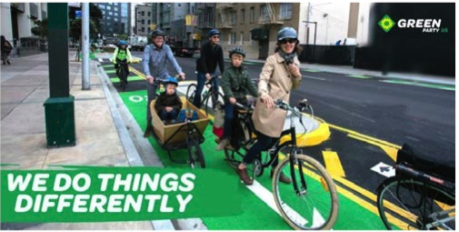
...an America that works for us!
If "Life, Liberty, and the Pursuit of Happiness" mean anything, these inalienable rights must belong to all, must be respected by all. Our so-called leaders in Washington act as if the wealthiest 1% of Americans and their close friends are the only ones entitled to those rights.
Corporations, though they do not have the right to vote, through sheer wealth have more rights than we do.

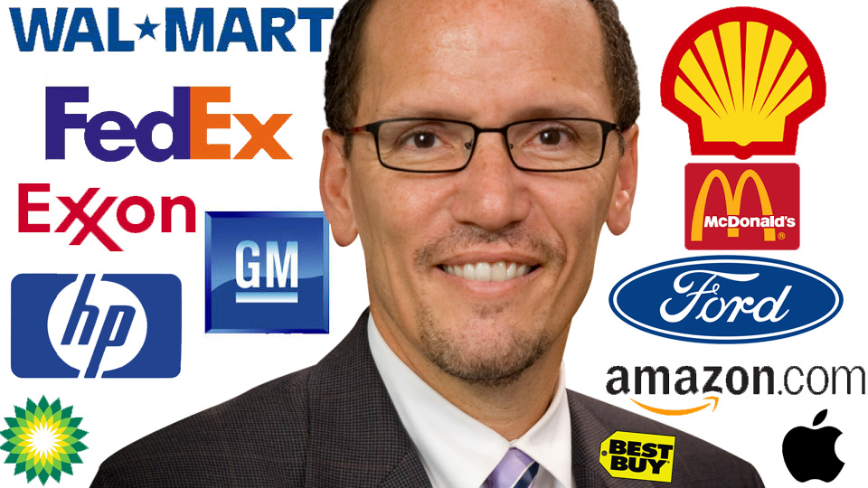…Both major parties share the blame:
- Both parties helped create the National Security State after World War II, and both have perpetuated the Homeland Security State after 2001.
- Both parties pave the way for corporations to write our nation's laws in their favor.
- Both parties take money out of your paychecks to keep the 1% wealthy and powerful, because both parties get the bulk of their campaign contributions from corporate America.

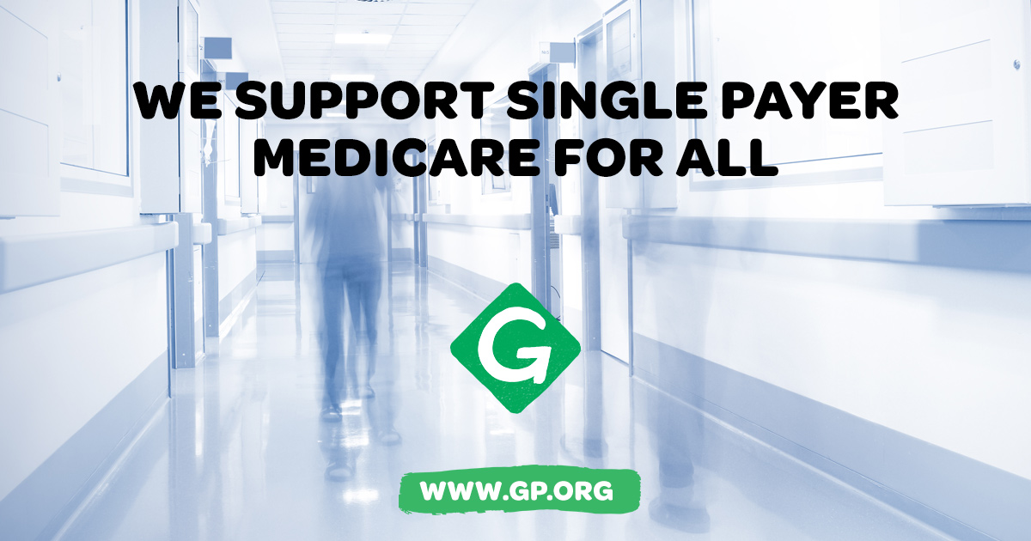

Is This a New Party?

The Green Movement has been active in the United States since 1980. It is patterned after parties in Germany, Australia, and elsewhere that began by opposing nuclear power, nuclear weapons, and wholesale industrial trashing of the environment.
Since the 1980s, Green candidates have been elected to municipal, county, and state public offices in 28 states.
In 1996, California Greens endorsed Ralph Nader and Winona LaDuke as write-in candidates for President and Vice President.
In 2000, the various state Green Parties decided to create a national organization. At the first national convention in Denver, who appeared on ballots in 44 states.
If a bill or referendum does not fit with the key values, the Greens do not support it.
Since that time, Texas Greens have gained and lost ballot access several times, all the while steadily growing deeper roots in the community.
Though GPTX will again need to qualify for ballot access in 2018, we are confident that we will have ample support to meet the requirements. To that end, we invite you to join us and invest yourself in building connections between Greens and our communities!
What Does the Green Party
Believe and Work for?
The Ten Key Values of the Green Movement:
- Grassroots Democracy
- Social Justice and Equal Opportunity
- Ecological Wisdom
- Non-violence
- Decentralization
- Community-based Economics
- Feminism and Gender Equity
- Respect for Diversity
- Personal and Global Responsibility
- Future Focus and Sustainability
If a bill or referendum does not fit with the key values, the Greens do not support it.
It's time for government on a human scale.
It's time to separate corporation and state.
It's time for the Greens to occupy the government

www.txgreens.org
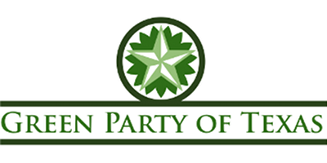
We are not the alternative; we are the imperative.

—Rosa Clemente,
2008 Vice Presidential Nominee
The Green Party of Texas is here for those who have had their fill, who refuse to choose between two political parties that work on behalf of Wall Street and the Perpetual War Machine. We believe that millions of American voters would like to create...

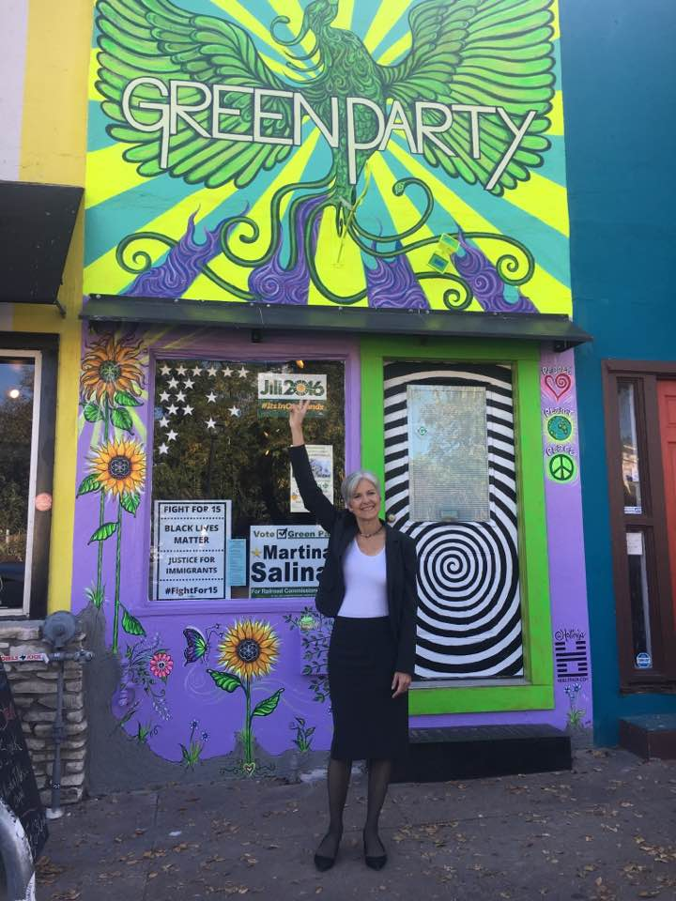
www.txgreens.org

