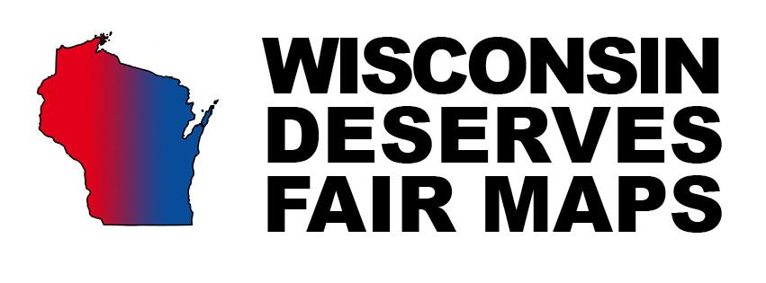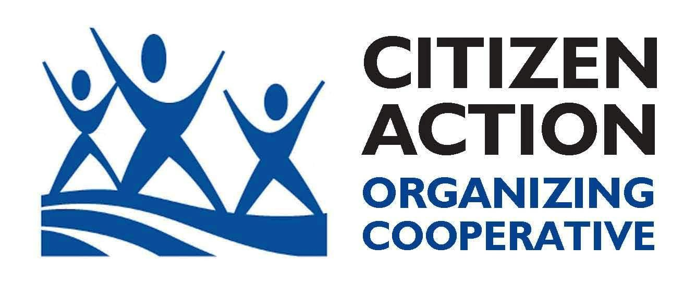

Guide to Passing a County Resolution on Fair Maps

County boards across Wisconsin are passing resolutions calling for fair state electoral maps. The purpose of the county resolutions is to create a groundswell of opposition to the partisan gerrymandering that led a federal court to rule Wisconsin’s electoral maps unconstitutional in 2016. The resolution also calls on the state legislature to create an impartial, nonpartisan process for drawing our state’s voting maps (as proposed in State Senate Bill 13 and Assembly Bill 44). Concerned groups of citizens are organizing to introduce and pass the resolution in as many counties as possible. You can help! Here is a guide to get you started. For more information, email Hans Breitenmoser at breitenmoser.jr@gmail.com.

Step 1: Download the resolution.
Included on the last page of this guide is recommended language for your resolution from advocates in Lincoln County. Make sure to review and change the county name to your own. Print several copies to share with other advocates and board members.

Step 2: Find a well-liked champion.
A champion is a board member who will introduce the resolution. It is a good idea to find a champion that will not only be a strong advocate on the issue, but is also someone that is well liked and respected by the other board members. Don’t pick someone that is high drama or alienates the board – this could set people against your resolution before it is even introduced.

Step 3: Craft a nonpartisan argument that will appeal to all members of the board.
Work with your county board champion to craft an argument that will appeal to both conservative and progressive board members. Focus on issues such as fairness, nonpartisanship, and cost-effectiveness. For example, it is hard for anyone to defend the nearly $2 million in tax dollars that the state legislature has used to draw and defend flawed maps. A nonpartisan redistricting process would cost comparatively little for the state to draw fair maps. It is also worthwhile to point out that this resolution is not a partisan issue – both the Democratic Party (in Illinois) and the Republican Party (in Wisconsin) have gerrymandered electoral maps. Voting in favor of this resolution is about doing what’s right to promote fairness for voters and defend democratic principles.
(Scroll down to see talking points crafted specifically to persuade county supervisors who might be on the fence about supporting a fair maps resolution.)

Step 4: Get to know the committee that will review the resolution first.
Before your resolution is introduced to the board, it will first have to pass a committee. Each county is different, but often the committee that will review your resolution first will bear the name “legislative” of “executive.” Work with your champion to get to know the members on this committee before the resolution is introduced. Present your argument to them and make sure you have all your yes votes secured before the committee votes.

Step 5: Reach out to each of the board members to see how they will vote.
It’s imperative that you make sure you have enough votes to pass the resolution before bringing it up – having it defeated is a setback for the statewide effort. Work with your champion to reach out to each of the board members to get an idea of how they feel about the issue. You don’t just want to find people who will vote yes – you want to find other board members who will speak up in support the resolution during the discussion. If there is opposition on the board, you don’t want those voices to drown out support and intimidate board members into voting no. Don’t spend a lot of time trying to convince people who will obviously vote against it. Focus on the moderates who will be swayed by a sound argument.

Step 6: Pack your county board meeting with supporters.
When it is time to vote on the resolution, call up friendly organizations and ask them to bring supporters to speak up on behalf of fair maps. For example, your local Citizen Action Organizing Cooperative, a nearby chapter of the League of Women Voters, or the Farmer’s Union have all supported the resolution in other counties. It is very important to have constituents from each of the county districts represented. Ask them to read a short statement about why they feel their county board representative should vote yes. Encourage them to focus on the key points of your argument: fairness, nonpartisanship, and cost-effectiveness.

Step 7: Leverage the press.
If you will have lots of supporters at the board meeting, call up local reporters and let them know. After the resolution passes, send out a press release to local and statewide media (we have included a sample press release at the end of this guide) or ask a supportive county board member to author an Op-Ed for the local paper. Make sure to emphasize that the effort in your county is part of a diverse, statewide movement in support of fair maps. Familiarize yourself with the counties that have passed the resolution so far and emphasize the diversity of rural and urban, progressive and conservative counties that are part of this effort. Ask your champion or other supporters to participate in interviews about why they voted yes.

Step 8: Make sure your success is widely known!
Your City Clerk will distribute the resolution to state officials as outlined in the resolution. Also make sure to notify the Wisconsin Democracy Campaign (wisdc@wisdc.org), which is tracking counties that have passed the resolution. When a new county joins the growing list, we encourage you to announce it at your county board meeting to continue promoting the issue in your area.

RESOLUTION TO CREATE A NONPARTISAN PROCEDURE FOR THE PREPARATION OF LEGISLATIVE AND CONGRESSIONAL REDISTRICTING PLANS

WHEREAS, currently under the state constitution, the legislature is directed to redistrict legislative districts according to the number of inhabitants at its next session following the decennial federal census by the majority party; and at the same intervals, the legislature also reapportions congressional districts pursuant to federal law, and
WHEREAS, legislative and congressional redistricting plans enacted pursuant to this procedure are used to elect members of the legislature and members of Congress in the fall of the second year following the year of the census, and
WHEREAS, historically legislative and congressional plans in Wisconsin have been subject to partisan influence that put the desires of politicians ahead of the electoral prerogative of the people, and
WHEREAS, the 2011 process to draw the maps and fight litigation contesting those maps cost taxpayers nearly $1.9 million, and
WHEREAS, a panel of federal district court judges has ruled that the redistricting that was done in Wisconsin in 2011 was unconstitutional, and
WHEREAS, redistricting to achieve partisan gains is improper, whether it is done by Republicans or Democrats,
NOW THEREFORE BE IT RESOLVED that the Lincoln County Board of Supervisors insists upon the creation of a nonpartisan procedure for the preparation of legislative and congressional redistricting plans, and
BE IT FURTHER RESOLVED that the process promotes more accountability and transparency and prohibits the consideration of voting patterns, party information, and incumbents’ residence information or demographic information in drawing the maps, except as necessary to ensure minority participation as required by the U.S. Constitution.
BE IT FURTHER RESOLVED that the County Clerk is directed to send a copy of this resolution to the Governor of the State of Wisconsin, the Wisconsin Counties Association, the Wisconsin Towns Association, the Wisconsin League of Municipalities, all members of the state legislature, and to each Wisconsin County.

PRESS RELEASE
Date: <date of release>
Contact: <your name>
<Your County> Becomes Latest to Pass Fair Maps Resolution
Resolution Calls for Nonpartisan Redistricting of Legislative Districts
<Your city>, Wis. – <Your county> became the latest county in the state to pass a resolution calling for a nonpartisan process for the preparation of legislative and congressional maps electoral maps. Board members voted <insert vote tally here> to pass the resolution and oppose partisan gerrymandering in the state of Wisconsin.
Supporters of the resolution filled the county board meeting to speak in favor of the resolution, expressing outrage at the nearly $2 million in tax dollars spent by the state legislature drawing and defending flawed maps that were ruled unconstitutional by federal judges. A nonpartisan process would redraw the state’s electoral maps fairly for a fraction of the cost.
<quote from a supporter, you or the champion of the resolution about why it is important to have fair maps>
The counties that have passed the resolution so far represent a diverse cross-section of Wisconsinites. Other counties include: Lincoln, Wood, Outagamie, Door, Jefferson, Dunn, and Douglas to name a few.
Wisconsin’s electoral maps drawn in 2011 were ruled unconstitutional by a panel of federal judges in 2016. The state is under orders to redraw the maps by November 2017. The Wisconsin Department of Justice along with high priced lawyers being paid with public money appealed to the U.S. Supreme Court, which is expected to rule on the case within the next year.
Nonpartisan redistricting legislation that would establish an impartial process to redraw Wisconsin’s state and congressional districts has been introduced in the state legislature. Wisconsin State Senate Bill 13 and Assembly Bill 44, currently in committee, would establish a fair and impartial redistricting process in Wisconsin. The Legislative Reference Bureau, a nonpartisan state agency, would take control of drawing state and congressional district boundaries. The legislation is modeled after Iowa’s system, which has been in place for over three decades.

TALKING POINTS FOR PERSUADABLE COUNTY SUPERVISORS
- Our elections need to be fair. No matter what your politics, I hope you can agree that the health of our democracy depends on the integrity and fairness of our election system.
- That fairness is compromised when politicians have the power to draw their own district lines. It’s in their interest to gerrymander areas to make it easier for members of their party to get elected.
- It results in a rigged electoral system in which politicians are choosing their voters, not the other way around. Both Democrats and Republicans do it. And it is wrong either way.
- As many of us know, a federal court ruled that our current maps, drawn behind closed doors by pricey lawyers hired by the Republican Party, are unconstitutionally gerrymandered. What was the impact, a rigged slot machine, the election results were predetermined so as to guarantee the majority party with a majority of the seats.
- We see evidence of this election riggings from the election results in 2012, shortly after the new maps came into effect after the last census. That year, the GOP won only 48.6% of the statewide vote for Assembly candidates, but got 60/99 seats. And it 2014, the GOP won 52% of the vote, won 63/99 Assembly seats.
- Perhaps just as disappointing, back in the 2000’s when the Democrats controlled both houses of the legislature and the governorship, they did nothing to create a nonpartisan redistricting process. If they had done that, we would not be in the situation we are in today. Instead, the Democrats chose to leave the gerrymandering door open so that they might be able to gerrymander too once they had power of the legislature. That’s a huge problem too.
- If we believe that people running for office should all get a chance to play on an even playing field, then we need to support the creation of an impartial, transparent process for redistricting in Wisconsin.
- While related and important, the ongoing partisan gerrymandering case, Gill v. Whitford, is not a sufficient solution to this problem. That case would determine whether our current state assembly maps are constitutional or are unconstitutional, and would create a standard to measure this by. But this case has nothing to do with the process by which the state of Wisconsin chooses to draw it’s maps now and in the future. If we do not change the process now, before the new maps are drawn based on the 2020 census, then the state legislature – no matter what party controls it – will likely rig our elections again for the next ten years.
- As representatives elected by the people of [your county], we have a duty to ensure that every candidate has an even playing field when they run for office and that every person has an equal say in our democracy – no matter which political party they belong to.
- By supporting my fair maps resolution today, you are saying that [your county] cares about fair elections, and that you will stand with 20 other counties around the state, from rural Lincoln County to counties with cities like Eau Claire and Milwaukee.

