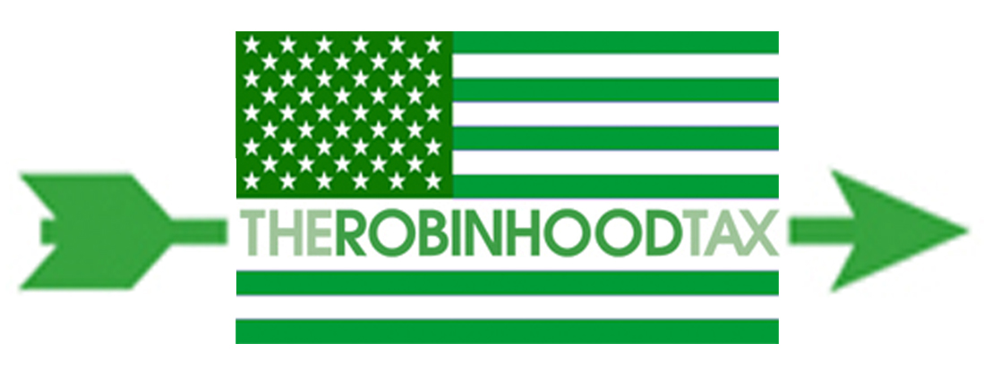
April 18, 2012

Dear Colleague

Invitation to join the Robin Hood Tax U.S.A. campaign

We’re writing to ask your organization to join the U.S. Robin Hood Tax campaign. The campaign calls for a Financial Speculation (Transaction) Tax as a way to rebalance our economy, reducing speculation but even more importantly raise the resources needed to tackle massive unemployment, stop cuts to public services, and strengthen our infrastructure here in the U.S. while tackling AIDS, poverty, and climate challenges around the world.

This is not a policy coalition, but instead a vehicle for high profile public media and grassroots campaigning to demand a Robin Hood Tax. We have launched a great website with easy-to-understand content explaining the tax and opportunities for supporters to take action. We continue to gather the resources for high-profile endorsers with large followings, substantial mainstream media coverage, a strategic social media campaign, and several fun “products” you can share with your lists to get them excited.

There is no membership fee for joining the campaign, but there will of course be costs. If you can make a contribution, that would be very gratefully received - please let us know.

We look forward to hearing from you and working with you for this once in a lifetime opportunity to really make a difference.

Please send an email to RobinHoodEndorse@gmail.com with the organization name, contact details for the person or people in your organization who will be leading your involvement, and your logo. Thank you for joining in this exciting campaign.

Go to www.robinhoodtax.org for a list of endorsers.
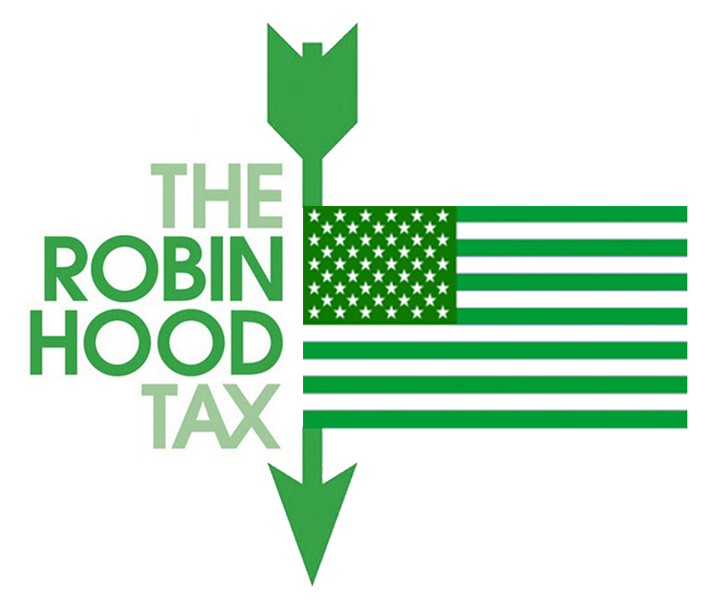

It’s Time for a Robin Hood Tax

We’re calling for a Robin Hood Tax on Wall Street to generate hundreds of billions of dollars every year in needed revenue for Main Street. The money raised will generate jobs and strengthen public services like health care, education and infrastructure at home while tackling AIDS, global health, poverty and climate challenges around the world.

Across America we see high levels of unemployment, broad declines in health, underfunded education, crumbling infrastructure, shrinking pensions and retirement savings, and teachers, nurses and fire fighters being laid off. Our social safety net has been shredded and our communities are hurting. Similarly, around the world millions of people have been pushed into poverty and the winnable fights to end AIDS, food insecurity, and environmental destruction lack the resources to succeed. All this because of a financial crisis we didn’t create.

Meanwhile, Wall Street and the big banks are exploiting tax loopholes while generating record profits and being rewarded with billions in bailouts and bonuses. Most of the recovery thus far has benefited the top 1%, not the 99%. It’s time for Wall Street to give back what it has taken from our country.

We’re calling on U.S. elected leaders to enact a Robin Hood Tax: a small tax on every financial trade that would generate hundreds of billions in urgently needed revenue every year—economists estimate up to $350 billon annually from the banks and traders who caused the economic crisis instead of working Americans who pay now. Plus it will help limit reckless short-term speculation that threatens financial stability. We need a domestic and global rescue plan for our communities and the revenue from this tax can help.

The Robin Hood Tax is just and fair. Wall Street can afford it. Over 1,000 leading economists have endorsed it, and a financial transaction tax is nearly certain to be adopted in Europe this year. Further, the Robin Hood Tax is already on the books and working well in some 40 countries. It is easy to enforce, tough to evade and won't touch the bank accounts, pensions or savings of the vast majority of the American people.

It's fair, it's timely, and it's possible: Mr. President, Congress, it’s time to enact a Robin Hood Tax.

Join the campaign:

Endorse this call, which will be sent to the Obama administration, Congress, and other political leaders
- When the campaign “launches” with high profile supporters & digital products in late may/early June send a note out to your email list urging everyone to sign and share
- Learn & Build—we’ll have a series of brainstorming and info sessions in person and via phone and the Web over the coming month.
- Sign on to the campaign online: https://docs.google.com/spreadsheet/embeddedform?formkey=dGNyZ0J1N3lUTERudlI4UGIxOFlKQXc6MQ
- Or below:
_____ Yes, please add my name to the Robin Hood Tax Campaign
Name of Lead Staff: _______________________Phone;________________Email:_________________
Organization:______________________________Website:____________________________________
Digital/Media Staff Name:___________________Phone:_________________Email:________________

