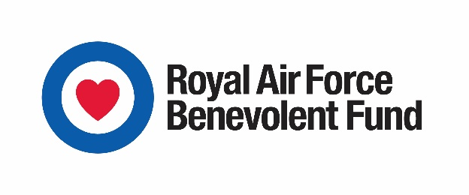
Immediate release
RAF Benevolent Fund launches new community scheme to help isolated RAF veterans
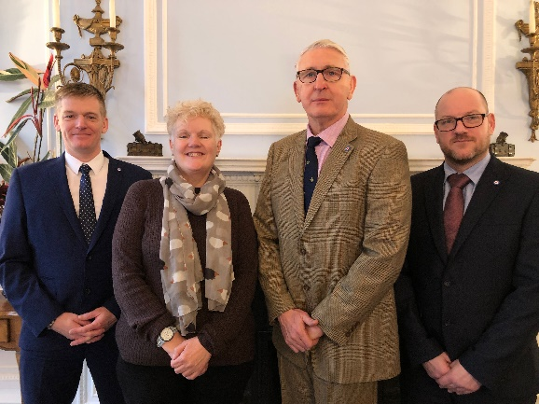
Caption: From left Community Engagement Workers Matt Rowe, Cambridgeshire, Sue Grogan, Norfolk, Graeme Spark, Lincolnshire and Declan Geraghty, Suffolk. Photo: RAF Benevolent Fund
Lincolnshire, Cambridgeshire, Norfolk, and Suffolk have been selected as pilot locations for a new project aimed at supporting RAF veterans who face loneliness and isolation.
The RAF Benevolent Fund, the RAF’s leading welfare charity, is launching a Community Engagement Worker scheme to help older RAF veterans get involved in their local communities. The scheme comes in response to research carried out by the Fund which highlighted these challenges as issues which most concern the older generation of RAF veterans.
Pete Ashcroft, Welfare Projects Manager at the RAF Benevolent Fund, said: “The Community Engagement Worker project is just one measure we have introduced to tackle the issue of loneliness and social isolation among older veterans. Other new initiatives include a Telephone Friendship Group service and group wellbeing breaks.
“This year marks the RAF Benevolent Fund’s centenary and we are asking the public to help us reach out to the members of the RAF Family who may have fallen off the radar and let them know, we are here to help before it’s too late. We want to ensure every RAF veteran, no matter how long they served, including National Service, receives the support their service to their country deserves.”
The Community Engagement Workers will get to know the social activities, groups and associations across the four counties and work with individuals to understand what the barriers are to them becoming more socially engaged and help them to overcome that, from attending a veterans’ breakfast meeting with someone for the first time, to establishing activities where none currently exist.
Graeme Spark, of Grantham, will be taking on the Lincolnshire Community Engagement Worker role. His 29-year career in the Royal Air Force means he knows the service well.
He said: “It has always been deeply humbling, the sacrifices that whose who fought before us made and as an RAF veteran I have some insight into that.
“This is an opportunity of a lifetime, and I feel like I’m part of the RAF family again. Success in this job is going to be very different for each person. This is about individuals and what they need to feel part of the RAF Family, and the wider community again.”
The pilot scheme will run for two years.
Ends

For more information and high res images please contact:
Rebekah Sharrock, PR Officer, RAF Benevolent Fund
E: rebekah.sharrock@rafbf.org.uk | T: 020 7307 3305 | M: 07595 657979.

RAF Benevolent Fund: The Royal Air Force Benevolent Fund is the RAF’s leading welfare charity. We exist to support current and former members of the RAF, their partners and dependants, whenever they need us. In 2017 we spent £18.8m supporting more than 55,000 members of the RAF Family. For more information visit: www.rafbf.org Twitter: https://twitter.com/RAFBF

