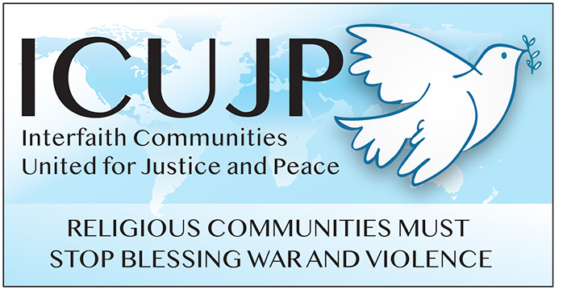
www.icujp.org • www.facebook.com/icujp

ICUJP Friday Forum Agenda

July 12, 2019

7:00–9:00 am
Immanuel Presbyterian Church
Facilitator: Louis Chase
7:00 Gathering/Networking
7:10 Introductions (NOTE: General Announcements will be at the end)
7:20 Reflection by Michael Novick
7:30 Affiliate Reports
7:45 National Get Organized for An ACTUAL Revolution Tour – Alex Hernandez and Michelle Xai, Revolution Club LA. This national tour is a movement to put actual revolution, the New Communism developed by Bob Avakian, on the map across this country and beyond. Michelle and Alex will discuss the National Tour and its goals. As defendants in the #Freeway9 and #UCLA5 protest cases, they'll also talk about what's at stake in these cases and how you can help spread the word and demand that charges be dropped.

8:45 General Announcements
8:50 Closing Circle and Prayer
Friendly reminder: ICUJP collects canned and packaged food and travel-sized toiletries each week to donate to Immanuel Presbyterian's Food Pantry, as the need continues to be critical.
________________

Upcoming Friday Forums:
JULY 19: White Privilege and Institutional Racism - Randy Heyn-Lamb, Anthony Manousos, Phil Way
JULY 26:American Friends Service Committee video, Endless War
AUG 2: Screening of Cuba film - Catherine Murphy, filmmaker
AUG 9: Report from Cuba - Carolfrances Likins and Michael Novick

ICUJP Board of Directors
Louis Chase • David Clennon • Grace Dyrness • Ed Fisher • Stephen Fiske • John Forney • Betsy Hailey
Maggie Hutchinson • Carolfrances Likins • Rita Lowenthal • Anthony Manousos • Marium F. Mohiuddin
Michael Novick • Rubi Omar • Chris Ponnet • George Regas • Steve Rohde • Fidel Sanchez
Susan Stouffer • Veda Veach • Phil Way

