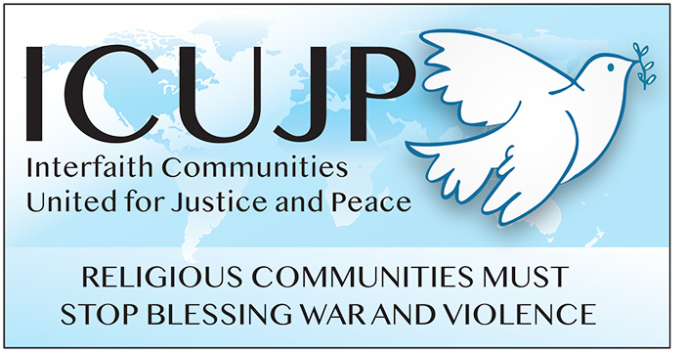
www.icujp.org • www.facebook.com/icujp

ICUJP Friday Forum Agenda

August 9, 2019

7:00–9:00 am
Immanuel Presbyterian Church
Facilitator: Dave Clennon
7:00 Gathering/Networking
7:10 Introductions (NOTE: General Announcements will be at the end)
7:20 Reflection by Anthony Manousos

7:30 Affiliate Reports

7:45 Cuba Today: A Report from ICUJP Board members who traveled to the island as acts of civil disobedience to challenge U.S. imperialism – Carolfrances Likins and Michael Novick. Carolfrances and Michael will discuss their respective trips to Cuba with the 30th Friendshipment Caravan, organized by Pastors for Peace/IFCO (Interreligious Foundation for Community Organization), and the 50th Anniversary of the Venceremos Brigade.

8:45 General Announcements
8:50 Closing Circle and Prayer
Friendly reminder: ICUJP collects canned and packaged food and travel-sized toiletries each week to donate to Immanuel Presbyterian's Food Pantry, as the need continues to be critical.
________________

UPCOMING EVENTS
SAT, SEPT 21: Sister Pat Krommer, CSJ (1932-2019): A Woman of Faith in Action. Hosted by Pax Christi SoCal and ICUJP. Storytelling, music, a peace action, and vegetarian lunch (donations welcome). Sr. Pat will posthumously be awarded the 2019 ICUJP George Regas Peacemaker and Pax Christi Nonviolent Witness awards. 10am-3pm, Ramona Secondary High School Holy Family Room, 1701 W. Ramona Rd., Alhambra. Info/RSVP: St. Camillus/Pax Christi, 323.225.4462 x221.
FRIDAY FORUMS:
AUG 16: Ending the Death Penalty - Nancy Haydt, Executive Director, Death Penalty Focus
AUG 23: Cuba Documentary - Catherine Murphy
AUG 30: Report on Peace Camp 2019 - Susan Stouffer

ICUJP Board of Directors
Louis Chase • David Clennon • Grace Dyrness • Ed Fisher • Stephen Fiske • John Forney • Betsy Hailey
Maggie Hutchinson • Carolfrances Likins • Rita Lowenthal • Anthony Manousos • Marium F. Mohiuddin
Michael Novick • Rubi Omar • Chris Ponnet • George Regas • Steve Rohde • Fidel Sanchez
Susan Stouffer • Veda Veach • Phil Way

