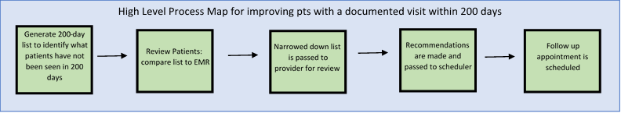
Step 1 | Step 2 | Step 3 | Step 4 | Step 5
How many patients are listed as NOT having a visit documented in the registry?  Are there any observations or learning opportunities for process step 1? | How many patients had a visit but the data wasn’t captured in the registry?  How many patients have a visit scheduled, however, the visit haven’t occurred yet?  How many patients did not have a visit but are being seen in infusion?  Are there any observations or learning opportunities for Process Step 2? | How many patients are lost to follow up, transferred to adult/ another clinic and should be deactivated?  How many patients are away at college?  How many patients were hospitalized resulting in a lack of appointment?  Are there any observations or learning opportunities for process step 3? | How many patients do not have a visit scheduled and require one?  How many patients should be deactivated?  How many patients do not have a recommendation for follow up care?  Are there any observations or learning opportunities for process step 4? | How many patients were unable to reach (did not have a working phone number, wrong number voicemail full, unable to leave message)?  How many patients were left a message?  How many patients were sent an alternative message?  Patient Portal:  Letter in the Mail:  Other:
How many patients were contacted but refused the appointment?
Feeling well:
Timing isn’t right for the family:
Do not have calendar in front of them:
Insurance coverage:
Transportation challenges:
Other:

How many patients successfully had a visit scheduled?

How are you documenting that the patients were contacted and the appointment was made?

Are there any observations or learning opportunities for process step 5?

