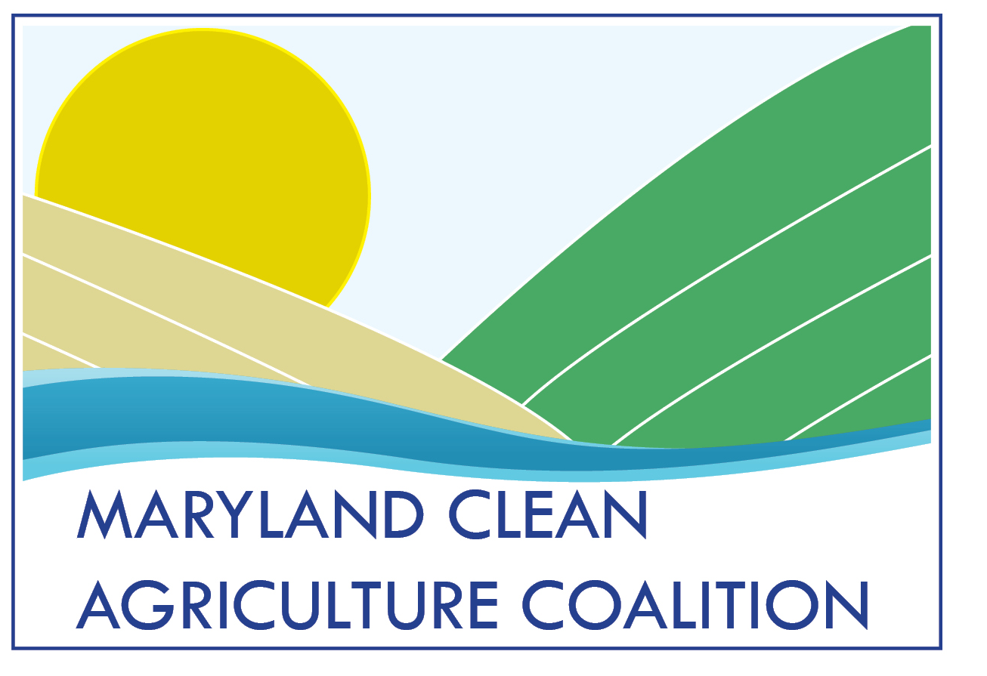

Contact: Dawn Stoltzfus, The Hatcher Group, (410) 562-5655
Tom Zolper, Chesapeake Bay Foundation, (443) 482-2066
FOR IMMEDIATE RELEASE
March 18, 2015

JOINT ENVIRONMENTAL STATEMENT ON HOGAN ADMINISTRATION’S REVISED PHOSPHORUS REGULATIONS
(Annapolis, MD) – The Maryland Clean Agriculture Coalition and the Chesapeake Bay Foundation released a joint statement today about Governor Hogan’s revised Phosphorus Management Tool (PMT) regulations:
We are pleased the Hogan Administration has agreed to close a loophole in its proposed proposed phosphorus regulations that could have allowed for delay after delay. Getting rid of this loophole will be a major accomplishment.
Environmental leaders worked with Senator Pinsky, Senator Middleton, Delegate Lafferty, the Hogan Administration and the agricultural industry to improve the regulations.
Our organizations would have liked to have begun using the Phosphorus Management Tool four years ago, as Maryland promised, and as the science dictated. Nevertheless, these revised regulations represent progress toward reducing pollution from agriculture – which we absolutely must do to protect the Chesapeake Bay and local waterways, as well as public health.
We thank the Hogan Administration for listening to our concerns and trying to address them. And we are enormously thankful to Senator Pinsky for his leadership to achieve stronger manure rules, as well as to Delegate Lafferty and the Chesapeake Bay Commission for their help. This has been a tough issue over many years, and we are fortunate to have Senator Pinsky and Delegate Lafferty as clean water champions.
The revised regulations are to include a 2022 implementation date. They still would allow the possibility of two one-year extensions, which could extend implementation until 2024.
The regulations would also create an advisory committee to evaluate whether any such extension is needed. It is a much more balanced committee that was originally proposed and includes two environmental organizations and other state agencies. Organizations working to protect the Chesapeake Bay and Eastern Shore waterways will strive to ensure that Governor Hogan’s regulations do what we hope they will and that they don’t get weakened or delayed in the months or years to come.
We will also be watching over the next seven years to ensure this long-overdue tool gets implemented as it is supposed to do. With levels of phosphorus pollution worsening on the Eastern Shore, this tool to better manage manure is needed more than ever before.
###
The Phosphorus Management Tool would reduce pollution by halting the excessive uses of manure on farm fields already contaminated with too much phosphorus. Phosphorus pollution causes algae blooms that threaten public health; kill underwater grasses; harm aquatic life like blue crabs, oysters and fish; and create an enormous “dead zone” in the Bay. Read a fact sheet about the tool here.
The U.S. Geological Survey recently released a report showing that Eastern Shore waterways have levels of nitrogen and phosphorus pollution that are among the “highest in the nation” due to agricultural operations.
###

The Maryland Clean Agriculture Coalition is working to improve Maryland waterways and protect public health by reducing pollution, and increasing transparency and accountability, from agriculture and other associated sources of water degradation.

Its partners include: Anacostia Riverkeeper, Audubon Naturalist Society, Assateague Coastal Trust, Blue Water Baltimore, Chesapeake Climate Action Network, Clean Water Action, Environment Maryland, Environmental Integrity Project, Gunpowder Riverkeeper, League of Women Voters of Maryland, Lower Susquehanna Riverkeeper, Maryland League of Conservation Voters, Maryland Pesticide Education Network, Midshore Riverkeeper Conservancy, Potomac Riverkeeper, Sierra Club, Maryland Chapter, South River Federation, Waterkeepers Chesapeake, West/Rhode Riverkeeper

Founded in 1967, the Chesapeake Bay Foundation (CBF) is the largest independent conservation organization dedicated solely to saving the Bay. Serving as a watchdog, we fight for effective, science-based solutions to the pollution degrading the Chesapeake Bay and its rivers and streams. Our motto, "Save the Bay," is a regional rallying cry for pollution reduction throughout the Chesapeake's six-state, 64,000-square-mile watershed, which is home to more than 17 million people and 3,000 species of plants and animals.

