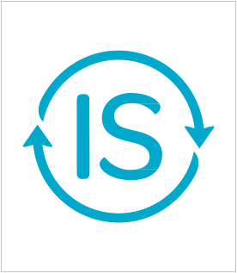

INFRASTRUCTURE SUSTAINABILITY RATING REGISTRATION OF INTEREST

Registering Organisation Details
Name of nominating organisation (Registrant):
Name of individual authorising this Registration:
Position:
Is the Registrant a member of ISCA? ☐Y ☐N
Contact person for this Registration:
Position:
Phone number:
Email address:
Organisation’s registered address:
Project/Asset Description
Project/Asset name (As it will appear on the IS certificate):

Project/Asset physical address:

Infrastructure type (may tick more than one):

Transport
☐ Airports
☐ Cycleways and footpaths
☐ Ports and Harbours
☐ Railways
☐ Roads

Communication
☐ Communication Transmission & Distribution

Water
☐ Sewerage and Drainage
☐ Water Storage and Supply

Energy
☐ Electricity Transmission and Distribution
☐ Gas Pipelines

Total capital cost (design and construction):
Annual operating cost:
Project key stakeholders

Proponent:
Designer(s):
Main constructor(s):
Operator(s):
Other key consultant(s):

Rating type: | Design | As Built | Operation | Please tick all you wish to pursue
Rating level targeted: | Commended | Excellent | Leading | Please indicate your target

Expected project start date:
Expected design completion date:
Expected date of construction practical completion:
Expected date for commencement of operation:
Project delivery contract type/arrangements (e.g. Alliance, D&C, BOOT, etc):

Short description of the Project/Asset:

Project/Asset Purpose:

Why are you pursuing an IS rating?

Next Steps
This Registration of Interest should be sent via email to info@isca.org.au
To formally register to pursue an IS rating, an IS Rating Agreement will be issued for review and execution to be returned to ISCA along with suitable images for registration profile.
Terms and Conditions
The IS rating tool has been developed by ISCA to evaluate various sustainability elements of infrastructure projects and assets to determine an IS rating. To be eligible for an IS rating, the registered Project/Asset must satisfy specified prerequisites and be awarded a minimum number of points, as described in the IS rating tool.
Subject to full compliance by the Applicant with its obligations under the IS Rating Agreement, the Verifier(s) will, after completing the Independent Verification, recommend the rating level to be certified. IS ratings will be certified at the levels of Commended, Excellent or Leading.
For more information about ISCA or the IS rating scheme, please visit: www.isca.org.au
Acknowledgement
I wish to register interest in pursuing an IS rating for the infrastructure Project/Asset described in this form.
Name:

Signed: Date:

