Undoing Racism/Community Organizing Workshop
September 14-16, 2018 New Haven, CT

Are you challenged by racism in your practice, institution, home, or classroom?
Are you concerned about the impact of racism in your community, state, or the nation?

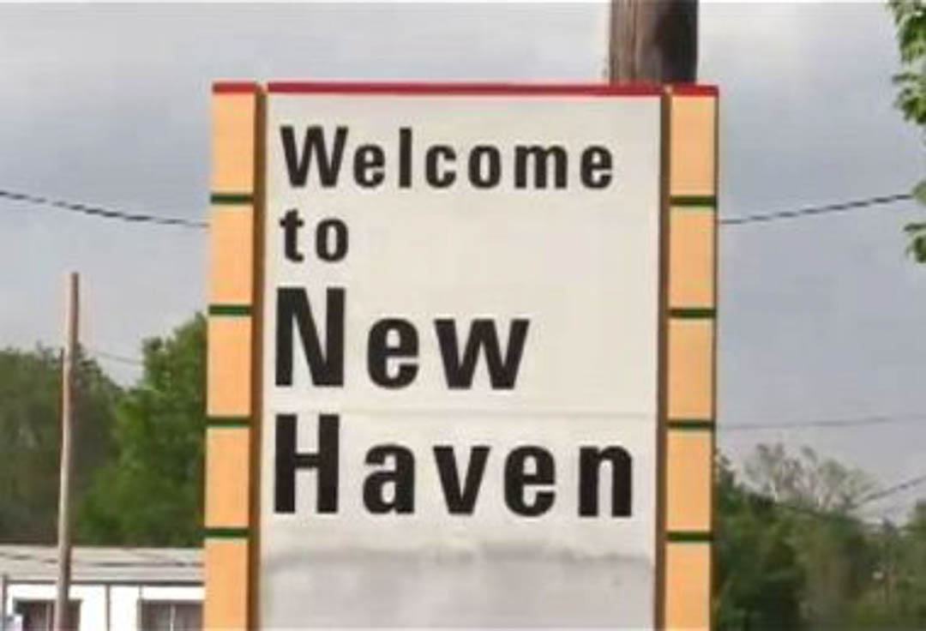

Undoing Racism/Community Organizing
This intensive workshop focuses on racism and educates, challenges, and inspires people to undo the race-based structures that block social change. We focus on what racism is, where it comes from, how it functions, why it is persists, and what we can do to dismantle it:
Analyzing Power
Recognizing Internalized Racial Oppression
Defining Racism
Understanding the Manifestations of Racism
Learning from History
Sharing Culture
Organizing to Undo Racism
This New Haven workshop is organized locally and offered with the People’s Institute for Survival and Beyond, a national, multiracial, anti-racist collective of veteran organizers and educators dedicated to building an effective movement for social change. Since its founding in 1980, The People’s Institute has led workshops for over 500,000 people in hundreds of communities throughout the United States and internationally (including many from New Haven and across Connecticut). More about the People’s Institute at www.pisab.org.

WHEN
Friday, September 14 5pm-8pm
Saturday, September 15 10am-6pm
Sunday, September 16 10am-5pm
Must be available for all 3 sessions.

WHERE
Yale Divinity School
409 Prospect Street, New Haven, CT
Exact workshop space to be determined. Free parking available.

MEALS
Dinner provided Friday.
Breakfast and lunch provided Saturday and Sunday.
Gluten-Free, Vegetarian, and Vegan options will be available.

HOW TO APPLY
Please complete online application at:

justmoves.nationbuilder.com

Applications due August 31, 2018.

COST
$400 (includes the workshop and all meals)
Full and partial scholarships available; request on application.
Free childcare available; request on application.
Fee payable upon acceptance.

Undoing Racism/Community Organizing Workshop
September 14-16, 2018 New Haven, CT

UNDOING RACISM/COMMUNITY ORGANIZING: WHAT DOES IT TAKE?

Analyzing Power: Effective organizing requires accurate analysis of the systems that keep racism in place. The workshop examines why people are poor, how institutions and organizations perpetuate the imbalance of power, and who benefits from the maintenance of the status quo.
Recognizing Internalized Racial Oppression: The workshop explores how internalized racial oppression manifests itself both as Internalized Racial Inferiority and Internalized Racial Superiority.
Defining Racism: In order to undo racism, organizers and educators must understand what racism is, and how and why it was constructed. The workshop explores how the idea of race was created to implement systems that benefit some people and oppress and disadvantage others.
Understanding the Manifestations of Racism: Racism operates in more than just individual and institutional settings. The workshop examines the dynamics of cultural racism, linguistic racism, and militarism as applied racism.
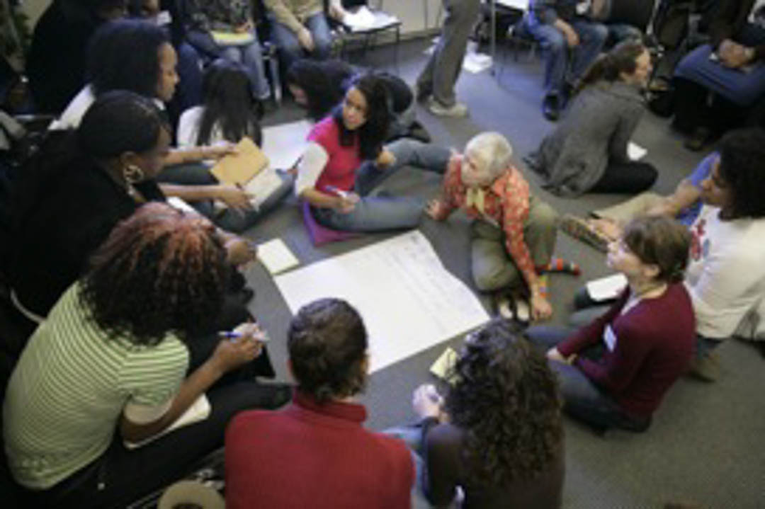
Learning From History: Racism has distorted, suppressed and denied the histories of people of color and white people as well. The workshop demonstrates that a full knowledge of history is a necessary organizing tool as well as a source of personal and collective power.
Sharing Culture: The workshop process demonstrates that even as racism divides people, sharing culture unites us. Cultural sharing is a critical organizing tool and is central to the workshop experience.
Organizing to Undo Racism: The workshop explores principles of effective organizing, strategic techniques of community empowerment, the importance of community accountability, and the internal dynamics of leadership development.

Our Partners

Citywide Youth Coalition
Community Foundation for Greater New Haven
Connecticut Mental Health Center Foundation
Just Moves
Perrin Family Foundation
William Caspar Graustein Memorial Fund
Yale Divinity School

