Southwark Labour Candidate Ward Preferences 2018 –
FOR COMPLETION & RETURN WITH APPLICATION FORM
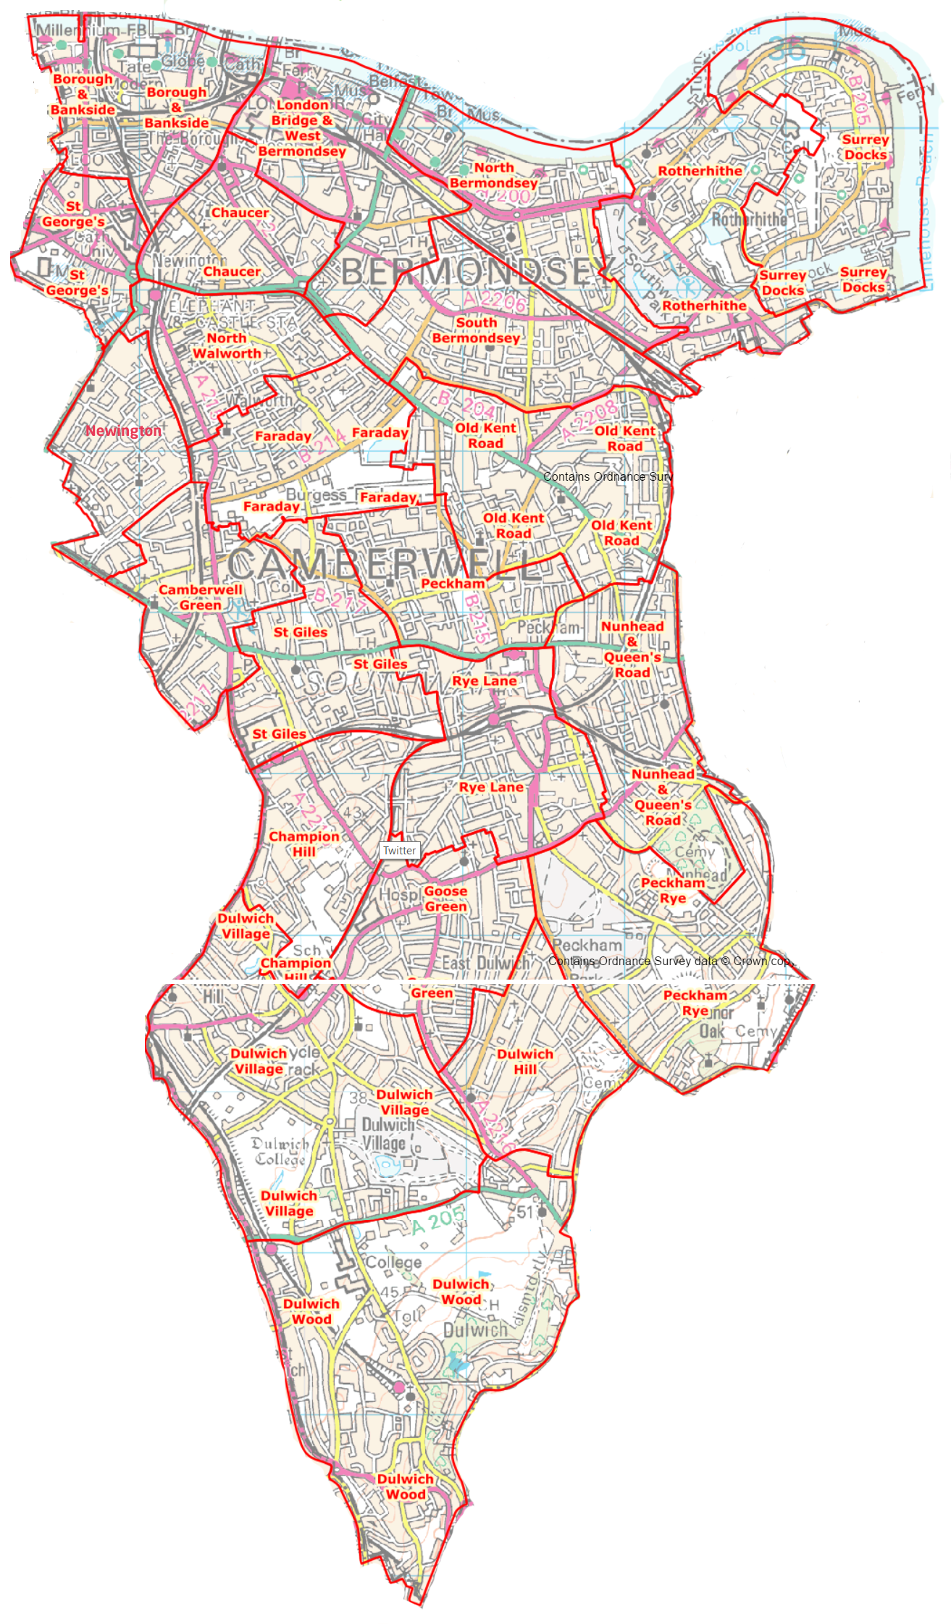 | Name :  Telephone :  Borough & Bankside   Chaucer   Newington   North Bermondsey   North Walworth   Rotherhithe   St George’s   South Bermondsey   Surrey Docks   West Bermondsey &  London Bridge   Camberwell Green   Champion Hill   Faraday   Nunhead & Queens Rd   Old Kent Road   Peckham   Peckham Rye   Rye Lane   St Giles   Dulwich Hill   Dulwich Village   Dulwich Wood   Goose Green 

