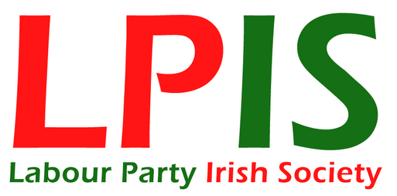
House of Commons
London
SW1A 0AA

Dear

Marriage equality for Northern Ireland

On Friday 11 May 2018, Conor McGinn’s private members bill is back in the House of Commons for a second reading. I was hoping you might be able to attend to ensure its progress to the next stage. This bill is vital for the basic and fundamental human rights of the LGBT community in Northern Ireland.

Northern Ireland remains the last place in the United Kingdom and Republic of Ireland to deny people marriage equality. The Stormont Assembly have voted in favour; the people of Northern Ireland support it; justice demands it – but the Democratic Unionists stop it every time.

The LGBT community of Northern Ireland should wait no longer. Please (a) attend the debate, (b) support the bill and (c) encourage your parliamentary colleagues to do the same.

Your sincerely,

Name: ____________________________________
Address: ____________________________________
Postcode: ____________________________________
Phone: ____________________________________
Email: ____________________________________
Yes, I am happy for the Labour Party Irish Society to keep my details on record to support their work and this campaign. Your data will not be sold or passed to a third party

