

La administración y el Personal de la Academia Young Oak Kim

**Invitan a nuestras familias y estudiantes a nuestro sexto anual**

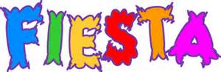 **YO’KAmmunity**

Jueves, 21 de Abril 2016

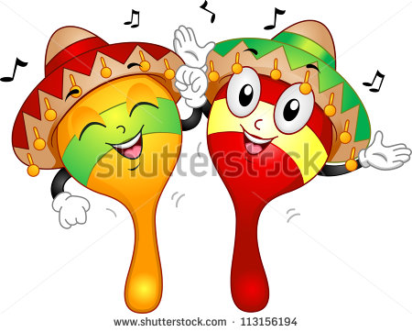 4:30 p.m. – 7:00 p.m.



**[](http://www.bing.com/images/search?q=free+food+vender+clipart&qpvt=free+food+vender+clipart&FORM=IGRE#view=detail&id=94214A42E28B93A9460F1A05056A4A1B178F572B&selectedIndex=539)Venga y desfrute una noche de familia, diversión y amistad!**

**EVENTOS Y PARTICIPANTES**

Mariachi / Actuaciones de Bailarinas de BTB/ Banda YOKA / YPI – GRYD/ GEAR UP / Paz Sobre Violencia / LAPL Bibliotecas Públicas / COFEM / WCKNC / Exhibiciones Estudiantiles / KYCC / Subway / Enfermeras del Distrito / Rite-Aid / KHEIR / YMCA / ZOC / DJ / Rifas / Bailables Típicos / ELAC / LACC / Dept. de Parques y Recreo y mucho más…

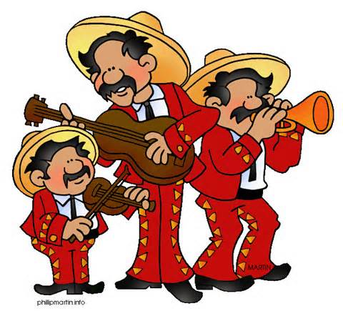Habrá Ricas Comidas para su desfrute.

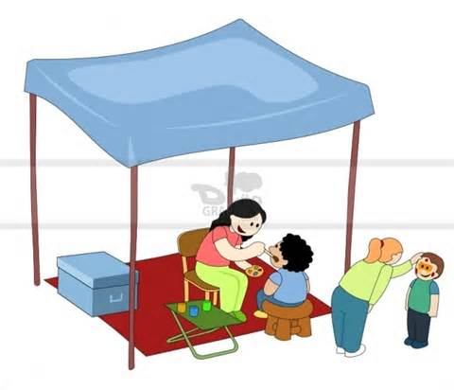 Use su vestimenta tipica !!!







The Administration and Staff of Young Oak Kim Academy

**Cordially Invite our Families and Students to our 6th Annual**

** YO’KAmmunity**

****Thursday, April 21, 2016 4:30 p.m. – 7:00 p.m.

**Come join us for an evening of fun, family, and friends!**

**EVENTS & PARTICIPANTS**

Mariachi / Performances by BTB Dancers/ YOKA Band/ YPI – GRYD / DJ / ELAC / ZOC / GEAR UP / Peace Over Violence / Public Libraries / COFEM / YMCA / LACC / WCKNC / Displays / KYCC / Subway / LAUSD Nursing / Rite-Aid / KHEIR / Raffles / Dept. of Parks & Recreation / Dept. Bus. Oversight & Education / Regional Dances and much more…

Delicious food choices will be available for your enjoyment.

Wear your traditional regional attire !!! 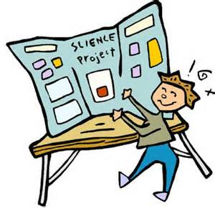

**[](http://www.bing.com/images/search?q=free+food+vender+clipart&qpvt=free+food+vender+clipart&FORM=IGRE#view=detail&id=94214A42E28B93A9460F1A05056A4A1B178F572B&selectedIndex=539)**