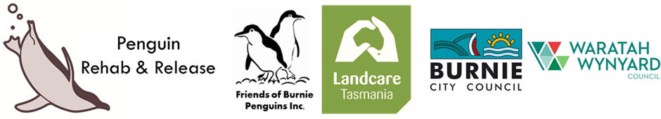
CAN YOU HELP?
Penguin Rehab & Release has received grants from Burnie City and Wynyard/Waratah Councils to build a penguin rehabilitation facility. It will be the first of its kind in the north-west of Tasmania, and will be dedicated to rehabilitating Little Penguins and preparing them for release back in to the wild. All birds are cared for by trained and registered carers and under the appropriate permits from Wildlife Management Branch, DPIPWE.
Penguin Rehab & Release is a small group of volunteers based in Burnie, registered with Landcare Tasmania and sponsored by Friends of Burnie Penguins, Inc. We are about to start construction on the facility and are looking for people who would be interested in being part of the volunteer work crew. We have an experienced owner builder who is giving his time and expertise to supervise the work, which will occur in 5 phases across 5 days. The work needs to be done on Mondays as this is the day available for the supervisor, and we need a crew of 4 people on each day. It does not need to been the same 4 people each time.
The first phase is putting in the footings, which will then need to cure, so there will be a four week break until the next working day.
No building experience is necessary as our building supervisor, Simon, will be on hand. Neither will any great strength be required, just a basic level of fitness and willingness to get the job done.
Lunches, morning and afternoon teas will be supplied. Some basic PPE gear will also be provided – basic protective goggles, dust masks and gloves. You will need to wear suitable work boots and if you have a hard hat, please bring it along.
The project is insured for public liability through Landcare Tasmania, and a safety induction will be given each day prior to work starting. To ensure that you are covered for insurance purposes you will need to fill out the registration form on the final page and return it prior to your working day. Please, only return the registration form if you are definitely available, as we will only be catering for a work crew of 4.
A copy of the proposed schedule is attached, and we are keeping our fingers crossed for good weather.
We are desperately trying to get this project finished before the busy season for Little Penguins really kicks in. At the moment, all penguins requiring more than 3-4 days in care, need to be transported to the south of the state where there are the only pools suitable for their rehabilitation. Penguins need to be able to swim for up to 8 hours at a time before they are fit for release. And, once they are ready for release, they need to be transported back to the north. This is extremely stressful for the birds and should be unnecessary. Please help us to make sure it is unnecessary in the future!

PENGUIN REHAB FACILITY

DAY 1 –
MONDAY 3RD SEPTEMBER

FOOTINGS

PREP FOR ELECTRICIAN

- Mark out
- Dig holes
- Position stirrups
- Concrete stirrups (concrete mixer)

- Dig trench for power – 600mm deep, 12m long, 2 bends
- Lay conduit
- Fill trench

Concrete mixer – Bunnings
String line, pegs
Post-hole borer – WA
Shovel
Stirrups

DAY 2 – MONDAY 1ST OCTOBER
FRAME UP

- Stand up posts
- Fit up 6 x 1 bracing
- Place wires
- Trench for conduit to pool – 6m + 2 bends

Posts, bugle screws
6 – 1
Screws, wire
Staples, gripples
Need Drill/Driver
Oil

DAY 3 – MONDAY 8TH OCTOBER
CLADDING

- Fit shade cloth inside walls
- Fit shade cloth to roof
- Fit mesh/netting to roof
- Fir mesh walls
- Clad aviary
- Make and fit doors

Shade cloth
Mesh
Clips
Aviary wire
Hinges
Catches

DAY 4 – MONDAY 15TH OCTOBER
INSTALL POOL

- Sand
- Assemble
- Pump
- Wiring – RC
- Fill and test

Pool
Sand

DAY 5 – MONDAY 22ND OCTOBER
FINISH ENCLOSURE & AVIARY

- 20cm sand layer
- Decorate

Sand
Grasses, rocks, tyres
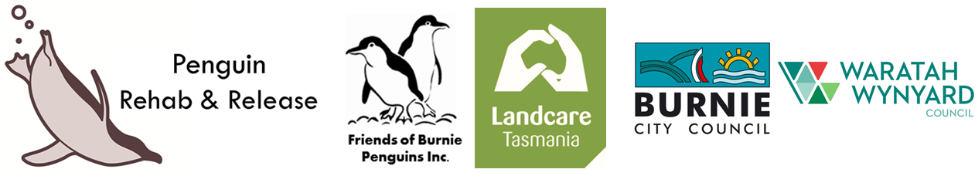
VOLUNTEER REGISTRATION
PENGUIN REHABILITATION FACILITY PROJECT
FIRST NAME | LAST NAME
EMAIL ADDRESS | CONTACT PHONE NUMBER
EMERGENCY CONTACT NAME | EMERGENCY CONTACT NUMBER

Do you have any pre-existing medical conditions or injuries that could affect your activity in this project?
If yes, please give details below.

Which day/s will you be available?

Morning/afternoon teas and lunches will be provided. Do you have any particular dietary requirements?

Return form to Kathy Grieveson, kathygrieveson@gmail.com

